**VSEPR TAKE AWAY NOTES**

**What is VSEPR Theory?**

**Line Wedge and Dash Drawings:**

Line: In the plane of the paper: **_____**

Wedge: Coming forward, in front of the plane of the paper: 

Dash: Going backward, behind the plane of the paper: 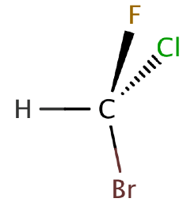

Where is each of the 5 atoms in the molecule CHFClBr?

In the plane of the paper ______ ______ ______

In front of the plane of the paper ______

Behind the plane of the paper ______

**The VSEPR Shapes You Are Responsible for Knowing:**

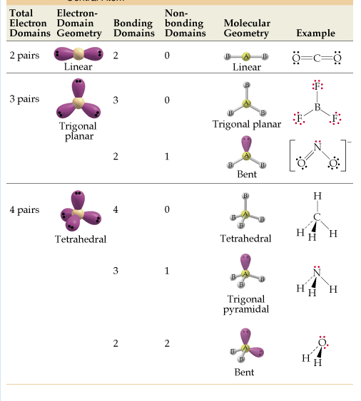

**\*Only take into consideration electron domains on the CENTRAL ATOM when determining shape.**

**Let’s Practice:**

|  |  |  |  |
| --- | --- | --- | --- |
| **Molecule** | **Lewis Structure** | **3-D Drawing** | **VSEPR Name** |
| **H2Se** |  |  |  |
| **BF3** |  |  |  |
| **CHFCl2** |  |  |  |
| **CS2** |  |  |  |
| **AsH3** |  |  |  |