Is there variation within species and if so, why is it important?

You have probably heard the expression “as alike as two peas in a pod.” But are they really? To us, the differences between humans are obvious, but we may be less sure about the differences within other species. In this lab you will observe specific characteristics of members of several species to see if there are in fact differences between individuals. Such differences between individuals within a species are known as variations*. Variations can be described using pictures, words or measurements. A good way to reveal any patterns that may exist is to observe traits that can be measured or counted and graph them. In this investigation you will look for and measure differences in the organisms within three species: peas, grasshoppers and humans. You will then graph your results for each species to show the extent of variation and to see if there are any common patterns in the variation for the traits. You will then be asked to think about why the variation exists and the possible effects that certain variations might have on the organisms’ ability to survive.

*NOTE: Variation and diversity do not mean the same thing. Diversity refers to the many different kinds of organisms –that is, the differences between species. Variation refers to differences among members of the same species.

Materials: One pea pod per student, mm ruler, calculator

Lab Group Data

1. Peas: Remove all peas from the pod. Peel outer “skin” from one pea and separate it into 2 halves. Use mm ruler to measure the longest distance across the flat surface of one of the halves to the nearest 0.5 mm. Place measured half in the appropriate test tube at the front of the classroom. Discard the other half. Repeat until you have measured all peas in your pod. Enter your data on the class data table.

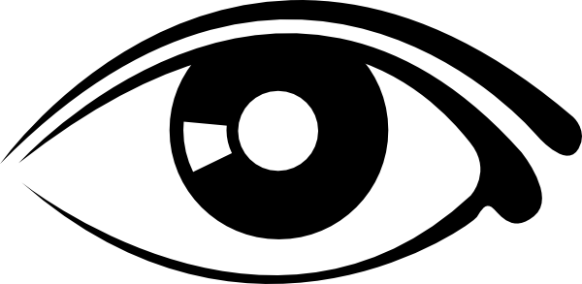
2. Eyeball Width: Measure the width of student eyeballs.

3. Human reaction time: Partners alternate being experimenter and subject.
- Subject: Sit with dominant arm resting on table, hand extending past edge, thumb and forefinger parallel to ground 4 cm apart. Check with ruler. Keep uniform through all trials or results may be affected.
- Experimenter:
- Hold meter stick vertically between subject’s thumb and index finger with 50cm line on meter stick even with index finger and thumb.
- Without warning drop stick.
- Subject: Attempt to catch the meter stick between your thumb and index finger.
- Experimenter: Record the number of centimeters (to nearest 0.1 cm) the meter stick dropped.
- Repeat 4 more times and record. Calculate the average of the 5 trials and record on the board.
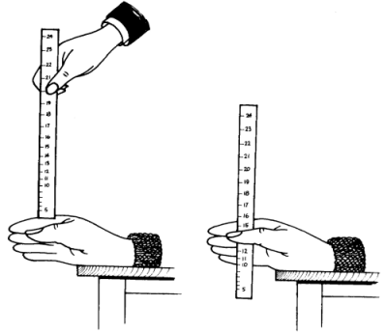
- Switch roles and repeat steps a-e

Organizing the Class Data

- For each of the three sets of group data (peas, eyeballs and reaction times) set up a table similar to example in Figure 1) showing the class total for each measurement.

- For each set of data prepare a graph like Figure 2 showing the distribution of the measurements in all classes.

You need 3 separate graphs one for each trait you measured (peas, eyeballs, reaction time). In each case the vertical axis is the number of individuals and the horizontal axis is the range of measurements.
- x axis = the bins or categories (measurements) mm or cm.
- y axis = number of peas, or eyeballs, or students.

- On the reaction time graph make an “X” on at the point where your own reaction time is shown. Label it “My Reaction Time”. Where do you fall in the compared to the rest?

Figure 1: Sample class data table

Distance dropped (cm) | Enter smallest measurement | Enter increasing measurements here, adding boxes as needed |  |  |  |  | Enter largest measurement
Number of students

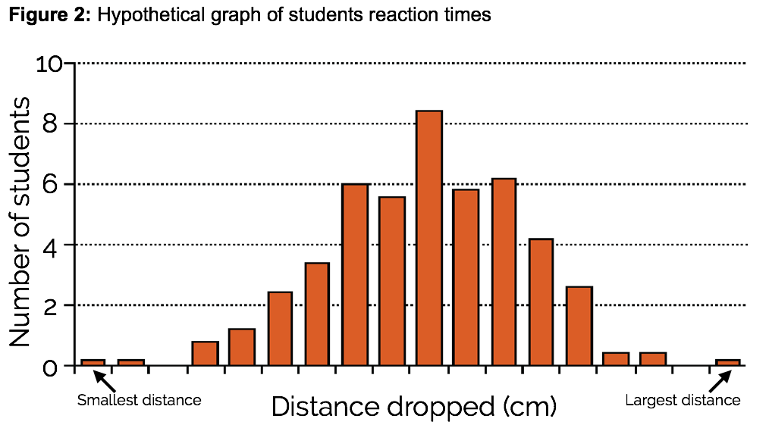

Discussion Questions

  - Study your graphs and see if you can find a pattern. What are the graphs telling you? Can you describe each graph in few words?

  - Patterns in data often reflect phenomena in nature. However, sometimes they reveal error in an experiment. Are there patterns in any of the graphs that might have been caused by error? Be specific and explain.

  - Pea seeds contain the tiny embryo of the new baby plant but are mostly made of the food that nourishes it until it sprouts above the surface and can produce food on its own.
- What are some things that would affect how much food the embryo will need?
- Is there an advantage to large seed size? Explain.
- Do you think baby pea plants always need all of the food stored in their seeds? Might any of the peas we measured have more food than they need?
- What might be a disadvantage of making seeds larger than really needed by the baby plant?
- What size do you think is about optimal for a pea seed…that is, provides enough food for the baby plant to survive under most circumstances but not so much that there is food left over and wasted?

  - Look at the eyeball data:
- What is the range of eyeball width in our sample (smallest → largest)?
- Is it an advantage to larger eyes have? Explain thoroughly why you think it is or is not.
- Do you think that an eyeball could be too large –in other words, so large that it would be a disadvantage to the person? What are some possible disadvantages?

  - If we measured and graphed the reaction times of 10,000 high school students how would the of the distribution compare to our graph of reaction times for five biology classes? Why?

Lab Group Data

Data Type | Record Measurements Here
Peas
Eyeball Width
Human Reaction Time

Class Data

Pea Width | Enter smallest measurement | Enter largest measurement
Number of Peas

Group
#

Group
#

Eyeball Width | Enter smallest measurement | Enter largest measurement
Number of students

Group
#

Group
#

Distance Dropped (cm) | Enter smallest measurement | Enter largest measurement
Number of students

Group
#

Group
#

