UCS BIOLOGY STUDY GUIDE FOR 1ST SEMESTER MIDTERM EXAM 2019-20

Write your answers on a separate sheet if you need more space.

Population Dynamics
- What are the factors that affect the birth rate of a population?

- What are the factors that affect the death rate of a population?

- Explain the relationship of birth rates and death rates on the three sections of the graph.
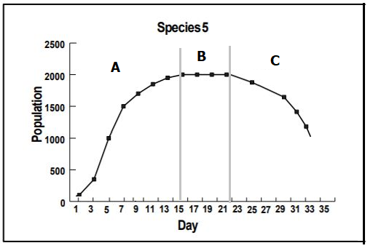

- What are some factors that cause a species to go extinct? What role do humans play in these factors?

- Explain how the wolf and moose on Isle Royal have historically interacted with each other. Sketch a basic graph of what this relationship looks like.

- Sketch a graph of what a population would look like if a population was not limited by resources.

- Sketch a graph of what a population would look like if a population was not limited by resources.

Natural Selection
***Do not underestimate natural selection, this unit has the most questions on the exam. Most of the problems can be answered based on our model developed in class and/or graph interpretation. ***
- Use your model sheet to write out the Natural Selection theory that we developed in class of how species change over time.

- What is the importance of the following in the theory you wrote above?
  - Advantageous Traits:

  - Overproduction:

  - A Struggle to Survive:

  - Genetic Variation:

- Using the theory you wrote above, write a narrative of why the finches’ beaks on the Galapagos Islands changed after the drought. ***The importance of this question is not to memorize the narrative, but to be able to apply our Natural Selection Model to other examples of species changing over time***

- What determines if a new variation found in a population will stay in the population over time?

Chemical Reactions
- What are some inputs and outputs in our bodies?

- Why do our bodies rearrange inputs into outputs?

- A student burns a piece of paper. Explain how matter and energy change during this chemical reaction.

- What are the three main molecules found in the food we eat?

- Fill the chart out below.
Molecule | Elements that Compose it | Subunit (monomer) | Picture
Carbohydrate
Lipid
Protein

- Explain which of the molecules in the table above store the most energy. Explain your answer.

- How is energy release from food that we eat?

- Draw an energy diagram for the follow (label products and reactants on the diagram):
  - A chemical reaction in which energy is released.

  - A chemical reaction in which energy is absorbed.

- What unit is used to measure energy in food?

- What would it mean if a food burns more intently than another?

- Explain what bromothymol blue (BTB) is and how it is used in an experiment.

Cellular Respiration
- Write the chemical equation for cellular respiration.

- What is the role of the mitochondria in a cell?

- What are the energy transformations that take place within an organism from the food they eat to the movement in their muscles?

- Explain how burning ethanol (combustion reaction) is similar to the process of cellular respiration.

- What is the first food molecule that is used as fuel in the process of cellular respiration?

- Draw an energy diagram for the chemical reaction of ATP ADP.

- Draw an energy diagram for the chemical reaction of ADP ATP.

Biosynthesis
- What are some examples of biosynthesis in your body?

- Explain how both plants and animals obtain their mass as they grow.

- What happens to a person’s mass when they lose weight?

Photosynthesis
- Write the chemical equation for photosynthesis.

- Do plants only perform photosynthesis, only cellular respiration, or both? Explain your answer.

- Describe the relationship between photosynthesis and cellular respiration.

- Be able to follow the flow of energy from the sun through a series of energy transformations through various organisms in an ecosystem.

