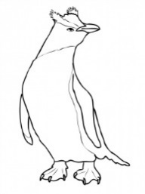
Biology 1 Name:
Strange Evolution Date:
Video Review Sheet Hour:

Describe why each species discussed is considered a case of “strange evolution”.

Species | Why is it strange?
Dingiso
Kagu
Skink
I’iwi
Kea Alpine Parrot
Fiordland Crested Penguins
Weta
New Zealand Bats
Kakapo
Tautara
Indian Mongooses in Hawaii
People of Tanna Island
Rats of Easter Island

