Ring-necked Pheasants

The ring-necked pheasant is native to Asia but has been successfully introduced as a game bird in many places, including Europe and North America. Unlike some introduced species, pheasants have adjusted well to their new homes and have not disrupted local ecosystems. Although they can fly fast for short distances pheasants prefer to run and spend most of their time on the ground. They are rarely seen in trees. As you can see, the male ring-necked pheasant is brightly colored. The white ring at the base of the red and green head stand out against the dull, brownish colors of the fields in which they live. The female, on the other hand, appears well camouflaged in this habitat.
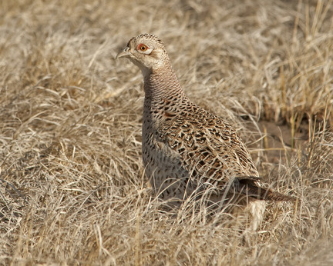
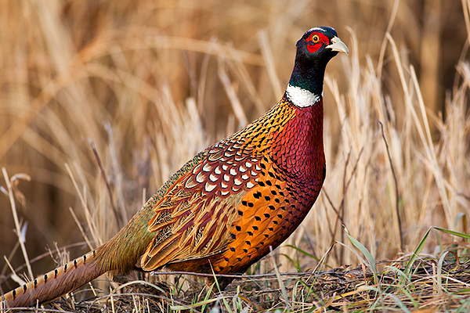

Habitat: The ring-necked pheasant largely inhabits grassland areas at the edge of stands of trees or hedges. The presence of dense grasses appears to be an important habitat attribute. Female birds often situate their nests in cover that provides partial to complete overhead concealment. Males, because of their bright coloration, have difficulty concealing themselves in their typical habitat.

Feeding behavior: All pheasants are largely vegetarian, and the majority are adapted to seed eating. Individual birds often have definite preferences for particular types of food. During the first few weeks of life pheasants consume a high incidence of insects. By the time the birds are adult, however, over 90 percent of the food intake comes from plant sources.

Reproduction: Pheasant hens build their nests on the ground and have one brood per year with an average clutch size of 10 eggs. Mating season is mid-March to June. The young grow up quickly and can fly within two weeks of hatching. They usually remain with their mother for the first 6-7 weeks and reach sexual maturity at about 1 year.

Lifespan and predation: Pheasants are a prey species. Their average life expectancy in the wild is only 10-20 months, but they can live 15-25 years in captivity. Predators include foxes, minks, weasels, owls, and hawks. The majority of these detect their prey by sight during daylight hours. Pheasants are also prized game birds so are often killed by hunters.

