Chemistry 1 Name:
Semester 1 Review Date:
Hour:
Periodic Trends Review
Property: _______________ Property: _______________

Property: _______________ Electron Configuration Review
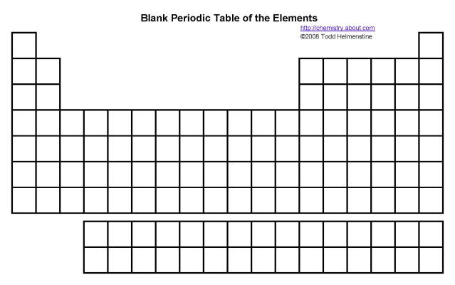

Naming Compounds Review
Type of Compound | How do you know it is this type of compound? | Rules for Naming
Ionic
Covalent
Acid
Base
Define:

Physical Change:

Chemical Change:

Gas Laws Review

What is Kinetic Molecular Theory and what does it assume?

Law | Mathematical Formula | Real World Example
Avagadro’s
Charles’
Boyle’s
Combined Gas Law

Why you NEVER have to ask “What do I round my answer to?”

When is a digit “significant”?
What do you do about adding and subtracting when considering significant figures?
What do you do about multiplying and dividing when considering significant figures?

