Biology 1
Science and Experimental Design Basics - NOTES

Science Basics
- Observations are the backbone of science
  - Observations must be unbiased and objective to be valid
  - Observations are descriptions not explanations
- There is no proof or absolute truth in science (you can’t “prove” something – it can only be proved wrong)
- A hypothesis is an educated guess based on observations.
  - It can be disproved
  - Example: If you see no difference in the cleaning ability of various laundry detergents, you might hypothesize that cleaning effectiveness is not affected by which detergent you use. You can see this hypothesis can be disproved if a stain is removed by one detergent and not another. On the other hand, you cannot prove the hypothesis. Even if you never see a difference in the cleanliness of your clothes after trying a thousand detergents, there might be one you haven't tried that could be different. Null hypothesis is often a great one. It says that “nothing will happen.” This is often proved to be false warranting further investigation.
- A theory summarizes a hypothesis or a group of hypotheses that have been supported with repeated testing.
  - A theory is valid as long as there is no evidence to dispute it. Therefore, theories can be disproved.
  - Example: It is known that on June 30, 1908 in Tunguska, Siberia, there was an explosion equivalent to the detonation of about 15 million tons of TNT. Many hypotheses have been proposed for what caused the explosion. It is theorized that the explosion was caused by a natural extraterrestrial phenomenon, and was not caused by man. Is this theory a fact? No. The event is a recorded fact. Is this theory generally accepted to be true, based on evidence to-date? Yes. Can this theory be shown to be false and be discarded? Yes.
- A law generalizes a collection of observations.
  - A law explains things but does not describe them. It does not answer “why?”
  - No exceptions have been found to a law.
  - Example: Consider Newton's Law of Gravity. Newton could use this law to predict the behavior of a dropped object, but he couldn't explain why it happened.

Experimental Design Basics
- Variables are the changeable components of an experiment
- Controlling variables involves ensuring certain variables remain constant
- Experimental variable is the variable that is being studied
- Independent variable (manipulated variable) is the variable that is manipulated by the experimenter.
- Dependent variable (responding variable) is the variable that responds to, or is affected by the other variable. This is often the variable that scientists will observe and measure.
- Experimental group is the group that is being exposed to the experimental variable
- Control group is not exposed to the experimental variable. It provides baseline data.
- Other keys to a good experiment
  - Repeatability – Can the experiment be easily repeated by others?
  - Only one variable is changed from one trial to the next.
  - Multiple trials – Eliminates the impact of a random error on data set
  - Accuracy and Precision
    - Accuracy is how close to the actual value any given observation is.
    - Precision refers to how close measured values are to each other.
Low Accuracy High Accuracy High Accuracy
High Precision Low Precision High Precision
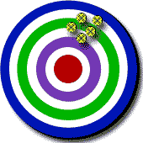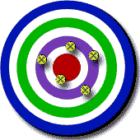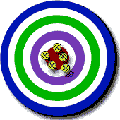

Drawing Conclusions Basics
- Consider “Causation vs. Correlation”
  - Does A actually cause B or are they simply related?
Consider the following statement:

People who own red cars are twice as likely to have an accident as people who own blue cars.

Does the red color actually cause the accidents?
If so then what would be the conclusion we should draw from these observations?

People who own red cars should re-paint their cars blue.

That’s just silly!

Is there a correlation (relationship/connectedness) between color and accidents?

Yes.

Does the color of a car actually cause the accidents?
No.

Causations are much harder to prove than correlations.

