Root Word Mash-up
Learning vocabulary can be one of the most difficult challenges in biology. One way to develop your biological vocabulary is to know the definition of the Greek and Latin root words that make up many words used in biology. Use your list of common biological root words to make up your own fictitious biological words. Write each root you will be using, the definition of each root, the new biological word they make. Then draw a picture using colored pencils to illustrate your new term. You may combine 2-4 roots to create your new words. Fill in your table with 6 new words and their roots.
 | New Word | Roots with  Definition | New Word Definition | Picture of New Word
 | Ectochymosome | Ecto- Outside of  -chym- juice  -some Body | A mass of fluid on the outside of the body
 |  |  |  | 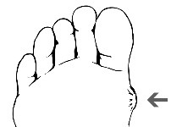

New Word | Roots with Definition | New Word Definition | Picture
 | *must use 2 root words
 | *must use 2 root words
 | *must use 2 root words
 | *must use 3 root words
 | *must use 3 root words
 | *must use 3 root words
 | *must use 4 root words
 | *must use 4 root words
 | *must use 4 root words
 | *Challenge: try 5 root words

