4.1-4.2 Review

READ THIS: For this review you will need: Your notes, your PHet, and any other resources that helped you to succeed in this content. EXPECT to see the content in a variety of forms. For example it is not enough to have memorized that protons are positive and are in the center of the atom. You will need to be able to recall and use that definition when looking at models, pictures, charts etc. Please provide your answers to the following questions on lined paper. Be sure to clearly label each question!

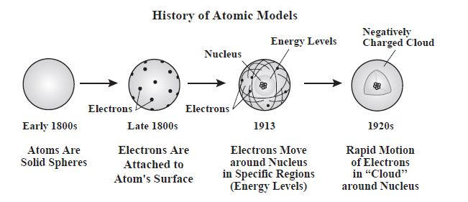
- Dalton’s early 1800’s model, seen above, lacks subatomic particles. We now know they exist. Fill in the chart below for each subatomic particle:

Particle | Location | Charge | AMU Mass | Symbol(s)
 |  |  |  | p+ or +
 |  |  |  | nº
 |  |  |  | e- or -
- Dalton was an English scientist who proposed that atoms were hard, indivisible spheres. Looking at the other three models shown above it is clear that the atom has a different internal structure.
  - What claim did Ernst Rutherford make about the atom?
  - Describe the evidence he had for this claim. Be sure to address the experiment and the results of the experiment as your evidence.
  - Use scientific reasoning that clearly links his evidence to his claim.
- Compare Thomson’s late 1800’s model to Bohr’s 1913 model seen above. What do they have in common? What are the major differences?
- Compare the 1913 Bohr model to the 1920’s Schrodinger model seen above. What do they have in common? How are they different?
- Based on the chart from question 1, what is the overall charge of the nucleus?
- Based upon the chart from question 1, where is nearly all of the mass of the atom located?
- Which of the three subatomic particles is responsible for identification of the element?
- Can you change the proton count of the atom and still have it be the same element?
- What is an isotope?
- Which subatomic particle changes and creates isotopes of the same element?
- What is an ion?
- Which subatomic particle changes to create ions?
- Write a complete sentence that explains what must be true for an atom to be considered electrically neutral.
- What is the strong force? Where is it located on the atom?
- What is the definition of Atomic Number?
- How do you calculate Mass Number?
- Rearrange the equation from question 16 to solve for neutrons.
- What is the calculation needed to find charge?
- How can you rearrange the equation in question 18 to solve for the number of electrons on an ion?
- Use the table above to answer questions a -f.
Isotopes | Atomic Mass (AMU) | % Natural Abundance
Neon – 20 | 19.99 | 90.9%
Neon – 21 | 20.99 | 0.3%
Neon – 22 | 21.99 | 8.8%
- How many isotopes of neon exist in nature?
- Make a claim! Will the average atomic mass of Neon be closer to 20, 21 or 22? State your Evidence! What evidence do you have to support the claim you just made? Provide your reasoning! State scientific reasoning that connects your claim to your evidence.
- Using your answers to b and c – DO you think the mass on the periodic table, the average atomic mass, is a weighted average or a simple average in which all isotopes are represented equally?
- What is one difference in terms of subatomic particles between the three isotopes?
- Calculate the average atomic mass of Neon – show all work as if this were the test! That means you show the equation, your plug in values, and an answer with AMU units!
- For the following nuclei symbols answer a-e that follow:

${}_{34}^{78}{Se}$ ⁺² ${}_{20}^{42}{Ca}$ ${}_{53}^{127}I$⁻¹ ${}_{20}^{40}{Ca}$ ${}_{34}^{78}{Se}$ ${}_{24}^{53}{Cr}$

  - Which two nuclide symbols compare the neutral atom to the ion for the same element?
  - Which two nuclide symbols are isotopes of the same element?
  - What is the total number of neutrons in the isotope symbol shown above having an Atomic Number of 53?
  - Why does the Selenium atom with a +2 charge have a positive net charge?
  - What is the total number of protons and neutrons on the Calcium-42 isotope?

- Draw a picture of an atom that has 5 protons, 4 neutrons and 5 electrons that is consistent with the current model of the atom. Is this an ion? How can you tell? Write the nuclei symbol for this atom.
- Fill in the missing parts of the tables. PLEASE remember that when the symbol is requested we mean the nuclei symbol with MN, AN, and Charge.
Nuclei Symbol |  | Nuclei Symbol
Atomic Number |  | Atomic Number | 35
Mass Number | 138 | Mass Number
Protons | 56 | Protons
Neutrons |  | Neutrons | 44
Electrons |  | Electrons | 36
Charge | +2 | Charge

