**Biology 1 Name: Date:**

***Cellular Respiration Analogy*  Hour:**

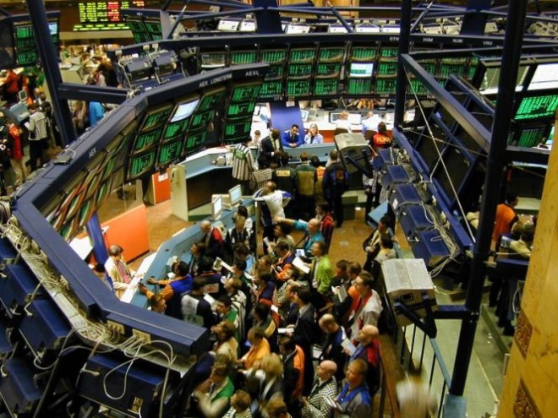

Use profits to buy stocks. Earn tons of money when the companies make it big!

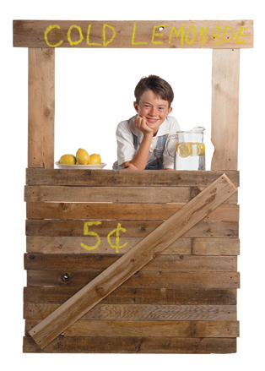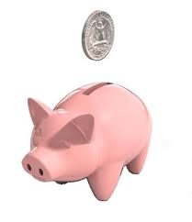[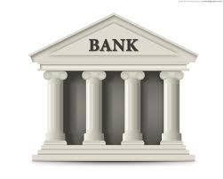](http://www.google.com/imgres?hl=en&biw=1024&bih=546&tbm=isch&tbnid=VZNTeMC-RI-D2M:&imgrefurl=http://malkeetsingh9.blogspot.com/2012/06/bank.html&docid=juKiGdjhTsa73M&imgurl=http://3.bp.blogspot.com/-x2wwO9YA2Q4/T-qnGCgGz1I/AAAAAAAAAsk/l2gsjPOJpsc/s1600/bank-building-icon.jpg&w=1280&h=1024&ei=2j8JUNqQGc2LrQGWhKClCg&zoom=1&iact=hc&vpx=119&vpy=159&dur=359&hovh=201&hovw=251&tx=146&ty=140&sig=107829347292374027911&page=2&tbnh=159&tbnw=213&start=8&ndsp=12&ved=1t:429,r:0,s:8,i:154)

Save profits in a bank account. Make a modest amount in interest.

Open up a lemonade stand to make some money.

Fermentation

Aerobic Respiration

Krebs Cycle

Glycolysis

Electron Transport Chain

**Biology 1 Name: Date:**

***Cellular Respiration Analogy*  Hour:**

Fermentation

Aerobic Respiration

Krebs Cycle

Glycolysis

Electron Transport Chain