Biology 1 Name:
Welcome Back to the Book Web Site Name:
Virtual Investigation #2 Date:
Hour:

Our Modern Biology book has a fairly comprehensive website. You will be able to find the book on-line and utilize numerous resources.

Go to the following website: my.hrw.com
Your user name is: astudents90
Your Password is: a7k7

Click ‘Go to the Online Textbook’. Here you will find a digital copy of your book. This will also give you access to audio files of vocabulary, digital copies of worksheets and virtual investigations (like the one we are doing today).

From the drop down menu at the top, select ‘Chapter 43: Mammals’. Then click the eActivities tab.

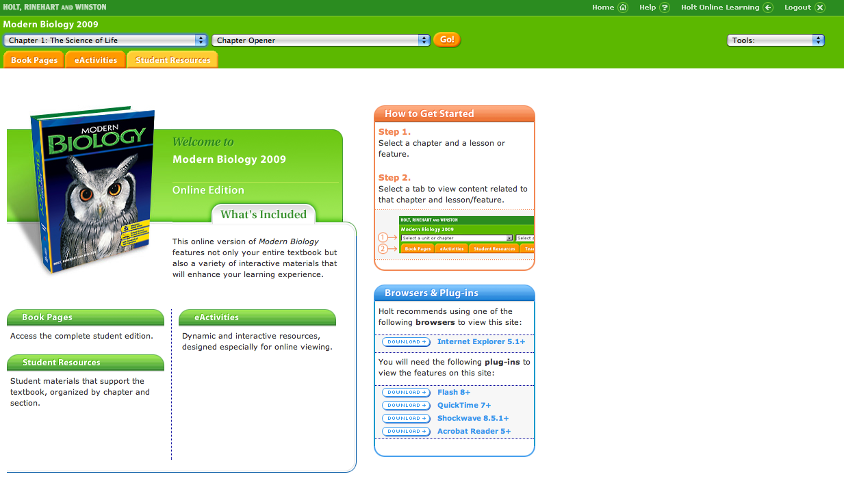

Now you are ready to try out our first Virtual Investigation. Click on ‘Respiration in Vertebrates’ link.
Navigate through the Virtual Investigation for The Scientific Process on the Holt website. Answer these questions as you proceed. This should serve as a refresher on the ‘Scientific Method’ as well as a reinforcement of the concepts related to photosynthesis that we’ve been talking about in class the past few days.

Remember, for full credit you must use complete sentences!

Part 1 of 5

___________ are the structures used by terrestrial animals for respiration (ventilate).

___________ are the structures used by aquatic animals for respiration (ventilate).

Why do animals need a circulatory system?

__________________________________________________________________________________________

__________________________________________________________________________________________

__________________________________________________________________________________________

Part 2 of 5

What is the purpose of cellular respiration? What byproduct is produced by respiration (and must be exhaled)?

__________________________________________________________________________________________

__________________________________________________________________________________________

Part 3 of 5
What does metabolism have to do with body temperature?

__________________________________________________________________________________________

__________________________________________________________________________________________

__________________________________________________________________________________________

Which organisms require more energy, terrestrial or aquatic? _____________________________________

__________________________________________________________________________________________

Which organisms require more energy, endotherms or exotherms? _________________________________

__________________________________________________________________________________________

Part 4 of 5

Energy Requirements
Arrange the organisms on the interactive webpage until you have correctly determined the order from lowest to highest energy requirements. Record your findings (by name) in the diagram below.

Lowest Highest

What do you notice about the hummingbird’s respiratory system that is different from yours?

__________________________________________________________________________________________

__________________________________________________________________________________________

__________________________________________________________________________________________

What factors affect the efficiency of circulation of oxygen throughout the body?

__________________________________________________________________________________________

__________________________________________________________________________________________

__________________________________________________________________________________________

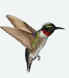

Part 5 of 5 - Fill in this table using information from the virtual investigation.
 | Fish | Amphibian | Reptile | Bird | Mammal
Oxygen source
Respiratory organ
Circulatory loops
# of Atria
# of Ventrcles
Mix oxygen-rich & oxygen-poor blood
Mix oxygen-rich & oxygen-poor air
Ventilation
Relative Efficiency

What difference(s) allow amphibians to respire more efficiently than fish?

__________________________________________________________________________________________

__________________________________________________________________________________________

What difference(s) allow reptiles to respire more efficiently than amphibians?

__________________________________________________________________________________________

__________________________________________________________________________________________

What difference(s) allow mammals to respire more efficiently than reptiles?

__________________________________________________________________________________________

__________________________________________________________________________________________

What difference(s) allow birds to respire more efficiently than mammals?

__________________________________________________________________________________________

__________________________________________________________________________________________

