Activity 6: Recombinant DNA Techniques

Objective
You will model the process of using restriction enzymes and plasmids to form recombinant DNA.

Background Information
The major tools of recombinant DNA technology are bacterial enzymes called restriction enzymes. Each enzyme recognizes a short, specific nucleotide sequence in DNA molecules, and cuts the backbones of the molecules at that sequence. The result is a set of double-stranded DNA fragments with single-stranded ends, called "sticky ends." Sticky ends are not really sticky; however, the bases on the sticky ends form base pairs with the complementary bases on other DNA molecules. Thus, the sticky ends of DNA fragments can be used to join DNA pieces originating from different sources.
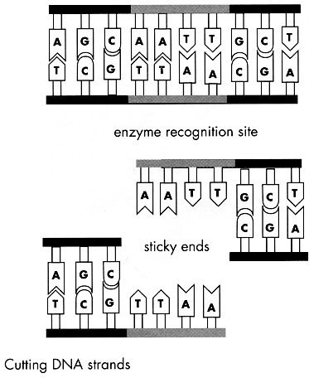
In order to be useful, the recombinant DNA molecules have to be made to replicate and function genetically within a cell. One method for doing this is to use plasmid DNA from bacteria. Small DNA fragments can be inserted into the plasmids, which are then introduced into bacterial cells. As the bacteria reproduce, so do the recombinant plasmids. The result is a bacterial colony in which the foreign gene has been cloned.
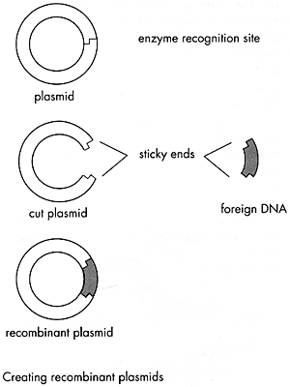
Materials
For each group:
- Handout: Plasmid Base Sequence Strips
- Handout: DNA Base Sequence Strips
- Handout: Restriction Enzyme Sequence Cards
- Scissors
- Tape
- Pencil
- Paper

Preparation
Duplicate Handouts Plasmid Base Sequence Strips, DNA Base Sequence Strips, and Restriction Enzyme Sequence Cards to distribute to students. You may want to duplicate each Handout on a different color page.

Instructions
- Cut out the plasmid strips (Handout 3) along the dotted lines. Line the strips end to end and tape/glue them together to form a single long strip. The letters should all be in the same direction when the strips are taped. The two ends of the strip should then be taped/glued together with the genetic code facing out to form a circular plasmid.
- Cut out the DNA base sequence strips (Handout 4), and tape them together to form one long strip. The pieces must be taped together in the order indicated at the bottom of each strip. There are extra tabs at the top and bottom of the strips to use to help you attach them.
- Next, cut out the restriction enzyme cards (Handout 5). The enzyme cards illustrate a short DNA sequence that shows the sequence that each particular enzyme cuts. There are many restriction enzymes that cut DNA. You must determine which enzyme to use (see the next steps).
- Compare the sequence of base pairs on an enzyme card with the sequences of the plasmid base pairs. If you find the same sequence of pairs on both the enzyme card and the plasmid strip, they should mark the location on the plasmid with a pencil, and write the enzyme number/letter in the marked area. Do this for each enzyme card. Please note that some enzyme sequences may not have a corresponding sequence on the plasmid, and that some enzyme sequences may have more than one corresponding sequence on the plasmid. This means these enzymes are useless to you.
- Once you’ve identified all corresponding enzyme sequences on the plasmid, identify those enzymes which cut the plasmid once and only once. Discard any enzymes that cut the plasmid in the shaded plasmid replication sequence. This would prevent DNA polymerase from initiating replication of this plasmid.
- Next, compare the enzymes that passed the test in step 5 against the cell DNA strip. Find any enzymes that will make two cuts in the DNA, one above the shaded insulin gene sequence and one below the shaded insulin gene sequence. Mark the areas on the DNA strip that each enzyme will cut. Be sure to get rid of any enzyme that would make a cut within the insulin gene.
- After you have compared each enzyme with the DNA strip, select one enzyme to use to make the cuts. The goal is to cut the DNA strand as closely as possible to the insulin gene sequence without cutting into the gene sequence. This results in the smallest possible plasmid. Remember this plasmid will have to be replicated by the bacteria as they grow and divide. A smaller plasmid will take less time to replicate and time is money! Make cuts on both the plasmid and the DNA strips. Make the cuts in the staggered fashion indicated by the black line on the enzyme card.
- Tape/glue the sticky ends (the staggered ends) of the plasmid to the sticky ends of the insulin gene to create a piece of recombinant DNA.

Discussion Questions
- Why was it important to find an enzyme that would cut the plasmid at only one site? What could happen if the plasmid were cut at more than one site?

- Why was it important to discard any enzymes that cut the plasmid at the replication site?

- Why might it be important to cut the DNA strand as closely to the desired gene as possible?

- In this activity, you incorporated an insulin gene into the plasmid. How will the new plasmid DNA be used to produce insulin?

Handout 3: Plasmid Base Sequence Strips

- Cut out strips along dotted lines.
- Tape together top to bottom in any order.
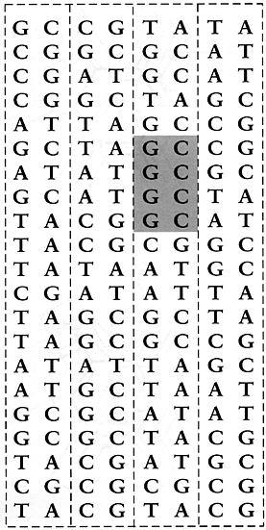
Shaded region = plasmid replication site

Handout 4: DNA Base Sequence Strips
- Cut out strips along dotted lines.
- Tape together top to bottom in numerical order.
Shaded region = insulin gene site

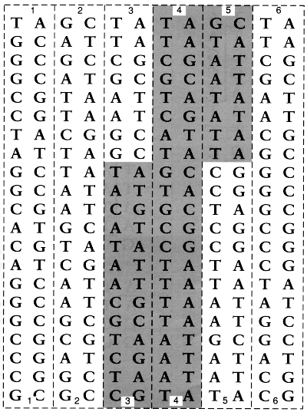

Handout 5: Restriction Enzyme Sequence Cards

- Cut out cards along dotted lines.
- Compare each enzyme sequence to the base sequences on the plasmid and DNA strips.
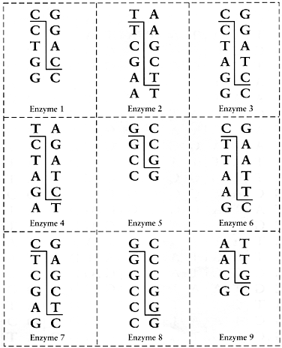
Enzyme E
Enzyme D
Enzyme C
Enzyme B
Enzyme A

Handout 5: Restriction Enzyme Sequence Cards

- Cut out cards along dotted lines.
- Compare each enzyme sequence to the base sequences on the plasmid and DNA strips.
Enzyme 5
Enzyme 4
Enzyme 2
Enzyme 3
Enzyme 1

