Name ____________________________ Hr _____
Types of Reactions
Choose the correct symbol for the type of reaction. Place that answer in the blank at the beginning of each equation and then balance each equation correctly. Below the reaction, show how you were able to determine the type.

S = synthesis (combination) SD = single displacement (single replacement)
D = decomposition DR = double replacement
C = combustion AB = neutralization (a specific type of DR)
- _____ CO (g) + O₂ (g) CO₂ (g)

- _____ Fe(OH)₂ (aq) + HCl (aq) FeCl₂ (aq) + H₂O (l)

- _____ NaNO₃ (s) NaNO₂ (s) + O₂ (g)

- _____ CH₄ (g) + O₂ (g) CO₂ (g) + H₂O (g)

- _____ Fe (s) + CuNO₃ (aq) Cu (s) + Fe(NO₃)₂ (aq)

- _____ KI (aq) + Cl₂ (g) KCl (aq) + I₂ (aq)

- _____ Na (s) + H₂O (l) NaOH (aq) + H₂ (g)

- _____ Al (s) + S (s) Al₂S₃ (s)

9. _____ KClO₃ (s) KCl (s) + O₂ (g)

10. _____ C₄H₁₀ (g) + O₂ (g) CO₂ (g) + H₂O

WORKSHEET ON SINGLE & DOUBLE REPLACEMENT REACTIONS
Directions: Complete ALL work on a lined piece of paper. Predict the products. Write formulas and balance each reaction. If there is no reaction, then just put NO RXN.
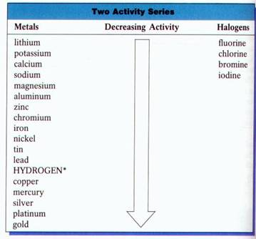
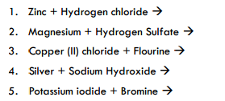
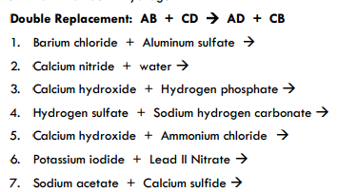
In addition to writing formulas, predicting products and balancing the reaction, also identify if the reaction is Single Replacement (SR) or Double Replacement (DR). Write the type to the LEFT of the number of the problem on your lined paper.
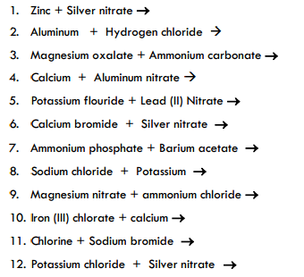

Writing Chemical Equations
Directions: Write a balanced equation for each of the following: Also to the left of the number identify the type of reaction. Hints: Remember the 7 diatomic elements. Ionic compounds require “swap drop reduce”, while covalent compounds use prefixes. Use the symbols (s), (l), (g), and (aq) where appropriate.
1. Oxygen gas reacts with solid copper metal to form copper (II) oxide solid.
__________________________________________________________________________
2. Voltage is applied to two electrodes in a solution of iron (III) chloride and a yellow-green gas bubbles form on one electrode and metallic deposits form on the other electrode.
__________________________________________________________________________
3. Oxygen gas reacts with hydrogen gas to form liquid water.
__________________________________________________________________________
4. Dinitrogen pentoxide gas in the presence of a platinum catalyst and high enough temperature forms nitrogen gas and oxygen gas.
__________________________________________________________________________
5. Sulfur solid reacts with iron solid to form solid iron (III) sulfide.
__________________________________________________________________________
6. Hydrogen gas and iron (III) oxide powder react to form liquid water and solid iron powder.
__________________________________________________________________________
7. Magnesium metal reacts with hydrochloric acid to form magnesium chloride solution and hydrogen gas.
__________________________________________________________________________
8. Magnesium sulfide solid and hydrochloric acid react to form hydrogen sulfide gas and magnesium chloride solution.
__________________________________________________________________________
9. Hydrogen sulfide gas is bubbled through a sodium hydroxide solution to produce sodium sulfide solution and liquid water.
__________________________________________________________________________
10. Hydrogen gas and aluminum chloride solution are produced when solid aluminum is reacted with hydrochloric acid.
__________________________________________________________________________

Chemistry 1 Name:
Predicting Products Practice Date:
Hour:
WRITE ALL OF YOUR ANSWERS ON A SEPARATE SHEET OF LINED PAPER
Single-Replacement Reactions
Step 1 - Write the formulas of the reactants on the left of the yield sign
Step 2 - Look at the Activity Series on page 437 to determine if the replacement can happen
Step 3 - If the replacement can occur, complete the reaction and balance it. If the reaction cannot happen, write N.R. (no rxn) on the product side.

1. lead + zinc acetate →
2. iron + aluminum oxide →
3. silver nitrate + nickel →
4. sodium bromide + iodine →
5. aluminum bromide + chlorine →
6. sodium iodide + bromine →
7. calcium + hydrochloric acid →
8. magnesium + nitric acid →
9. silver + sulfuric acid →
10. potassium + water →
11. sodium + water →

Double-Replacement Reactions
In these reactions, all you do is look at the names of the reactants, and "switch partners". Just be sure that the new pairs come out with the positive ion named first, and paired with a negative ion.

1. aluminum iodide + mercury(II) chloride →
2. silver nitrate + potassium phosphate →
3. copper(II) bromide + aluminum chloride →
4. calcium acetate + sodium carbonate →
5. ammonium chloride + mercury(I) acetate →
6. calcium nitrate + hydrochloric acid →
7. iron(II) sulfide + hydrochloric acid →
8. copper(II) hydroxide + acetic acid →
9. calcium hydroxide + phosphoric acid →
10. calcium bromide + potassium hydroxide →

Examine the products of the Double Replacement reactions on this page, and determine in each whether a gas, water, or a precipitate is formed. Rule: Double displacement reactions occur if ONE of the products is water, a gas or insoluble (a solid). Use the solubility table on page 434 at the back of your textbook to determine the solubilities of the reaction products. If there is no gas, water, or precipitate produced, put an "X" through the yield sign, because no reaction occurs.
ANSWERS
Single-Replacement Reactions
1. lead + zinc acetate →
Pb + Zn(C2H3O2)2 → N.R.
2. iron + aluminum oxide →
Fe + Al2O3 → N.R.
3. silver nitrate + nickel → nickel(II) nitrate + silver
2AgNO3 + Ni → Ni(NO3)2 + 2Ag
4. sodium bromide + iodine →
NaBr + I2 → N.R.
5. aluminum bromide + chlorine → aluminum chloride + bromine
2AlBr3 + 3Cl2 → 2AlCl3 + 3Br2
6. sodium iodide + bromine → sodium bromide + iodine
2NaI + Br2 → 2NaBr + I2
7. calcium + hydrochloric acid → calcium chloride + hydrogen
Ca + 2HCl → CaCl2 + H2
8. magnesium + nitric acid → magnesium nitrate + hydrogen
Mg + 2HNO3 → Mg(NO3)2 + H2
9. silver + sulfuric acid →
Ag + H2SO4 → N.R.
10. potassium + water → potassium hydroxide + hydrogen
2K + 2H2O → 2KOH + H2
11. sodium + water → sodium hydroxide + hydrogen
2Na + 2H2O → 2NaOH + H2
Double-Replacement Reactions
1. aluminum iodide + mercury(II) chloride → aluminum chloride + mercury(II) iodide
2AlI3 + 3HgCl2 → 2AlCl3 + 3HgI2(ppt)
2. silver nitrate + potassium phosphate → silver phosphate + potassium nitrate
3AgNO3 + K3PO4 → Ag3PO4(ppt) + 3KNO3
3. copper(II) bromide + aluminum chloride → copper(II) chloride + aluminum bromide
3CuBr2 + 2AlCl3 → 3CuCl2 + 2AlBr3
4. calcium acetate + sodium carbonate → calcium carbonate + sodium acetate
Ca(C2H3O2)2 + Na2CO3 → CaCO3(ppt) + 2NaC2H3O2
5. ammonium chloride + mercury(I) acetate → ammonium acetate + mercury(I) chloride
2NH4Cl + Hg2(C2H3O2)2 → 2NH4 C2H3O2 + Hg2Cl2(ppt)
6. calcium nitrate + hydrochloric acid → calcium chloride + nitric acid
Ca(NO3)2 + 2HCl → CaCl2 + 2HNO3
7. iron(II) sulfide + hydrochloric acid → iron(II) chloride + hydrogen sulfide (g)
FeS + 2HCl → FeCl2 + H2S
8. copper(II) hydroxide + acetic acid → copper(II) acetate + water
Cu(OH)2 + 2HC2H3O2 → Cu(C2H3O2)2 + 2H2O
9. calcium hydroxide + phosphoric acid → calcium phosphate + water
3Ca(OH)2 + 2H3PO4 → Ca3(PO4)2 + 6H2O
10. calcium bromide + potassium hydroxide → calcium hydroxide + potassium bromide
CaBr2 + 2KOH → Ca(OH)2 + 2KBr

