Biology 1 Name:

***Photosynthesis Practice Test*** Date:

Hour:

1. What is the overall reaction for photosynthesis?

1. How does this compare to the overall reaction for cellular respiration?

1. Where does the energy for photosynthesis come from?

1. What plant pigments are involved in photosynthesis?

1. Explain why chlorophyll appears green to us in terms of what happens to different wavelengths of light that strike a chlorophyll molecule.
2. How does the amount of energy in light change as the wavelength increases?
3. Which colors of light are most effective for photosynthesis? Explain why.
4. In what organelle of a plant cell does photosynthesis take place?

1. What are the two stages of photosynthesis?

1. In which part of the chloroplast does each stage occur?

1. What happens to water molecules in the light reactions?

1. What photosynthesis waste product is formed in the light reactions?

1. What two products of the light reactions are used up in the Calvin cycle?

1. What happens to carbon dioxide molecules in the Calvin cycle reactions?

1. How can cells store the sugar that is produced in photosynthesis?

1. Label the diagram below to summarize the two stages of photosynthesis. Use the word bank below the diagram to fill in the blanks.

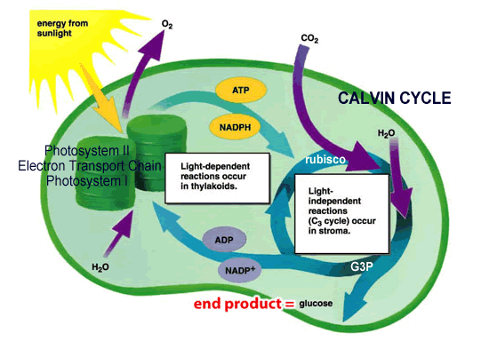

4. _____

10.

11.

5.

9.

8.



6.

12.

13.

14.

3.

7.

2.

1.

Word list:

thylakoids Calvin cycle CO2  NADP+

granum light NADPH O2

stroma H2O ATP ADP + P

light reactions sugar

Photosynthesis REVIEW ANSWERS

1. What is the overall reaction for photosynthesis?

6 CO2 + 6 H2O 🡪 C6H12O6 + 6 O2

carbon dioxide + water = glucose + oxygen gas

1. How does this compare to the overall reaction for cellular respiration?

It is the reverse of the overall reaction for cellular respiration.

1. Where does the energy for photosynthesis come from?

From sunlight

1. What plant pigments are involved in photosynthesis?

chlorophyll a, chlorophyll b, and carotenoids

1. Explain why chlorophyll appears green to us in terms of what happens to different wavelengths of light that strike a chlorophyll molecule.

We see light that bounces off of objects (reflected light). Chlorophyll is best at trapping and absorbing the red – orange wavelengths of light and the blue, indigo, and violet wavelengths of light. It is not good at absorbing the green wavelengths. The green light is reflected, so it is the part we see. Therefore, chlorophyll looks green to us.

1. How does the amount of energy in light change as the wavelength increases?

As wavelength increases, amount of energy decreases. Thus, violet light (which has a shorter wavelength) has more energy that red light (which has a longer wavelength).

1. Which colors of light are most effective for photosynthesis? Explain why.

Chlorophyll looks green to us because most of the green wavelengths are reflected rather than being absorbed. For this reason, green light is not an effective color of light to power photosynthesis. Chlorophyll a and b together absorb light most effectively in the blue to violet range and the orange to red range. Since violet wavelengths have the most energy in the visible light range (due to their shorter wavelengths) they can provide the maximum energy for photosynthesis.

1. In what organelle of a plant cell does photosynthesis take place?

In the chloroplasts

1. What are the two stages of photosynthesis?

Light Reactions and Calvin cycle

1. In which part of the chloroplast does each stage occur?

The light reactions take place in the thylakoids.

The Calvin cycle takes place in the stroma.

1. What happens to water molecules in the light reactions?

Water molecules (H2O) are split to give electrons, H+ ions, and oxygen gas (O2).

1. What photosynthesis waste product is formed in the light reactions?

Oxygen gas (O2)

1. What two products of the light reactions are used up in the Calvin cycle?

ATP and NADPH

1. What happens to carbon dioxide molecules in the Calvin cycle reactions?

In the Calvin cycle, carbon dioxide molecules (CO2) are combined with each other and with the electrons and H’s from NADPH to form glucose (C6H12O6).

1. How can cells store the sugar that is produced in photosynthesis?

Complex carbohydrate (polysaccharide) - starch

1. Label the diagram below to summarize the two stages of photosynthesis. Use the word bank below the diagram to fill in the blanks.

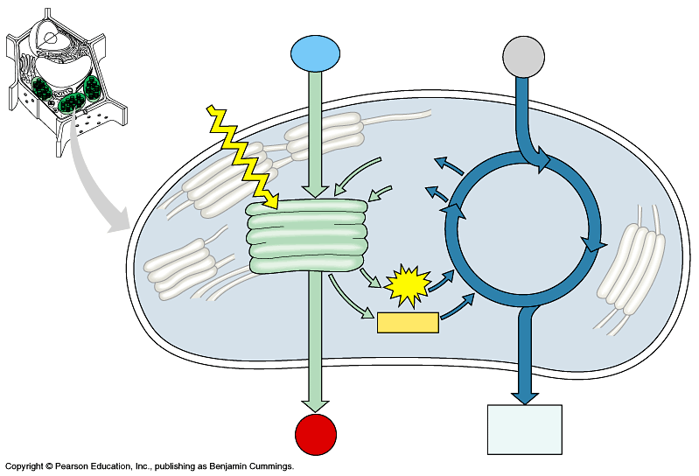

1. light

2. H2O

3. CO2

5. granum

6. light

reaction

11. Calvin

Cycle

7. NADP+

8.ADP+P_

9.ATP

10.NADPH__

13. O2

14. sugar

4. stroma

12. thylakoid

4. _____

12. _______

Word list:

thylakoids Calvin cycle CO2  NADP+

granum light NADPH O2

stroma H2O ATP ADP + P

light reactions sugar