Biology 1 Name:

***Photosynthesis Practice Test*** Date:

Hour:

1. What is the overall reaction for photosynthesis?

1. How does this compare to the overall reaction for cellular respiration?

1. Where does the energy for photosynthesis come from?

1. What plant pigments are involved in photosynthesis?

1. Explain why chlorophyll appears green to us in terms of what happens to different wavelengths of light that strike a chlorophyll molecule.
2. How does the amount of energy vary between the products and the reactants of photosynthesis?
3. Which colors of light are most effective for photosynthesis? Explain why.
4. In what organelle of a plant cell does photosynthesis take place?

1. What happens to water molecules in the light reactions?

1. What photosynthesis waste product is formed in the light reactions?

1. What happens to carbon dioxide molecules in the Calvin cycle reactions?

1. How can cells store the sugar that is produced in photosynthesis?

1. Label the diagram below to summarize the two stages of photosynthesis. Use the word bank below the diagram to fill in the blanks.

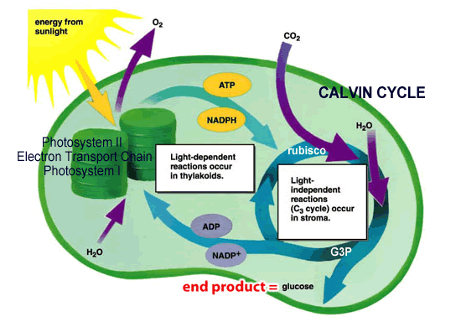

1.

5.

2.



4.

3.

Word list:

CO2

light O2

H2O sugar

1. Do plant cells do respiration, photosynthesis or both? Explain why.
2. The mass gained by a plant, as it grows, can ultimately be traced back to what molecule? What is the source of this molecule (where is it found/obtained)?

Photosynthesis REVIEW ANSWERS

1. What is the overall reaction for photosynthesis?

6 CO2 + 6 H2O 🡪 C6H12O6 + 6 O2

carbon dioxide + water = glucose + oxygen gas

1. How does this compare to the overall reaction for cellular respiration?

It is the reverse of the overall reaction for cellular respiration.

1. Where does the energy for photosynthesis come from?

From sunlight

1. What plant pigments are involved in photosynthesis?

chlorophyll a, chlorophyll b, and carotenoids

1. Explain why chlorophyll appears green to us in terms of what happens to different wavelengths of light that strike a chlorophyll molecule.

We see light that bounces off of objects (reflected light). Chlorophyll is best at trapping and absorbing the red – orange wavelengths of light and the blue, indigo, and violet wavelengths of light. It is not good at absorbing the green wavelengths. The green light is reflected, so it is the part we see. Therefore, chlorophyll looks green to us.

1. ..

The reactants have less energy than the products. The products are able to be produced, in part, because energy (from light) is absorbed by the plant.

1. Which colors of light are most effective for photosynthesis? Explain why.

Chlorophyll looks green to us because most of the green wavelengths are reflected rather than being absorbed. For this reason, green light is not an effective color of light to power photosynthesis. Chlorophyll a and b together absorb light most effectively in the blue to violet range and the orange to red range. Since violet wavelengths have the most energy in the visible light range (due to their shorter wavelengths) they can provide the maximum energy for photosynthesis.

1. In what organelle of a plant cell does photosynthesis take place?

In the chloroplasts

1. What happens to water molecules in the light reactions?

Water molecules (H2O) are split to give electrons, H+ ions, and oxygen gas (O2).

1. What photosynthesis waste product is formed in the light reactions?

Oxygen gas (O2)

1. What happens to carbon dioxide molecules in the Calvin cycle reactions?

In the Calvin cycle, carbon dioxide molecules (CO2) are combined with each other and with the electrons and H’s from NADPH to form glucose (C6H12O6).

1. How can cells store the sugar that is produced in photosynthesis?

Complex carbohydrate (polysaccharide) - starch

1. Label the diagram below to summarize the two stages of photosynthesis. Use the word bank below the diagram to fill in the blanks.

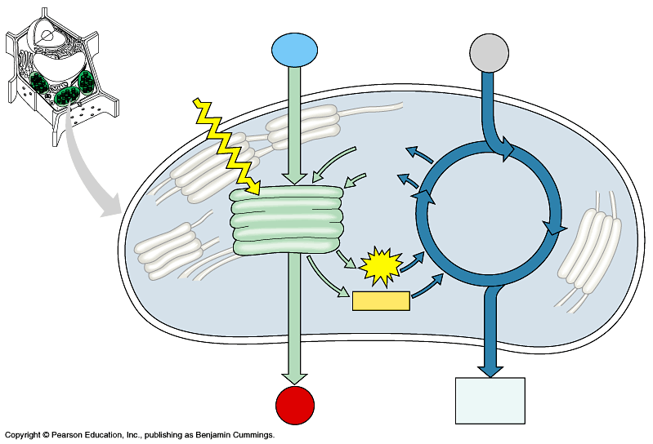

1. light

2. H2O

3. CO2

5. granum

6. light

reaction

11. Calvin

Cycle

7. NADP+

8.ADP+P_

9.ATP

10.NADPH__

13. O2

14. sugar

4. stroma

12. thylakoid

4. _____

12. _______

Word list:

thylakoids Calvin cycle CO2  NADP+

granum light NADPH O2

stroma H2O ATP ADP + P

light reactions sugar

14. Both, photosynthesis stored energy (from sun) in organic molecules, reparation releases energy stored in organic compounds when it is needed (growth, development, reproduction)

15. CO2 - air