Biology 1 Name
Photosynthesis Virtual Labs Date
Hour

Site 1: Tutorial
http://www.harcourtschool.com/activity/science_up_close/512/deploy/interface.html

Watch and listen to the tutorial found in the link above. Fill in the following answers as you watch. Stop and replay anything you don’t understand – this is a complicated topic!

1. Plants use photosynthesis to make __________________ for the plant.

2. What do plants need in order to perform photosynthesis?

3. How is the plant able to obtain each “ingredient?”

4. Identify the plant cell organelle in which photosynthesis takes place.

5. Summarize the process of photosynthesis.

Water and carbon enter the chloroplast…..

6. What happens to the oxygen that is produced as a result of photosynthesis?

7. Why is photosynthesis also important for people and animals?

Site 2: Glencoe Photosynthesis Lab
http://www.glencoe.com/sites/common_assets/science/virtual_labs/LS12/LS12.html

Experiment Question: "Which colors of the light spectrum are most important for plant growth?"

1. Make a hypothesis about which color in the visible spectrum causes the most plant growth and which causes the least plant growth.

Plants will grow best with [ red / violet / blue / green / orange ] light (circle)

Plants will not grow well with [ red / violet / blue / green / orange ] light (circle)

2. Collect data by changing the color of light. Test each type of plant and use the ruler to measure the height. Take an average for each plant at each color.

Color | Spinach |  | Radish |  | Lettuce
Red | Individual | Average | Individual | Average | Individual | Average
Orange
Green
Blue
Violet
3. Write your conclusions which include an answer to the original question / hypothesis. Your answer should be in a complete sentence.

Site 3: University of Reading – Measuring Photosynthesis in Elodea
http://www.reading.ac.uk/virtualexperiments/ves/preloader-photosynthesis-full.html

Bubbles are given off by the plant through photosynthesis. By measuring the rate at which the bubbles are produced it is possible to tell how fast the plant is photosynthesizing. Read and follow the directions on how to use this lab simulator. Press start and record the bubbles per minute for each of the following light distances. Then graph your data (be sure to label each axis)!

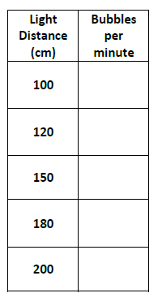

1. Based on your data, draw a conclusion regarding how light intensity affects the rate of photosynthesis.

Site 4: Photolab
http://www.kscience.co.uk/animations/photolab.htm

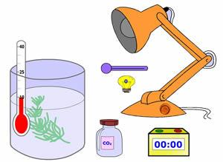
This simulation allows you to manipulate many variables. You already observed how light colors will affect the growth of a plant, in this simulation you can directly measure the rate of photosynthesis by counting the number of bubbles of oxygen that are released.

Propose hypotheses on how each of these variables effect the production of oxygen from a plant. (circle below)
a) Increasing the light intensity will [ increase / decrease ] rate of photosynthesis.

b) Increasing CO2 levels will [ increase / decrease ] rate of photosynthesis.

c. Increasing temperature will [ increase / decrease ] rate of photosynthesis.

I. Question: How Does Light Intensity Affect the Rate of Photosynthesis?
Procedure: The purple slider can be used to change the light levels. You will count the number of bubbles at each level. The timer in the square box can be used to measure 30 seconds.

Light Intensity | 0 | 5 | 10 | 15 | 20 | 25 | 30 | 35 | 40 | 45 | 50
Number of bubbles (30 sec)

A) Based on the light tests, as you increase the intensity of light, the rate of photosynthesis

[ increases / decreases / stays the same ]. (circle)

B) How do you know?

C) What are the bubbles really showing?

II. Question: How Does Carbon Dioxide Affect the Rate of Photosynthesis?

Procedure: Set the light to its highest intensity (50). Adjust the CO2 levels by clicking on the bottle.

 | Full CO₂ | Half CO₂
Number of bubbles (30 sec)

*Write a conclusion in a complete sentence that describes how the level of CO₂ affects the rate of photosynthesis. (Use Question 1A to help you write this. It will look similar. )

III. Question: How Does Temperature Affect the Rate of Photosynthesis?

Create a data table (use the ones above to help you) and input values for at least 3 Temperatures

Use your data to write a conclusion. This should be in a complete sentence.

