Biology I
Phases of Mitosis Virtual Investigation - INSTRUCTIONS

Go to the following website: http://learning.kentwoodps.org/science/holt/biology_vi/

Click “Genetics”. Then click the “Phases of Mitosis”.
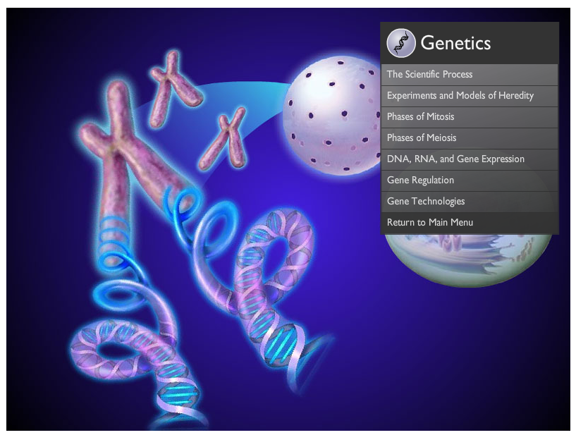
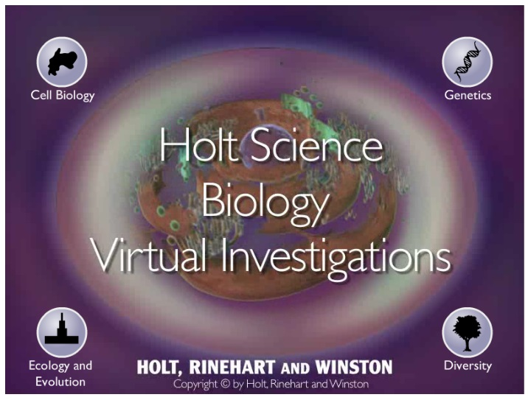

Now you are ready to work through a Virtual Investigation. Answer the following questions as you proceed.

Remember, for full credit you must use complete sentences!

Biology I Name:
Phases of Mitosis Name:
Virtual Investigation Hour:

Navigate through the virtual investigation titled “Phases of Mitosis” on the website. Answer these questions as you proceed. This should serve as a refresher on the scientific method. Remember, for full credit you must use complete sentences.

Part 1 of 5
Use the box below to take notes on what happens during Interphase.

Part 2 of 5
Draw the cell at the beginning and at the end of Prophase. Label the chromosomes.

Beginning End

Part 2 of 5
Draw the cell as it appears at the end of Metaphse. Label the chromosomes.

Part 3 of 5
Draw what the cell looks like during anaphase. Label the sister chromatids (chromosomes).

In your own words: Describe what happens during this phase.

Part 3 of 5
Draw what the cell looks like during this phase. Label the two new nuclei.

Part 4 of 5
Draw what the cell looks like when cytokinesis starts and ends. Label the two daughter cells.

Beginning End

Part 4 of 5

Fill in the table below:

 | Prophase | Metaphase | Anaphase | Telophase
Nuclear Membrane
Centrosomes

Spindle

Form of Chromosomes
Chromosome Composition

