Station 1:
Cracking the Alien Periodic Table Code
The modern Periodic Table is based on the Periodic Law. This law states that physical and chemical properties of elements are a function of their atomic numbers and repetitive behaviors. By using Periodic Law, we can find a variety of trends in both physical and chemical properties.
Within each group, all the elements in that column will be exactly the same in some way (KEY SIMILARITY) AND must also share some feature that changes regularly as you move down the group (VARYING TRAIT.) Similarly, within each period, all the elements in the row must be exactly the same in some way as you move across the period (KEY SIMILARITY) AND must also share some feature that changes regularly as you move across the row (VARYING TRAIT.)
Examine the Alien Periodic Table found at this station and determine the periodic patterns you see going both across a period and down a family.
If you notice, there are two Aliens missing.
Your job:
- Draw pictures on your answer sheet of what the two missing aliens should look like.
- Explain how you knew what the missing aliens should look like.
- What was the KEY SIMILARITY that put the aliens in a GROUP together?
- List at least two of the VARYING TRAITS you noticed as you look down a group.
- What was the KEY SIMILARITY that puts the aliens in a PERIOD together?
- List at least two of the VARYING TRAITS you noticed as you go from left to right across a period.
- How does this theoretical periodic table relate to the actual Periodic Table of Elements? List at 2 ways. Please be specific.

Station 2:
Let’s Test Your Understanding of Coulombic Attraction!
Coulomb’s Law describes the strength of attraction between protons and electrons. The distance between the proton and electrons as well as the number of protons in the nucleus can effect the attraction.
Observe the picture below:
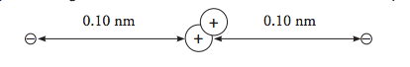
It depicts an atom with two protons and two electrons. The electrons are 0.10 nanometers away from the nucleus. The force of attraction on each electron in Newtons is 4.6 x 10⁻⁸.
Your Job:
Draw pictures of the following descriptions and answer the questions that follow.
Description 1: An atom with three protons and two electrons. The electrons are 0.10 nm away from the nucleus.
- Compared to the picture you see above, would the protons and electrons of your drawing have stronger or weaker attractive forces than 4.6 x10⁻⁸ Newtons? Explain your answer using the rules of Coulombic attraction.
- If the three protons combine for 6.9 x 10⁻⁸ Newtons, predict the amount of attraction that will be felt by each of the two electrons. Explain your answer.
Description 2: An atom with two protons and two electrons. The electrons are 0.40 nm away from the nucleus.
- Compared to the picture you see above, would the protons and electrons of your drawing have stronger or weaker attractive forces based on Coulombic attraction? Explain your answer.

Station 3:
Light my Fire! The Flame Tests
Teacher will demonstrate the flame tests. Please read the paragraph on the answer sheet before approaching this station. Record observations and complete the questions.
Station 4:
Here are spectra for some elements common in the atmospheres of stars (The black lines represent the light absorbed from the spectrum):
Use these spectra to identify the elements in the star emissions on your answer sheet and answer the questions that follow. Below you will see five different star spectra. Your job is to identify all the elements you can detect in the star's atmosphere by comparing it to the individual spectra given to you at this station.
1.
2.
3.
4.
5.
Station 5:
The Colors In Our Stars: Spectroscopy Reading Passage
What you need to know:
The energy levels of the electrons in atoms and ions are the key to the production and detection of light. Energy levels or "shells" exist for electrons in atoms and molecules. The colors of dyes and other compounds results from electron jumps between these shells or levels, just like the colors of fireworks result from jumps of electrons from one shell to another.
Atoms have two kinds of states; a ground state and an excited state. The ground state is the state in which the electrons in the atom are in their lowest energy levels possible (atoms naturally are in the ground state). Specific amounts of energy are needed to excite an electron in an atom and produce an excited state. This energy can be added to atoms many different ways. It can be in the form of light, an electric discharge or heat. This added or extra energy is emitted when the excited electrons in the atoms give off light and fall back to lower shells. The light emitted has wavelengths of colors that depend on the amount of energy originally absorbed by the electron for the transition and whether the electron drops in steps or back down all at once. Different elements emit different emission spectra when they are excited because each type of element has a unique energy shell or energy level system. Therefore every element has its own characteristic spectrum that we can use to identify them! Cool huh?

Station 6:
What you see in front of you an emission tube that will emit light only from one type of atom. Each atom will emit a different spectrum based on the structure of its atom and the quantum of light that is released when the electrons drop back to the ground state.
- Turn the emission tube on and look at the light through the spectroscope. Record the element inside (there is a label on the end of the tube) and sketch the spectrum you see produced on your answer sheet using colored pencils.

Station 6: The Hog Hilton!
Watch the video on The Hog Hilton which is on the ikechemistry.weebly.com website.

You are the manager of a prestigious new hotel in downtown Detroit—the “Hog Hilton”. It’s just the “snort of the town” and you want to keep its reputation a cut above all the other hotels. Your problem is your clientele. They are hogs in the truest sense.
Your major task is to fill rooms in your hotel. The funny shape of your hotel is to accommodate the habits of the hogs. The penthouse is on the first floor and the less desirable rooms are on the top floor. You must fill up your hotel keeping the following rules in mind:
1) Hogs are lazy! They prefer to stay on the lowest floor possible!
2) Hogs can’t stand each other except when rule #1 forces them to
put up with each other.
3) They stink, so you can’t put more than two hogs in each room.
4) If hogs have their own room, they face up. If hogs are in the same
room they will face in opposite directions, one pointing up and one pointing down.

Please watch the video and move the hogs accordingly. Below is a tool for you to use to practice filling. The example with 15 hogs is just for you to practice. PLEASE DO NOT WRITE ON THIS STATION ONLY YOUR ANSWER DOCUMENT.
Your hotel looks like the diagram below and each line represents a room on the floor:

6th floor ____ ____ ____ ____ ____
5th floor ____ ____ ____
4th floor ____
3rd floor ____ ____ ____
2nd floor ____
1st floor ____

Your hotel can hold 28 hogs.
Sample problem:
a. Book 15 hogs into their rooms
6th floor ____ ____ ____ ____ ____
5th floor ____ ____ ____
4th floor ____
3rd floor ____ ____ ____
2nd floor ____
1st floor ___

On your own, set up your hogs like the video showed you on your desk to fill your hotel for the following days of the week. Once you’ve set up your hogs, transfer them to this worksheet but represent the hogs with up and down arrows.

Station 7: The Science Behind Fireworks
Read the fireworks article at your bench.

Station 8: Wint-O-Green Mints
Follow your teacher’s directions. Do not get the
Wint-o-green mints wet!

Station 9: Electron Energy and Light
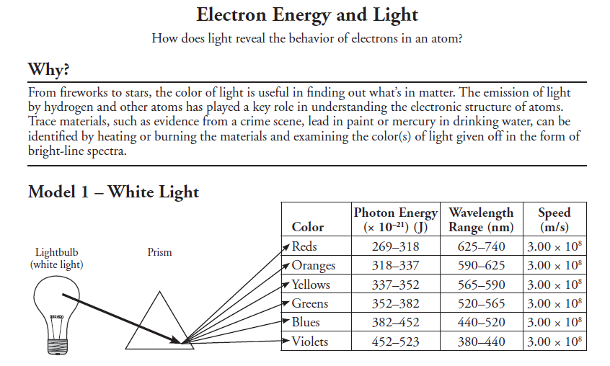

Station 10: Emission Spectra

