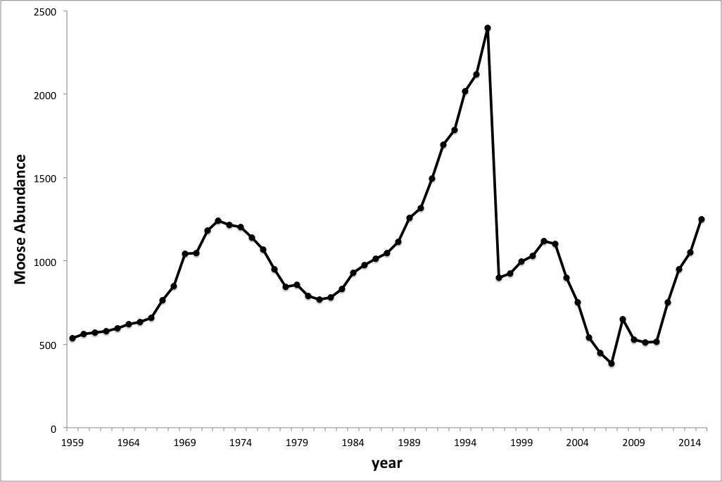

*www.modelbasedbiology.com*

**Isle Royale moose population through 2015**