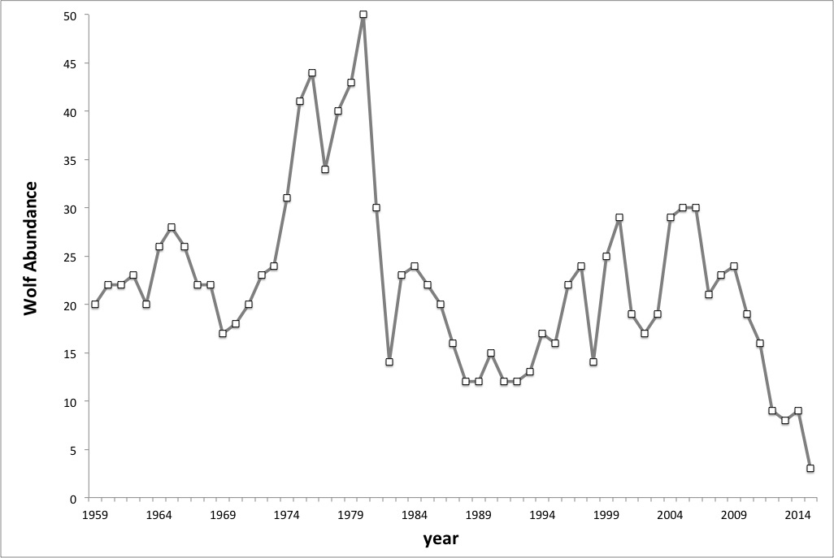

**Wolf population on Isle Royale through 2015**

*www.modelbasedbiology.com*