Biology 1 Name:
Tonicity and Osmosis Worksheet Date:
Hour:

Part I. Fill in the blanks:

A _____________ is a fluid in which a substance is dissolved.

A _____________ is a substance dissolved in a solvent.

A _____________ is a combination of solute and solvent.

The process by which H20 diffuses across a membrane is called ____________ .

Part II. Look at the solutions illustrated below and fill in the blanks.
- Solution B is __________________ to solution A. This is because solution B has a greater concentration of ___________ in it than does solution A. Solution C has no solutes dissolved in it, therefore it is __________________ to both Solutions A and B.
- As the relative concentration of solutes in two solutions increases, of necessity the relative concentration of water in the same two solutions _______________. Solution A has a lower concentration of ________ than does Solution C; Solution A is also hypertonic to Solution C.
- If you wanted to make Solution A isotonic to Solution B, you could add water to Solution ____ or you could add solute to Solution ____ . If you took all three solutions, put them into a large container and mixed them thoroughly, then redistributed the solution among the three containers, Solution A would be _______________ to Solution B. Solution A would also be _______________ to Solution C, and Solution C would be _________________ to Solution B.

A B C
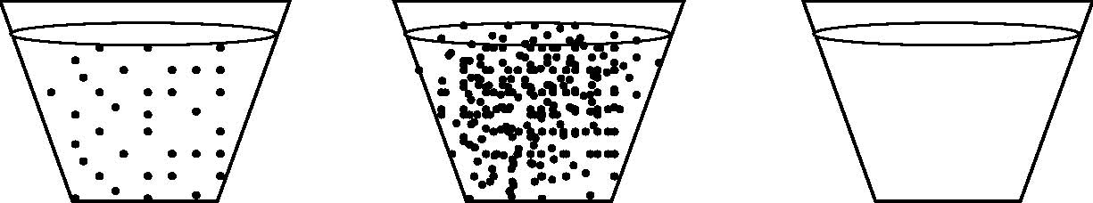
Part III. Below are represented a plant cell and an animal cell. Refer to the key at the top left of page one and fill in the blanks below. (If you find yourself counting solute dots, you’re working much too hard!) Assume that the cell membranes allow only water (not the solutes) to pass through.

animal cell plant cell

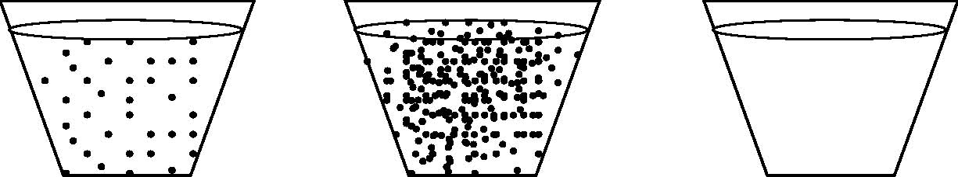
A B C

- Because the cytoplasms of the plant and the animal cell have equal concentrations of solutes, we can say that their cytoplasms are _______________ to each other. If we put both the plant and the animal cells into Solution A, we would expect no change in the cells, because Solution A is _______________ to the cytoplasm of each cell.
- Let’s put both cells into Solution B. Because Solution B is hypertonic to the cytoplasms of the cells, we would expect water to ___________ the cells through the process of ____________ . This would result in the cytoplasm of both cells shrinking.
- Now we’ll put both the plant and the animal cell into Solution C, which, because it contains no solutes at all, is __________________ to the cytoplasm of both cells. ____________ will enter both cells through osmosis. The animal cell is likely to ______________, unfortunately. The plant cell, however, is protected from this because of the presence of its ________ ___________, which is lacking in the animal cell.

WORD BANK FOR THIS ASSIGNMENT:
A
B
C
Osmosis Increases
Diffusion Decreases
Solvent Water
Solute
Solution
More
Less
Higher
Lower
Cell Wall
Cell Membrane
Hypertonic
Hypotonic
Isotonic
Move in/Enter
Move out/Leave
Swell (Turgor or Cytolysis)
Shrivel (Plasmolysis)

