Biology 1 Name:
Organic Molecules in Food Date:
Review at least 5“Nutritional Facts” labels from foods that you regularly eat. Record the information for each food in the chart below. Hour:
Food Product | Total Calories (per serving) | Total Fat (grams per serving) | Calories from Fat | Saturated Fat (grams per serving) | Calories from Saturated Fat | Unsaturated Fat (grams per serving) | Calories from Unsaturated Fat | Total Carbohydrates (grams per serving) | Calories from Carbohydrates | Sugars  (grams per serving) | Calories from Simple Carbs. | Complex Carbohydrates  (grams per serving) | Calories from Complex Carbs. | Protein  (grams per serving) | Calories from Protein
TOTAL
**Calorie totals may not add up exactly. This is because 4 calories/gram and 9 calories/gram are estimates based on average calorie content per gram of the given organic macromolecule.**

Helpful Tips:

Total Fat (11g) - Saturated Fat & Trans Fat (3g) = (8g) Unsaturated Fat

Total Carbohydrate (14g) – Sugars (1g) = (13g) Complex Carbohydrates (polysaccharides such as starch)

Sugars (1g) = (1g) Simple Carbohydrates (monosaccharides & disaccharides such as glucose & sucrose)

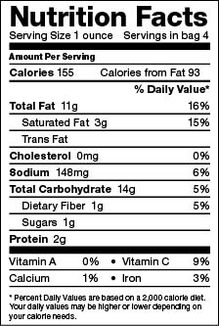

Fat: 1 gram = 9 calories

Protein: 1 gram = 4 calories

Carbohydrates: 1 gram = 4 calories

Calorie Requirements
Gender | Age (Years) | Sedentary | Moderately Active | Active
Child | 2-3 | 1,000 | 1,000-1,400 | 1,000-1,400
Female | 4-8  9-13  14-18  19-30  31-50  51+ | 1,200  1,600  1,800  2,000  1,800  1,600 | 1,400-1,600  1,600-2,000  2,000  2,000-2,200  2,000  1,800 | 1,400-1,800  1,800-2,200  2,400  2,400  2,200  2,000-2,200
Male | 4-8  9-13  14-18  19-30  31-50  51+ | 1,400  1,800  2,200  2,400  2,200  2,000 | 1,400-1,600  1,800-2,200  2,400-2,800  2,600-2,800  2,400-2,600  2,200-2,400 | 1,600-2,000  2,000-2,600  2,800-3,200  3,000  2,800-3,000  2,400-2,800

These levels are calculated by gender, age, and activity level for reference-sized individuals.
- Sedentary means a lifestyle that includes only the light physical activity associated with typical day-to-day life.
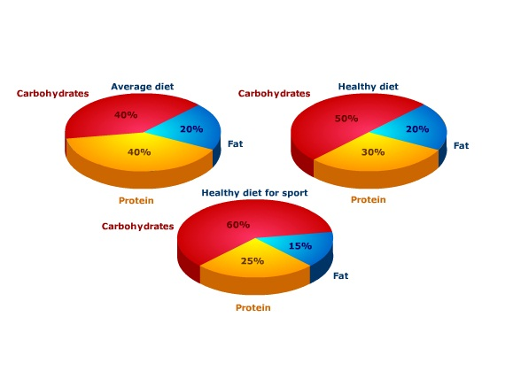
- Moderately active means a lifestyle that includes physical activity equivalent to walking about 1.5 to 3 miles per day at 3 to 4 miles per hour, in addition to the light physical activity associated with typical day-to-day life
- Active means a lifestyle that includes physical activity equivalent to walking more than 3 miles per day at 3 to 4 miles per hour, in addition to the light physical activity associated with typical day-to-day life.

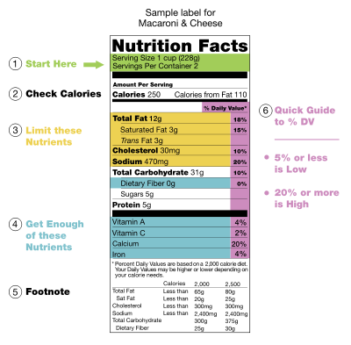
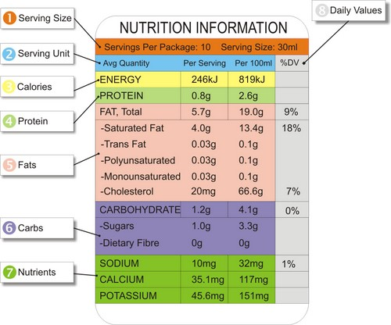

Biology 1 Name:
Organic Molecules in Food Date:
Answer these questions in complete sentences. Hour:
Conclusions:

- Was the food that you analyzed something that you would eat on a regular basis? Explain.

- Would you consider the food that you analyzed healthy or junk-food? Explain.

- Considering all the food that you analyzed: Rank the types of organic molecules that we studied in terms of how large of a component they are in the food that we eat. Consider the total calories of each type of molecule you counted.

- Pick an item that you analyzed that you feel has low nutritional value. Where do most of the calories come from? (type of organic molecule)

- Pick an item that you analyzed that you feel has high nutritional value. Where do most of the calories come from? (type of organic molecule)

- On the back: Construct a pie chart using the data you’ve collected from above. You’ll have to calculate total calories by adding calories from carbs, fats & protein.

Total Carb Grams: _____
Total Protein Grams: _____
Total Fat Grams: _____
Total Grams of Above: _____

Carb.

Protein

Fat

Do you feel that you eat a healthy diet (or is the one you described in this activity healthy)? Describe the main types of food you eat. If you eat healthy, describe the types of food you eat that you feel are good for you. If you don’t eat healthy, describe the types of food you feel that you should eat more of.

