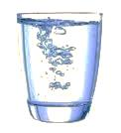
Chemistry 1 Name
Mole Challenge Date
Hour

- Answer the following questions:
  - How many moles of water are in one mouthful?
data collected
  - How many molecules of water are in one mouthful?
- You will have access to the following materials:
  - Balance
  - Paper cup
  - Water
- Record your data and show your calculations below.
calculations

moles of water in a mouthful
molecules of water in a mouthful

