Biology 1 Name:
Microscope Parts, Rules & Use Date:
Hour:
PARTS

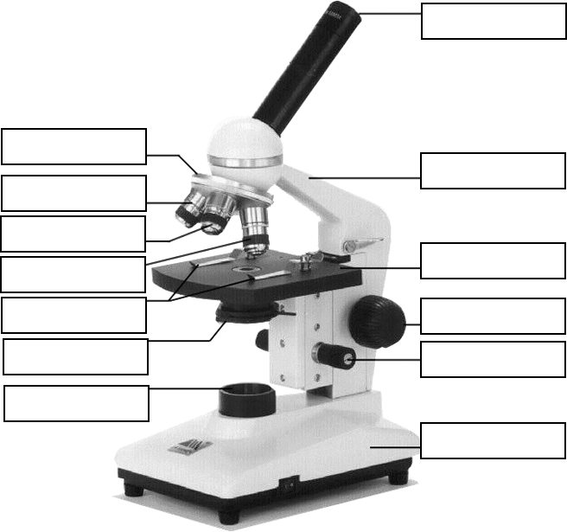

Biology 1 Name:
Microscope Parts, Rules & Use Date:
Hour:
RULES

- Use TWO hands to carry the microscope – one under the base, one under the arm.
- Be sure power cords do not hang in the way where someone could trip over them.
- ALWAYS focus at low power FIRST. Work up to the highest practical magnification.
- Use ONLY lens paper to clean the lenses.
- Always use a cover slip at high power.
- All microscope drawings should:
  - Be large
  - Be in pencil
  - List magnification used
  - List stain used (if applicable)
  - Label main parts observed and their size (if asked to do so)
- When you are finished, wrap the cord around the base and replace the dust cover.

USE

- Under LOW POWER – Focus the specimen. Use COURSE adjustment first, then fine adjustment
- Center the area of interest.
- Switch to MEDIUM POWER – Refocus. You may need to use the course adjustment but will, most likely, only need to use the fine adjustment.
- The area of interest should still be centered. (Double Check)
- Switch to HIGH POWER – Refocus. You should only need to use the fine adjustment at this point.
  - Be sure that you are moving the stage/objectives away from each other. You can easily break a slide if the stage is moving towards the objective while you are looking into the eyepiece.

