Mendel's Genetics
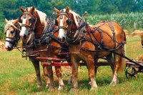
Hybridized domesticated horses
For thousands of years farmers and herders have been selectively breeding their plants and animals to produce more useful hybrids. It was somewhat of a hit or miss process since the actual mechanisms governing inheritance were unknown. Knowledge of these genetic mechanisms finally came as a result of careful laboratory breeding experiments carried out over the last century and a half.
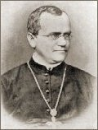
Gregor Mendel
1822-1884
By the 1890's, the invention of better microscopes allowed biologists to discover the basic facts of cell division and sexual reproduction. The focus of genetics research then shifted to understanding what really happens in the transmission of hereditary traits from parents to children. A number of hypotheses were suggested to explain heredity, but Gregor Mendel , a little known Central European monk, was the only one who got it more or less right. His ideas had been published in 1866 but largely went unrecognized until 1900, which was long after his death. His early adult life was spent in relative obscurity doing basic genetics research and teaching high school mathematics, physics, and Greek in Brno (now in the Czech Republic). In his later years, he became the abbot of his monastery and put aside his scientific work.
Common edible peas
While Mendel's research was with plants, the basic underlying principles of heredity that he discovered also apply to people and other animals because the mechanisms of heredity are essentially the same for all complex life forms.
Through the selective cross-breeding of common pea plants (Pisum sativum) over many generations, Mendel discovered that certain traits show up in offspring without any blending of parent characteristics. For instance, the pea flowers are either purple or white--intermediate colors do not appear in the offspring of cross-pollinated pea plants. Mendel observed seven traits that are easily recognized and apparently only occur in one of two forms:
1. | flower color is purple or white | 5. | seed color is yellow or green
2. | flower position is axil or terminal | 6. | pod shape is inflated or constricted
3. | stem length is long or short | 7. | pod color is yellow or green
4. | seed shape is round or wrinkled
This observation that these traits do not show up in offspring plants with intermediate forms was critically important because the leading theory in biology at the time was that inherited traits blend from generation to generation. Most of the leading scientists in the 19th century accepted this "blending theory." Charles Darwin proposed another equally wrong theory known as "pangenesis" . This held that hereditary "particles" in our bodies are affected by the things we do during our lifetime. These modified particles were thought to migrate via blood to the reproductive cells and subsequently could be inherited by the next generation. This was essentially a variation of Lamarck's incorrect idea of the "inheritance of acquired characteristics."
Mendel picked common garden pea plants for the focus of his research because they can be grown easily in large numbers and their reproduction can be manipulated. Pea plants have both male and female reproductive organs. As a result, they can either self-pollinate themselves or cross-pollinate with another plant. In his experiments, Mendel was able to selectively cross-pollinate purebred plants with particular traits and observe the outcome over many generations. This was the basis for his conclusions about the nature of genetic inheritance.
Reproductive  structures of  flowers | 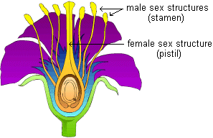

In cross-pollinating plants that either produce yellow or green pea seeds exclusively, Mendel found that the first offspring generation (f1) always has yellow seeds. However, the following generation (f2) consistently has a 3:1 ratio of yellow to green.
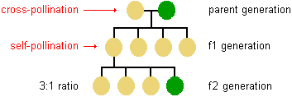
This 3:1 ratio occurs in later generations as well. Mendel realized that this underlying regularity was the key to understanding the basic mechanisms of inheritance.
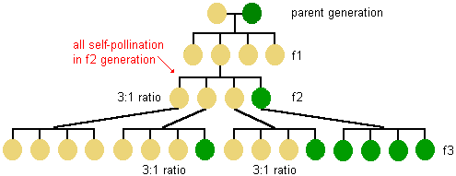
He came to three important conclusions from these experimental results:
1. | that the inheritance of each trait is determined by "units" or "factors" that are passed on to descendents unchanged (these units are now called genes )
2. | that an individual inherits one such unit from each parent for each trait
3. | that a trait may not show up in an individual but can still be passed on to the next generation.
It is important to realize that, in this experiment, the starting parent plants were homozygous for pea seed color. That is to say, they each had two identical forms (or alleles ) of the gene for this trait--2 yellows or 2 greens. The plants in the f1 generation were all heterozygous . In other words, they each had inherited two different alleles--one from each parent plant. It becomes clearer when we look at the actual genetic makeup, or genotype , of the pea plants instead of only the phenotype , or observable physical characteristics.
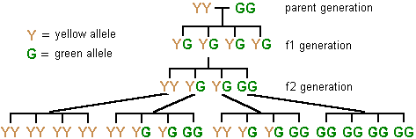
Note that each of the f1 generation plants (shown above) inherited a Y allele from one parent and a G allele from the other. When the f1 plants breed, each has an equal chance of passing on either Y or G alleles to each offspring.
With all of the seven pea plant traits that Mendel examined, one form appeared dominant over the other, which is to say it masked the presence of the other allele. For example, when the genotype for pea seed color is YG (heterozygous), the phenotype is yellow. However, the dominant yellow allele does not alter therecessive green one in any way. Both alleles can be passed on to the next generation unchanged.
Mendel's observations from these experiments can be summarized in two principles:
1. | the principle of segregation
2. | the principle of independent assortment
According to the principle of segregation, for any particular trait, the pair of alleles of each parent separate and only one allele passes from each parent on to an offspring. Which allele in a parent's pair of alleles is inherited is a matter of chance. We now know that this segregation of alleles occurs during the process of sex cell formation (i.e., meiosis ).
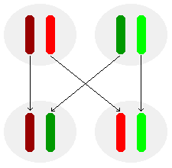
Segregation of alleles in the production of sex cells
According to the principle of independent assortment, different pairs of alleles are passed to offspring independently of each other. The result is that new combinations of genes present in neither parent are possible. For example, a pea plant's inheritance of the ability to produce purple flowers instead of white ones does not make it more likely that it will also inherit the ability to produce yellow pea seeds in contrast to green ones. Likewise, the principle of independent assortment explains why the human inheritance of a particular eye color does not increase or decrease the likelihood of having 6 fingers on each hand. Today, we know this is due to the fact that the genes for independently assorted traits are located on different chromosomes

