Biology 1 Name:
Cell Reproduction – Chapter 8 Date:
Additional Meiosis Lecture Notes Hour:

Meiosis 1
Chromosome  # | What happens?
Meiosis 2
Chromosome  # |  | What happens?

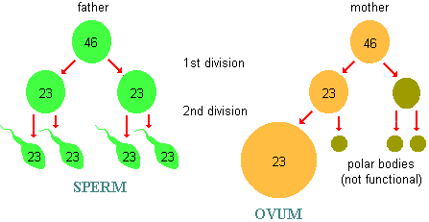
Spermatogenesis vs. Oogenesis

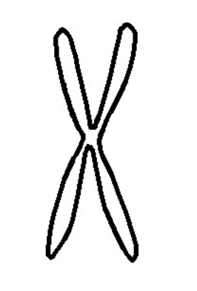
Crossing Over

