PHOTOSYNTHESIS INVESTIGATION – CLASS COPY

The biology behind the procedure
Leaf disks float, normally. When the air spaces are infiltrated (filled with) with solution the overall density of the leaf disk increases and the disk sinks. The infiltration solution includes a small amount of Sodium bicarbonate. Bicarbonate ion serves as the carbon source for photosynthesis. As photosynthesis proceeds oxygen is released into the interior of the leaf which changes the buoyancy--causing the disks to rise. Since cellular respiration is taking place at the same time, consuming oxygen, the rate that the disks rise is an indirect measurement of the net rate of photosynthesis.

Instructions
Read the entire lab (materials, procedure, data and conclusion) and then formulate a hypothesis. Record this on a separate sheet of lined paper. Then begin the procedure.

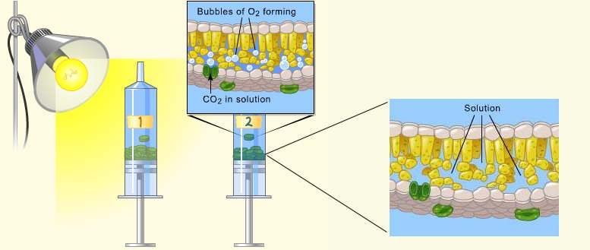

Materials
- Sodium bicarbonate (Baking soda)
- Liquid Soap
- Plastic syringe (10 cc or larger)—remove any needle!
- Leaf material
- Hole punch
- Plastic cups/Beakers
- Timer
- Light source

Procedure
- Prepare 300 ml of bicarbonate solution for each trial. The bicarbonate serves as an alternate dissolved source of carbon dioxide for photosynthesis. Prepare a 0.2% solution. (This is not very much it is only about 1/8 of a teaspoon of baking soda in 300 ml of water.)
  - Add 1 drop of dilute liquid soap to this solution. The soap wets the hydrophobic surface of the leaf allowing the solution to be drawn into the leaf. It’s difficult to quantify this since liquid soaps vary in concentration. Avoid suds. If your solution generates suds then dilute it with more bicarbonate solution.
- Cut 10 uniform leaf disks for each trial.
  - Single hole punches work well for this but stout plastic straws will work as well.
  - Choice of the leaf material is perhaps the most critical aspect of this procedure. The leaf surface should be smooth and not too thick. Avoid plants with hairy leaves. Ivy, fresh spinach, Wisconsin Fast Plant cotyledons--all work well. Ivy seems to provide very consistent results. Avoid major veins.
- Infiltrate the leaf disks with sodium bicarbonate solution.
  - Remove the piston or plunger and place the leaf disks into the syringe barrel. Replace the plunger being careful not to crush the leaf disks. Push on the plunger until only a small volume of air and leaf disk remain in the barrel (<10%).
  - Pull a small volume of sodium bicarbonate solution into the syringe. Tap the syringe to suspend the leaf disks in the solution.
  - Holding a finger over the syringe-opening, draw back on the plunger to create a vacuum. Hold this vacuum for about 10 seconds. While holding the vacuum, swirl the leaf disks to suspend them in the solution. Let off the vacuum. The bicarbonate solution will infiltrate the air spaces in the leaf causing the disks to sink. You will probably have to repeat this procedure 2-3 times in order to get the disks to sink. If you have difficulty getting your disks to sink after about 3 evacuations, it is usually because there is not enough soap in the solution. Add a few more drops of soap.
- Pour the disks and solution into a clear plastic cup/beaker. Add a small amount (less than ½ teaspoon bicarbonate to the beaker. Use the same amount of solution for each trial. Shallower depths work just as well. For a control, infiltrate leaf disks with a solution of only water with a drop of soap--no bicarbonate but keep everything else the same.
- Place under the light source and start the timer. At the end of each minute, record the number of floating disks. Then swirl the disks to dislodge any that are stuck against the sides of the cups. Continue until all of the disks are floating.
Data Collection and Analysis
  - Create a table to record the number of floating disks each minute for 15 minutes for both the sodium bicarbonate solution and the control solution. You may stop data collection early if all 10 disks are floating before the 15 minute observation window.
- Create a multiple –line graph representing data from both treatments.

Conclusion
  - Describe what you thought would happen.
  - Describe what happened.
  - Why did this happen?
  - What factors affect the rate of photosynthesis?
  - What factors were in effect here?
  - Describe ways that you could use a similar procedure to test another aspect/variable related to plants and photosynthesis or possible changes to this procedure to make it more effective (error analysis).

LEAF DISK PHOTOSYNTHESIS –

INVESTIGATION

The biology behind the procedure
Leaf disks float, normally. When the air spaces are infiltrated (filled with) with solution the overall density of the leaf disk increases and the disk sinks. The infiltration solution includes a small amount of Sodium bicarbonate. Bicarbonate serves as the carbon source for photosynthesis. As photosynthesis proceeds, oxygen is released into the interior of the leaf which changes the buoyancy--causing the disks to rise. Therefore, the rate that the disks rise at is an indirect measurement of the net rate of photosynthesis.

Instructions
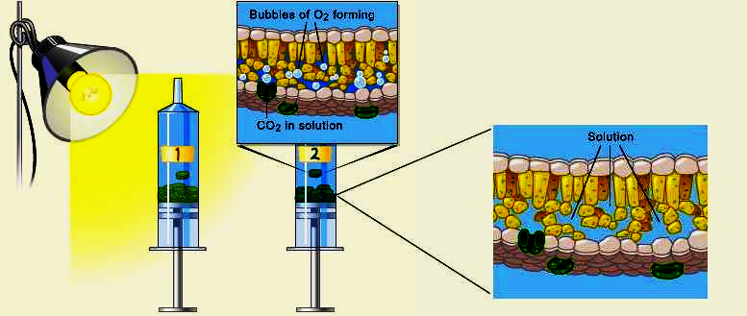
Read the entire lab (materials, procedure, data and conclusion) and then formulate a hypothesis. Record this on a separate sheet of lined paper. Then begin the procedure.

Materials
- Sodium bicarbonate (Baking soda)
- Liquid Soap
- Plastic syringe (10 cc or larger)—remove any needle!
- Leaf material
- Hole punch
- Plastic cups/Beakers
- Timer
- Light source

Procedure
Step 1 Prepare 300 mL of 0.2% bicarbonate solution for each experiment. The bicarbonate will serve as a source of carbon dioxide for the leaf disks while they are in the solution.

Step 2 Pour the bicarbonate solution into a clear plastic cup to a depth of about 3 cm. Label this cup “With CO2.” Fill a second cup with only water to be used as a control group. Label this cup “Without CO2.” Throughout the rest of the procedure you will be preparing material for both cups, so do everything for both cups simultaneously.

Step 3 Using a pipette, add one drop of a dilute liquid soap solution to the solution in each cup. It is critical to avoid suds. If either solution generates suds, then dilute it with more bicarbonate or water solution. The soap acts as a surfactant or “wetting agent” — it wets the hydrophobic surface of the leaf, allowing the solution to be drawn into the leaf and enabling the leaf disks to sink in the fluid.

Step 4 Using a hole punch, cut 10 or more uniform leaf disks for each cup. Avoid major leaf veins. (The choice of plant material is perhaps the most critical aspect of this procedure. The leaf surface should be smooth and not too thick.)

Step 5 Draw the gases out of the spongy mesophyll tissue and infiltrate the leaves with the sodium bicarbonate solution by performing the following steps:
a. Remove the piston or plunger from both syringes. Place the 10 leaf disks into each syringe barrel.
b. Replace the plunger, but be careful not to crush the leaf disks. Push in the plunger until only a small volume of air and leaf disk remain in the barrel (<10%).
c. Pull a small volume (5 cc) of sodium bicarbonate plus soap solution from your prepared cup into one syringe and a small volume of water plus soap into the other syringe. Tap each syringe to suspend the leaf disks in the solution. Make
sure that, with the plunger inverted, the disks are suspended in the solution. Make sure no air remains. Move the plunger to get rid of air from the plunger before you attempt Step d.
d. You now want to create a vacuum in the plunger to draw the air out of the leaf tissue. This is the most difficult step to master. Once you learn to do this, you will be able to complete the entire exercise successfully. Create the vacuum by holding a finger over the narrow syringe opening while drawing back the plunger (see
Figure 6a). Hold this vacuum for about 10 seconds. While holding the vacuum, swirl the leaf disks to suspend them in the solution. Now release the vacuum by letting the plunger spring back. The solution will infiltrate the air spaces in
the leaf disk, causing the leaf disks to sink in the syringe. If the plunger does not spring back, you did not have a good vacuum, and you may need a different syringe. You may have to repeat this procedure two to three times in order to
get the disks to sink. (If you have any difficulty getting your disks to sink after three tries, it is usually because there is not enough soap in the solution. try adding a few more drops of soap to the cup and replacing the liquid in the syringe.) Placing the disks under vacuum more than three times can damage the disks.

Step 6 Pour the disks and the solution from the syringe into the appropriate clear plastic cup. Disks infiltrated with the bicarbonate solution go in the “With CO2” cup, and disks infiltrated with the water go in the “Without CO2” cup.

Step 7 Place both cups under the light source and start the timer. At the end of each minute, record the number of floating disks. Then swirl the disks to dislodge any that stuck against the side of the cups. Continue until all of the disks are floating in the cup with the bicarbonate solution.

Step 8 Record the number of disks floating each minute for 15 minutes. An observation period of less than 15 minutes is acceptable if all 10 disks are floating for at least 2 consecutive readings. If this is the case, it can be assumed that all ten disks will remain floating for the remainder of the observation window.

Biology 1 Name:
Leaf Disk Photosynthesis - Date:
Investigation Hour:
Data/Calculations

Data: Analysis:
Create a multiple –line graph representing data from both treatments.
Time (minutes)
1
2
3
4
5
6
7
8
9
10
11
12
13
14
15

Conclusions:

  - Describe what you thought would happen.

  - Describe what happened.

  - Why did this happen?

  - What portion of your experiment serves as a control or control group?

  - What factors affect the rate of photosynthesis?

  - What factors were in effect here?

  - Describe ways that you could use a similar procedure to test another variable related to plants and photosynthesis.

  - Analyze the sources of error in this investigation. Describe any changes to this procedure (or what you did) that could make this investigation, and that data gathered from it, more effective and reliable.

