Thinking About Inquiry & Models

Name: ______________________ Date: _________________

The following table lists parts of the process you went through to investigate the cube and box.
Think back to your work with the Mystery Cube and the Biological Box. On the right side of the
table under the heading “Activity,” provide an example of what you did in that
activity that models the process of learning about the natural world.

Process Biological Box Activity
Process | Activity
Ask a testable question

Gather evidence by
making observations,
recognizing patterns, and
collecting data

Share information

Perform experiments

Provide an evidence-based
Explanation

EASY 1
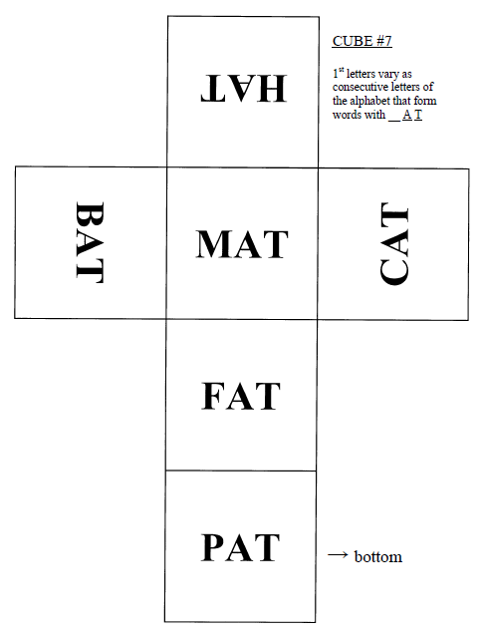

MEDIUM 1

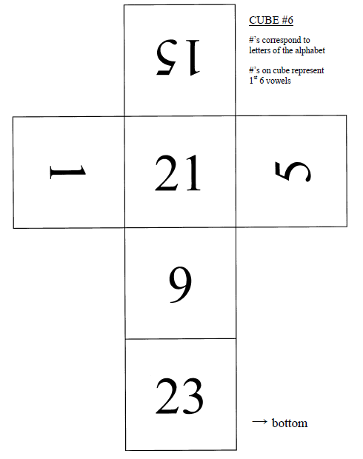

HARD 1

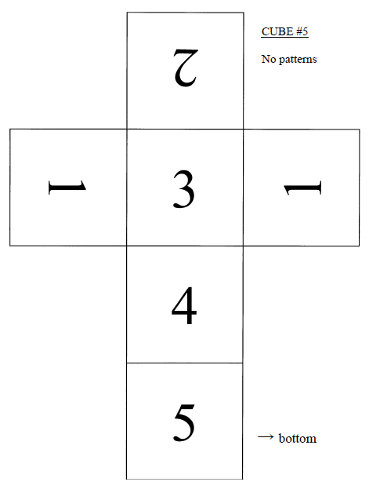

EASY 2

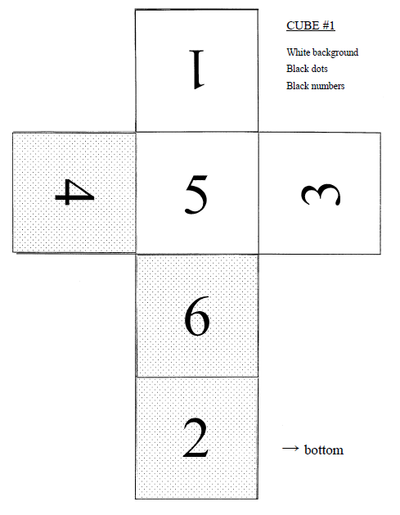

MAKE YOUR OWN
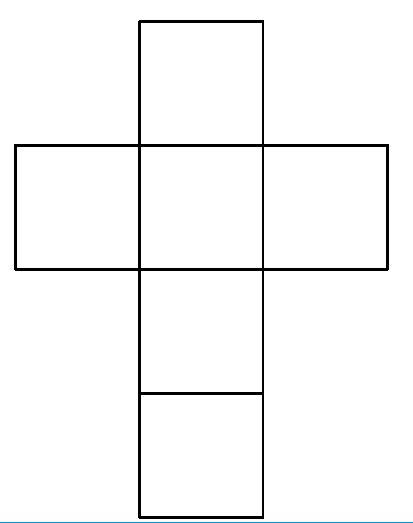

MEDIUM 2

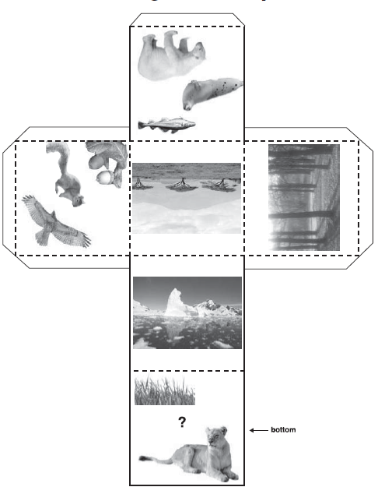

EASY 3

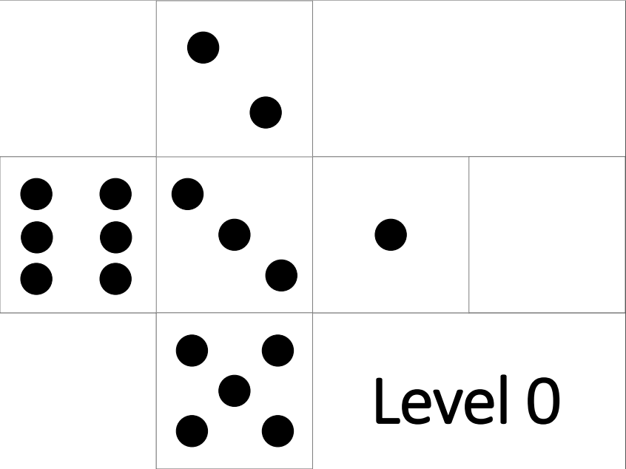

MEDIUM 3
