Writing Chemical Ionic Formulas HAVE OUT A PERIODIC TABLE AND POLYATOMIC LIST

- Ionic Compounds have a transfer of electrons from one atom onto another
- METALS lose electrons forming positive ions = CATIONS
- NONMETALS gain electrons forming negative ions = ANIONS
- AN IONIC COMPOUND is made up of a METAL and a NONMETAL or a CATION and an ANION
- THE IONIC COMPOUND HAS A NET CHARGE OF ZERO. ALL CHARGES ADD UP TO ZERO

TO WRITE AN IONIC CHEMICAL FORMULA FOLLOW THESE STEPS:

- Look at the name of the metal and write down its symbol.
- Get the charge of the metal and place it as a superscript to the right of the symbol.
  - If no roman numeral is given then we determine the charge of the metal from common ion charges.
Metals with Constant Charge:
Group 1 = +1
Group 2 = +2
Al = +3
Zn = +2
Ag = +1

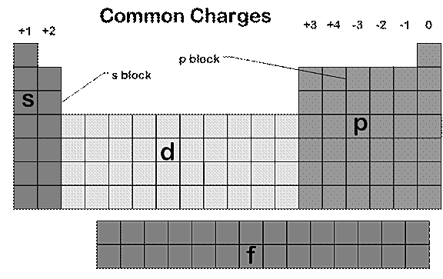
  - If a roman numeral is given then we KNOW the charge from the Roman numeral. ONLY TRANSITION METALS WILL HAVE ROMAN NUMERALS!
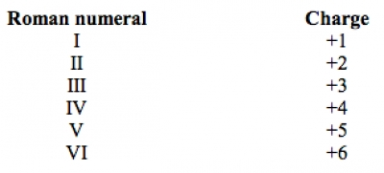
  - If it starts with ammonium, then write NH₄⁺¹
- Look at the name of the anion. Write down its symbol and charge as a superscript to the right
  - If it ends in –ide the symbol should be a nonmetal element and its charge will be based on the common ion charges above.
  - If it ends in -ate or –ite the symbol should be a polyatomic ion and it charge will be based on the SET charge of the polyatomic ion.
Acetate, CH₃COO⁻¹ OR C₂H₃O₂⁻¹  Ammonium, NH₄⁺¹  Carbonate, CO₃⁻²  Perchlorate, ClO₄⁻¹  Chlorate, ClO₃⁻¹  Chlorite, ClO₂⁻¹  Hypochlorite, ClO⁻¹ | Hydroxide, OH⁻¹  Nitrate, NO₃⁻¹  Nitrite, NO₂⁻¹  Peroxide, O₂⁻²  Phosphate, PO₄⁻³  Phosphite, PO₃⁻³  Sulfate, SO₄⁻²  Sulfite, SO₃⁻²
Polyatomic Ion List

- Swap Drop and Reduce the charges to get the CHARGE TO BALANCE TO ZERO.

Example: Barium Chloride Example: Lead (IV) Oxide

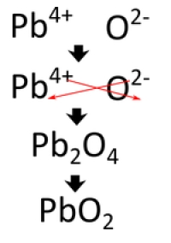
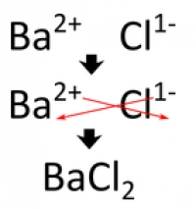

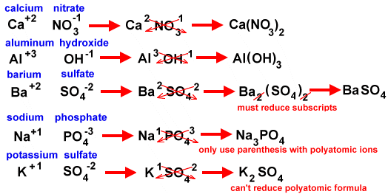
ONLY USE PARATHESIS WHEN YOU NEED MORE THAN ONE OF THE POLYATOMIC ION.

You Try Now:

- Beryllium sulfide __________________ 6. Silver carbonate __________________

- Potassium oxide __________________ 7. Iron (III) sulfate __________________

- Calcium hydroxide __________________ 8. Ammonium nitrite __________________

- Copper (I) phosphate __________________ 9. Barium acetate ___________________

- Aluminum chlorate __________________ 10. Zinc nitride ___________________

A SUMMARY OF FORMULA WRITING:

- Get the symbol for the Cation
- Get the charge Cation
- Get the symbol for the Anion
- Get the charge for the Anion
- Swap Drop and Reduce

HOW TO NAME– PLEASE HAVE OUT A PERIODIC TABLE AND POLYATOMIC ION LIST!!!!

PART ONE: NAMING BINARY IONICS WITH CONSTANT CHARGE

- These are the easiest Ionic Compounds
- They will be BINARY (2 elements – 2 capital letters)
- The METAL WILL HAVE A CONSTANT CHARGE.
- The METAL IS ALWAYS NAMED FIRST AND LISTED FIRST IN THE COMPOUND.

Metals that don’t change charge are:

Group 1 Group 2 3 Special Guests.
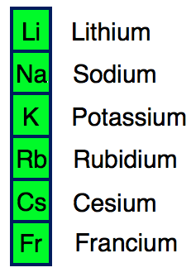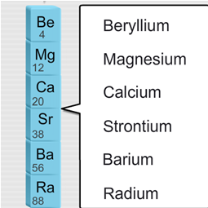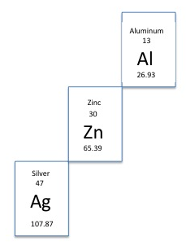

These will all start with a METAL that is listed above and end with a NONMETAL

Get To Know These Regions of Table:

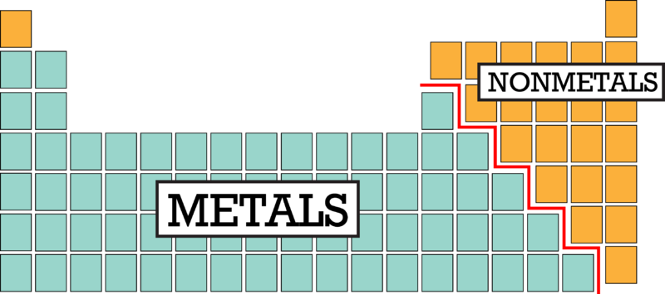

RULES:

- LOOK AT THE FIRST ELEMENT. IS IT LISTED ABOVE? IF YES
  - NAME THAT METAL
- LOOK AT THE SECOND ELEMENT. IT WILL BE A NONMETAL
  - NAME THAT NONMETAL AND CHANGE ITS ENDING TO –ide

Example: NaCl Sodium Chloride
For this example: Na is one of the metals listed above. Cl is the nonmetal chlorine and will change its ending to ide.

Now You Try! Name these SIMPLE IONIC COMPOUNDS

a. KBr __________________________________ e. AgI ______________________________________
b. RbCl __________________________________ f. Mg₃P₂ ______________________________________
c. SrS __________________________________ g. RaO ______________________________________
d. Li₃N __________________________________ h. ZnCl₂ ______________________________________

PART TWO: NAMING IONIC COMPOUNDS THAT CONTAIN A POLYATOMIC ION
- We will start easy again and just use metals with constant charge
- These will have MORE than 2 capital letters!

Here is the list of Polyatomic Ions you need to be familiar with:
Acetate, CH₃COO⁻¹ OR C₂H₃O₂⁻¹  Ammonium, NH₄⁺¹  Carbonate, CO₃⁻²  Perchlorate, ClO₄⁻¹  Chlorate, ClO₃⁻¹  Chlorite, ClO₂⁻¹  Hypochlorite, ClO⁻¹  Hydrogen carbonate or bicarbonate, HCO₃⁻¹ | Hydroxide, OH⁻¹  Nitrate, NO₃⁻¹  Nitrite, NO₂⁻¹  Peroxide, O₂⁻²  Phosphate, PO₄⁻³  Phosphite, PO₃⁻³  Sulfate, SO₄⁻²  Sulfite, SO₃⁻²
Polyatomic Ion List

RULES:

- LOOK AT THE FIRST ELEMENT. IS IT IN GROUP 1? GROUP 2? OR ONE OF THE SPECIAL GUESTS? IF YES THEN…
  - NAME THAT METAL
- IF IT STARTS WITH NH₄⁺¹
  - NAME IT AMMONIUM AS SEEN ABOVE IN THE POLYATOMIC ION LIST
- LOOK AT WHAT COMES AFTER THE METAL OR WHAT COMES AFTER AMMONIUM. IS IT A POLYATOMIC ION (2 OR MORE CAPITAL LETTERS)? IF YES THEN….
  - NAME THAT POLYATOMIC
  - Sometimes that polyatomic is in parentheses. That just means we need more than one of that polyatomic.

Examples: LiNO₃ Lithium Nitrate
Li is in group 1 so it is just named lithium and NO₃⁻¹ is a the polyatomic nitrate

Example 2: NH₄ClO₃ Ammonium chlorate
NH₄⁺¹ is named ammonium and ClO₃⁻¹ is named chlorate

Now You Try! Name these SIMPLE IONIC COMPOUNDS

a. SrSO₄ __________________________________ e. Fr₂CO₃ ______________________________________
b. Al(OH)₃ _________________________________ f. Mg₃(PO₄)₂____________________________________
c. NH₄NO₂ _________________________________ g. Ca(C₂H₃O₂)₂ __________________________________
d. AgNO3 _______________________________________________ h. CsClO _____________________________________

PART THREE: NAMING BINARY IONICS WITH METALS THAT CHANGE CHARGE (MULTIVALENT METALS)
- These will all start with a metal that is NOT a member of Group 1, Group 2 or Al, Zn, or Ag.
- They will be in the transition metal group (Section D)
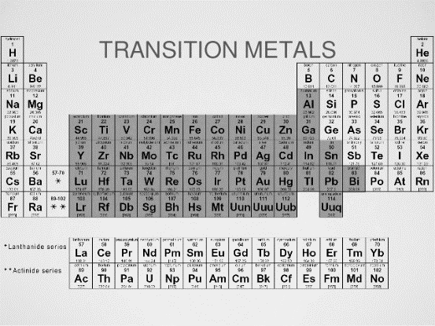

Naming Ionic Compounds that have a Transition Metal:

- Name the metal and if it is not in Group 1, Group 2 or Al, Zn, and Ag then put parenthesis after the metal’s name.
- Name the anion
  - If the anion is a monoatomic ion change its ending to –ide
  - If the anion is a polyatomic ion then the name doesn’t change
- Now we have to get the roman numeral that goes into the parenthesis. There are 2 ways to do this:
  - The compound must charge balance to zero.
  - Everything in the compound must add up to zero
  - Set up on equation that is equal to zero and solve for the unknown

Method 1: Fe₂S₃ 0 = 2Fe + 3S Iron (III) Sulfide
0 = 2Fe + 3(-2)
0 = 2Fe - 6
6 = 2Fe
Fe = +3

Method 2: Fe₂S₃ Reverse Swap and Check
-2
+3333333333
Fe₂S₃ Is the common ion charge of Sulfide a -2? YES!!!
Fe, iron must be +3!!! Iron (III) Sulfide
Try This!
Summary:
- Name the metal or cation
- If that metal is NOT IN Group 1, 2 or Al, Zn, Ag then put parenthesis after the metal name. Determine the charge on the metal using the methods shown and put that charge in ( ) as a roman numeral.
- Name the anion

- CuCl ___________________________________________________________________

- CrPO₄ ________________________________________

- NiSO₄ _________________________________________

- PbCl₄ _________________________________________

- FeO __________________________________________

HOW TO NAME COVALENT COMPOUNDS:

- COVALENT compounds are made up of TWO NONMETALS (RIGHT OF STAIRS)
- These will only contain TWO CAPITAL LETTERS
- These will all end in –ide

Steps to Naming Covalent Compounds:

- Look at the first part of the compound.
  - Is it a metal? Is it Ammonium? If it is then you are using the wrong system. These are ionic compounds and you should use the ionic notes to help you name these compounds.
  - If it is a nonmetal:
    - LOOK AT THE SUBSCRIPT ON THE FIRST NONMETAL.
    - If that subscript is an assumed one then just NAME THE NONMETAL.
    - If it is greater than one, convert that number to a prefix. Write down that prefix and then name the nonmetal.
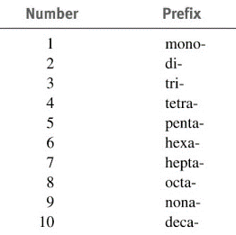
- Look at the second element in the compound.
  - Look at the subscript on the second element.
  - Convert that number to a prefix
  - Write down the prefix and then element name but CHANGE THE ENDING TO –ide

Note: When the addition of the Greek prefix places two vowels adjacent to one another, the "a" (or the "o") at the end of the Greek prefix is usually dropped; e.g., "nonaoxide" would be written as "nonoxide", and "monooxide" would be written as "monoxide". The "i" at the end of the prefixes "di-" and "tri-" are never dropped.

Let’s Try:

- N₂S₄ __________________________________________________________
- XeF₆ __________________________________________________________
- CCl₄ __________________________________________________________
- PBr₃ ___________________________________________________________
- N₂O₄ ___________________________________________________________
- CO ___________________________________________________________
- N₂O₅ __________________________________________________________
- C₃H8 ________________________________________________________________________________________
How to write the formula of COVALENT Compounds:

- This system is only used with COVALENTS
- The first part of the name will be a NONMETAL

Steps to writing the formula of a Covalent Compound:

- The first element named will be a nonmetal
  - If it has NO prefix than just write down the symbol of that nonmetal
  - If it has a prefix then convert the prefix to a number. Write down the element symbol and place the number as a subscript to the right of the first symbol
- The second element will always be a nonmetal with a prefix.
  - Convert the prefix to a number. Write down the element symbol and place the number as a subscript to the right of the second symbol
- NEVER REDUCE THESE COMPOUNDS!!!

Let’s Try:

- Boron trihydride ______________________________________________

- Dinitrogen tetroxide __________________________________________

- Pentacarbon decahydride ____________________________________

- Triarsenic hexiodide __________________________________________

- Sulfur dioxide __________________________________________________

