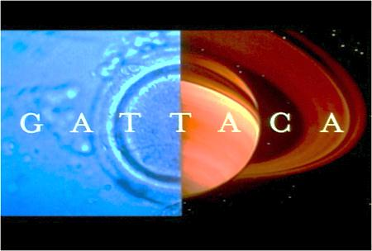
GATTACA Movie Assignment Name: Hour:
As you watch the movie GATTACA answer the questions below. Next to each question number is the approximate time that the question is answered in the movie. Once you have viewed the entire movie answer the discussion questions at the end. This assignment will be graded.

1. What does Jerome (Vincent) place on the comb at his workstation?
2. “They used to say that a child conceived in love has a greater chance of….” What?
3. What is Jerome’s (Vincent’s) life expectancy?
4. After Marie’s fertilized embryos are screened, how many healthy ones are left?
5. According to the geneticist, we have enough of this built in already. What is it?
6. What is Vincent’s and his brother’s favorite game?
7. What is the name given to discriminating against people because of their genetic profile?
8. “After all there is no gene for …” what?
9. What color is Jerome’s medal?
10. What is a “borrowed ladder” or “de-generate”?
11. What does Jerome (Vincent) leave behind at the murder scene?
12. The director claims that Gattaca is occasionally forced to accept candidates with “minor shortcomings”, but nothing that would prevent them from working in what field?
13. Why is it unlikely that Irene will travel into space?
14. When Jerome (Vincent) and Irene go to a concert, what is unusual about the piano player?
15. What does Irene leave behind at the club where she and Jerome are dancing?
16. Who killed the mission director?
17. Who does the detective leading the murder investigation turn out to be?
18. Why does Eugene think that he got the better end of the deal?
19. In what sport did Eugene receive his medal?
Discussion Questions – Answer the questions below in complete sentences. You may need to use an extra sheet of paper.
1. Explain the significance of the staircase in Jerome and Vincent’s home.

2. During a scene in GATTACA, Vincent’s parents visited a doctor who specialized in child conception to select for the best traits for his future brother. They hoped that his brother would have the best possible chances for a successful life. Some of the traits mentioned in GATTACA included intelligence, height and any possibility of inheritable diseases. If you decided to have a child one day and are given the opportunity to select for special traits, would you do so? Explain why or why not.

3. What are the positive and negative aspects of the world showed in the movie? List at least two positive and 2 negative aspects.
4. What does the movie GATTACA say about DNA determining a person’s potential? Provide examples from the movie to support your answer.
5. Describe 3 preparations Vincent had to do every day to pass as Jerome Morrow at GATTACA. In each case explain why he had to do that.

