Biology I
Virtual Investigation #1

Access the Online Textbook

- Holt’s Modern Biology is accessible by going to the following website and using the log-in information listed.
See login and password information below

Go to: my.hrw.com
Login: astudents90
Password: a7k7
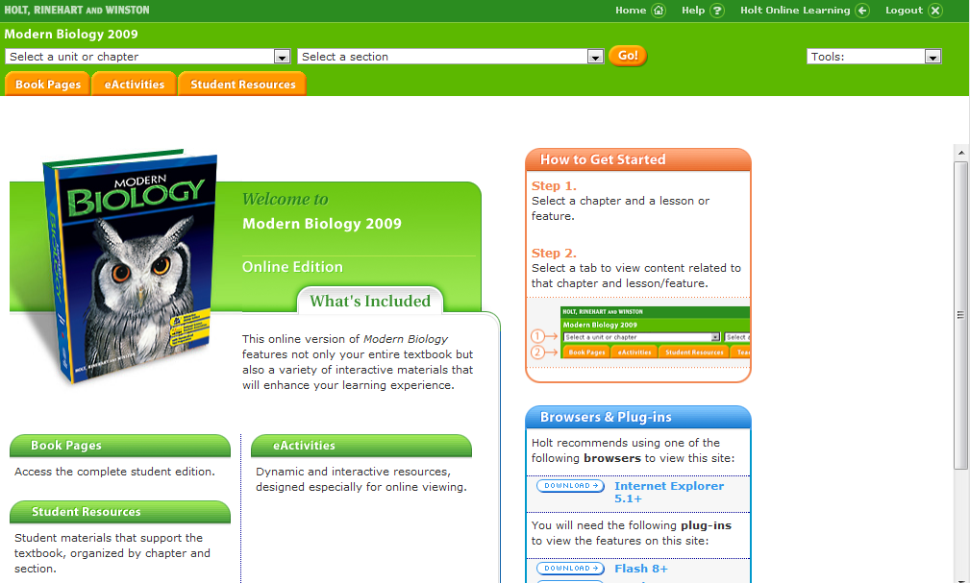

From the dropdown menu, select “Chapter 15:
The Science of Life” then click the “eActivities”
tab.

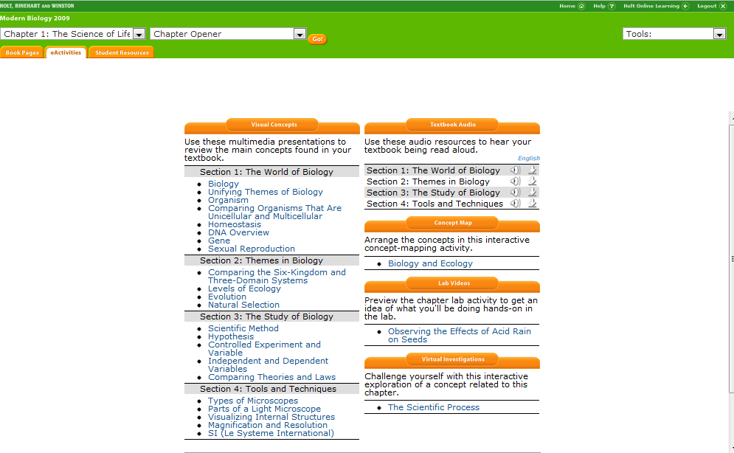
Click on the “Evolution and Natural Selection” link
under the “Virtual Investigations” heading.

Biology I Name:
Evolution & Natural Selection Name:
Virtual Investigation Hour:

Navigate through the virtual investigation for evolution and natural selection on the Holt website. Answer these questions as you proceed. Remember, for full credit you must use complete sentences.

Part 1 of 9
What are the four logical steps involved in natural selection?

______________________________________________________________________________________________________

______________________________________________________________________________________________________

Part 3 of 9
Draw a diagram of a bacteria cell below:

Part 7 of 9
What are antibiotics? What do they do?

______________________________________________________________________________________________________

______________________________________________________________________________________________________

Part 8 of 9
Fill in the following charts as you complete the experiment.
Case 1:
Prediction:
Start | Non-resistant Bacteria | Resistant Bacteria | Ratio
1
2
3
4
5
Conclusion:
Case 2:
Prediction:
Start | Non-resistant Bacteria | Resistant Bacteria | Ratio
1
2
3
4
5
Conclusion:

Case 3:
Prediction:
Start | Non-resistant Bacteria | Resistant Bacteria | Ratio
1
2
3
4
5
Conclusion:
Case 4:
Prediction:
Start | Non-resistant Bacteria | Resistant Bacteria | Ratio
1
2
3
4
5
Conclusion:

Part 9 of 9

Describe the most effective method of treatment with antibiotics?
______________________________________________________________________________________________________

______________________________________________________________________________________________________

What is antibiotic resistance? Why do we want to avoid it?

______________________________________________________________________________________________________

______________________________________________________________________________________________________

_____________________________________________________________________________________________________

