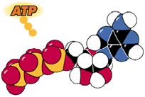
iology 1 Name:
Everything Respiration - Date:
Practice (Turn In) Hour:

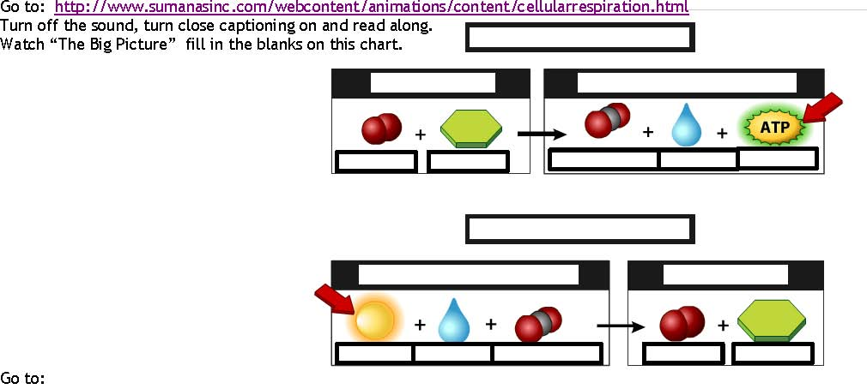

Go to:
https://www.wisc-online.com/learn/natural-science/life-science/ap15104/respiratory-basics
Click through the tutorial.
 | Alveoli | Capillaries | During Internal Respiration: Describe the movement of CO₂ and O₂. Use the terms “blood” & “systemic tissue cells”.
Describe the concentration of gasses inside the structure:
Fill in the chart below:

Go to:
https://www.khanacademy.org/science/high-school-biology/hs-energy-and-transport/hs-introduction-to-metabolism/v/adenosine-triphosphate
Watch the video. Use the video or another source to write the chemical formula for ATP and draw the molecule.

Formula: Structure:

Go to:
http://www.softschools.com/difference/aerobic_respiration_vs_anaerobic_respiration/438/
Fill in the chart below:

Anaerobic vs. Aerobic
Similarities | Differences

Biology 1
Everything Respiration
Reference
Source: https://www2.sluh.org/bioweb/bi100/tutorials/respiration.htm
Introduction
All living things require a constant input of energy into their cells in order to survive. This energy is needed for cell division, movement, maintenance & repair, and for building new materials. The autotrophs are organisms that can produce their own chemical (food) energy by the use of sunlight. The heterotrophs must eat chemical energy of other organisms to supply themselves with the necessary energy.
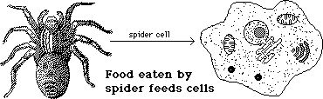

Photosynthesis is the process that converts the light energy to chemical energy for a plant. The chemical energy is stored in the molecule glucose. This is the same molecule that is found in the blood of all animals. Glucose is actually a universal food molecule for all organisms. It can easily be used for energy. Plants can make the glucose, animals must eat it.
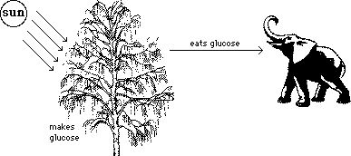

Glucose and ATP
Glucose can be easily used for energy. Yet, glucose is itself NOT a directly usable form of energy for the organelles of a cell. Organelles cannot use the stored energy of glucose directly because they cannot get the energy out of it. The glucose is actually converted to a more usable form of energy that all organelles can use. That form of energy is in a molecule called ATP.
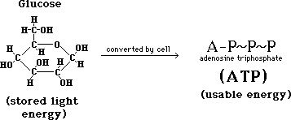

The energy in glucose is similar to the energy that is stored in gasoline. Although gasoline has much energy in it, it cannot cut the grass or move you safely down a street unless it is converted to a more usable form of energy -- moving mower blades or turning car wheels. Likewise, glucose is an energy rich molecule but it must be converted to a more versatile form of energy that all organelles can use -- ATP.
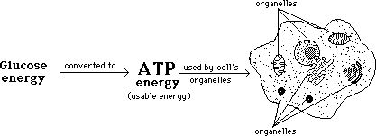

Equation for Respiration
Respiration is the process where the chemical energy of glucose is put into another molecule - ATP - which can then be used by all of the organelles of a cell. An equation is shown below which summarizes the chemical reactions involved in respiration. Glucose is broken down along with oxygen to form carbon dioxide,water and ATP.

ATP Structure
ATP is a molecule which consists of three smaller types of molecules: 1) adenine, 2) ribose, 3) phosphate. One ATP molecule consists of one adenine, one ribose, and three phosphates bonded together. It is pictured below. The wavy lines between the phosphates represent high energy bonds.
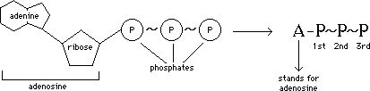

Most of the chemical energy of ATP is stored in the bond between the 2nd and 3rd phosphates. When the energy of ATP is used by an organelle for some activity, the third phosphate is broken off and attached to another molecule on the organelle, thus transferring the energy from the ATP to the organelle. This transfer of the phosphate to another molecule is called PHOSPHORYLATION. Since the ATP has lost one phosphate, it is now called adenosine diphosphate, or ADP. It is drawn below.
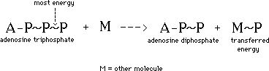

ADP to ATP
Respiration must constantly make more ATP by restoring ADP molecules. It does this by bonding phosphate molecules to the 2nd phosphate of ADP, thus converting it back to ATP, by USING GLUCOSE ENERGY. The ATP would then be ready to be used again by another organelle. ATP is also involved in other chemical reactions, such as photosynthesis, which was covered in a previous program.

ATP-ADP Cycle
The production of ATP and the use of ATP by organelles forms a cycle where ATP is produced, then used, then produced, then used --- over and over again. Essentially what is happening is that glucose energy is being used by organelles via ATP. An animation is shown below to represent this ATP cycle.

Photosynthesis and Respiration
Respiration is the process that releases the energy that was stored in glucose by photosynthesis. All organisms must carry out respiration -- plants and animals -- to harness the stored energy in glucose. So while plants photosynthesize and respire, animals only respire.
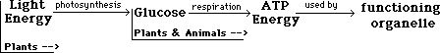

There are two types of respiration found in living things. (In other words, there are two different ways to make ATP from glucose energy.) The less efficient of the two is called ANAEROBIC RESPIRATION - which is respiration in the absence of air (oxygen). The second type of respiration is called AEROBIC RESPIRATION -- which is respiration which uses air.
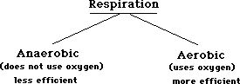

Most organisms (plants and animals) can carry out both types of respiration, although aerobic respiration is the preferred method of making ATP because it is more efficient. Some microbes carry out only anaerobic respiration because oxygen kills them. Yeast is an organism used by man that can carry out both -- when used to make bread they aerobically respire, when used to make alcohol they anaerobically respire. Humans can carry out both types of respiration also.
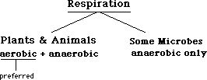

Aerobic vs Anaerobic
We will now explain the process of respiration in some detail. Note that the equations shown below appear to show that respiration, aerobic and anaerobic, occur in one step. Respiration, both aerobic and anaerobic, actually occur in many steps and are both quite complex. Aerobic is more complex because it requires more chemical reactions. Both types of respiration below occur in humans.
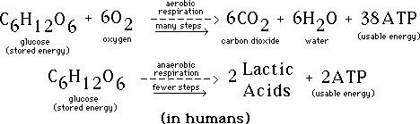

Note that in the chemical reactions of both aerobic respiration, glucose is a reactant, but oxygen is a reactant only in aerobic respiration, while glucose is the only reactant of anaerobic respiration. Aerobic respiration produces carbon dioxide and water while anaerobic produces lactic acid. Note that both processes produce ATP, aerobic - 36 ATP, anaerobic - 2 ATP. Aerobic is more efficient because it produces more ATP from the glucose.
36 ATP +
The pyruvic acid produced by glycolysis will then be further broken down by aerobic or anaerobic respiration. In anaerobic respiration the pyruvic acid is broken down only slightly, usually forming lactic acid (in animals) or alcohol in yeast or bacteria. In aerobic respiration the pyruvic acid is broken down as far as possible, all the way down to carbon dioxide and water. So anaerobic respiration only breaks down glucose part way, while aerobic respiration breaks down glucose all of the way.
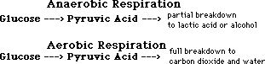

Fermentation another name for the anaerobic respiration of pyruvic acid, the breakdown of pyruvic acid without the use of oxygen. The fermentation of pyruvic acid does not produce any ATP so it is not useful for energy production. The pyruvic acid is broken down to lactic acid or alcohol for another reason.
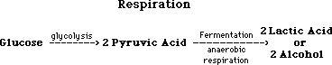

Anaerobic Respiration
To stay alive, a cell must have a constant uninterrupted supply of ATP. Usually a cell makes its ATP aerobically by breaking down glucose fully to carbon dioxide and water. If the cell should be deprived of oxygen temporarily, it could easily die if it could not make ATP anaerobically. This is why the pyruvic acid must be broken down to lactic acid or alcohol.
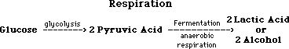

Anaerobic Respiration
Glycolysis requires empty NAD molecules (not carrying H-atoms) in order to occur. NAD-H-H (loaded NAD) are only used in aerobic respiration where the H-atoms are unloaded from the NAD. A cell has a limited supply of empty NAD molecules and if no air is present, all of the NAD molecules quickly become loaded with H-atoms from glycolysis. Without empty NAD molecules, glycolysis cannot occur and the cell would quickly run out of ATP and die.
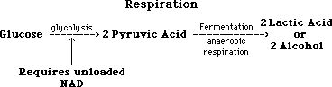

Lactic Acid vs Alcohol
There are two types of fermentation. One is called LACTIC ACID FERMENTATION where pyruvic acid is anaerobically broken down to lactic acid. This occurs in animals (especially muscle) and some microbes. The other type of fermentation is called ALCOHOLIC FERMENTATION where pyruvic acid is anaerobically broken down to alcohol and carbon dioxide. This occurs in some bacteria and fungi. Both types of fermentation are represented below. Note that neither produces any ATP, the purpose of both is to empty NAD-H-H so glycolysis can continue making ATP.
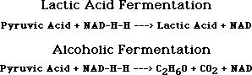

Anaerobic Respiration
Fermentation only occurs because a cell would die if it could not make ATP under conditions of temporary oxygen loss. All cells experience times of temporary oxygen loss. So, fermentation keeps a cell alive under those conditions, but only for a short time. If oxygen is not eventually supplied, the cell will die. Fermentation is too inefficient in making ATP to keep a cell with its organelles alive for long. Glycolysis alone only produces 2 ATP, aerobic respiration produces 36 ATP.
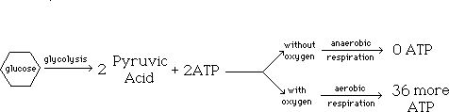

Aerobic Respiration
The equation shown below represents the result of glycolysis and aerobic respiration, the chemicals used and the chemicals produced. Obviously aerobic is more efficient than anaerobic respiration because aerobic respiration does produce ATP while anaerobic makes no ATP, it only keeps inefficient glycolysis working.
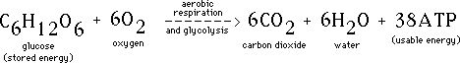

Mitochondrion
While glycolysis and anaerobic respiration occur in the cytoplasm of a cell, aerobic respiration occurs in the mitochondria of a cell. A mitochondria is shown below. It consists of 2 membranes, an outer smooth membrane and an inner folded membrane. The inner membrane is folded to maximize surface area for chemical reactions to occur.
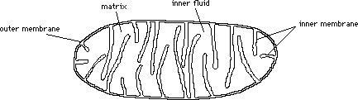

Aerobic Respiration
The fluid within the inner membrane is called the MATRIX. The fluid between the inner and outer membranes is called the INTERMEMBRANE SPACE. Note that the intermembrane space extends into the inner part of the mitochondria because of the folds of the inner membrane. The inner membrane and the matrix are the site of many chemical reactions.
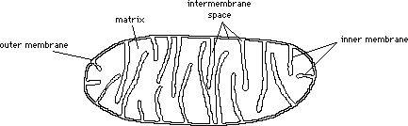

Other Fuels
Lipids and proteins can also be used for energy. They are broken down to acetic acid and sent through the Krebs Cycle to make H-atoms for the ETS. A single large fat molecule is worth about 350 ATP molecules to a cell. Fats are an efficient way for animals to store energy for this reason. Glucose is usually stored in the form of a polysaccharide (starch or glycogen) and broken down as needed for energy.
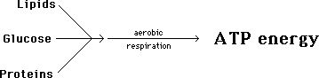

The ATP's that are made by respiration will be broken down to ADP and P when used by an organelle, and the trapped light energy that was passed from glucose to ATP will then be put to use by the organelle. Almost all life on the planet processes fuel in this way, and they almost all ultimately depend on the sun for the energy.
