WHAT ARE STEM CELLS AND HOW DO THEY WORK?
There are three types of stem cells. Each has potential for medical research and clinical applications based on its unique properties.
Peter Hoey, - The San Francisco Chronicle
STEM CELLS are the building blocks of the human body. At the start of life, they divide over and over again to create a full person from an embryo. As we age, they replenish cells in our blood, bone, skin and organs. Stem cells could be powerful tools in treating injury and illness.
EMBRYONIC STEM CELLS

The first cells to form after a sperm fertilizes an egg.
“Blank slate” cells: can become every other kind of cell in the body.
Can divide and multiply endlessly.
Controversial in medicine because embryos must be destroyed to obtain stem cells.
ADULT STEM CELLS

Mature stem cells that replenish blood, skin, gut and some other cells.
In some cases, can replace cells damaged by illness or injury.
Limited ability to become other types of cells.
Limited ability to divide and multiply.

INDUCED-PLURIPOTENT STEM CELLS

Adult cells that are reprogrammed to look and act like embryonic stem cells.
Can be made from skin, blood and other adult cells.
From their embryonic-like state, can be further altered to become any other type of cell.
Good potential use in medicine, but still a new area of research.

EMBRYONIC
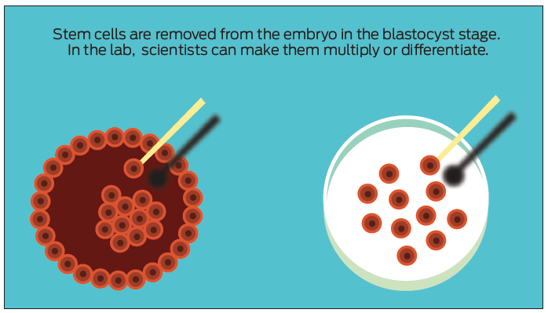
What are they?
Embryonic stem cells are the starter cells of the human body. They are undifferentiated, which means they have not matured and specialized, and they are able to become any other kind of cell in the body.
In embryos, these cells multiply and differentiate to become organs, bones and muscles. In the laboratory, they can be multiplied to create stem cell lines for study or for therapy.
Scientists harvest embryonic stem cells from three- to five-day-old embryos donated by people who have gone through in-vitro fertilization. Scientists isolated the first human embryonic stem cells in 1998.
What makes them different from other stem cells?
These are the only stem cells that naturally are able to become any other cell type and to multiply endlessly. Under the right circumstances in a lab, they can be nudged to become specific cell types.
Why do these characteristics give these cells medical potential?
Because of their ability to differentiate and multiply, embryonic stem cells long were thought to be the most powerful, and thus have the most potential for treating injury and disease. If scientists are able to control how they differentiate and how often, embryonic stem cells could be used to replace any damaged part of the body — from missing insulin-making cells in people with Type 1 diabetes to brain cells lost in Parkinson’s disease or skin cells scarred by burns.
What are the limitations of these therapies?
Many people have ethical problems using human embryos for scientific study. Also, embryonic stem cells’ ability to replicate endlessly means they may develop mutations that can interfere with their growth or allow them to keep dividing to the point of causing harm. Finding the right medical applications for embryonic stem cells is challenging.

ADULT
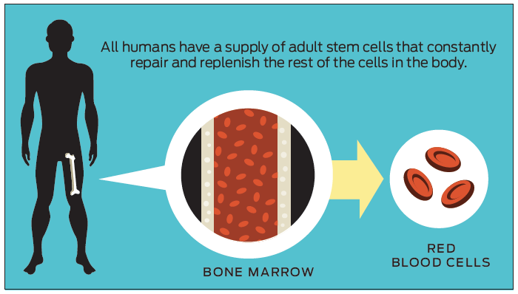
What are they?
Adult stem cells are so-named because they are more mature than embryonic stem cells, though they don’t necessarily have to come from adults. Their maturity means that they are limited in their ability to differentiate. Pockets of adult stem cells are found in many of our organs and they replenish cells in the organs in which they reside. Types of adult stem cells include:
HEMATOPOIETIC
Found in bone marrow and umbilical cord blood, they become blood and immune cells. They are the only stem cells approved by the FDA for therapy, for treatment of certain blood cancers.
MESENCHYMAL
These cells are found throughout the body, including in bone marrow, fat tissue and organs. They turn into the connective tissue found throughout the body, though the specific cell they become is related to the organ in which they’re located. These stem cells may decrease inflammation.
FETAL
Stem cells from fetuses are more mature, and therefore less able to differentiate, than embryonic stem cells, but they may be more multipurpose than other adult stem cells. For example, neural stem cells from fetal brain tissue can become several kinds of neurons, but neural stem cells from the adult brain are rare and have very limited ability to differentiate.
What makes them different from other stem cells?
Adult stem cells are limited in their abilities. They can only become certain types of cells — they are called multi-potent, instead of pluripotent, for that reason — and there is a limit to how often they can divide.
Why do these characteristics give these cells medical potential?
Adult stem cells are less powerful than embryonic, but they are easier to use, since all humans have their own supply of these cells. They may be useful for reducing inflammation.
What are the limitations of these therapies?
It’s unclear how useful these stem cells could be given their limited abilities. Though the idea of tapping into a person’s own source of adult stem cells and using them for treatment is appealing, these cells cannot repair serious injuries or replace cells lost to disease, like neurons or insulin-producing cells.

INDUCED-PLURIPOTENT
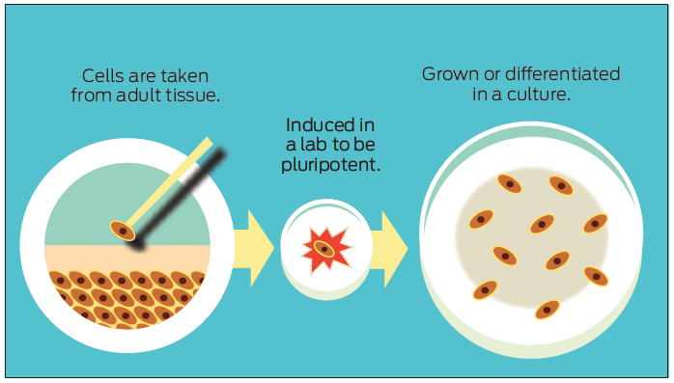
What are they?
Induced-pluripotent stem (IPS) cells are adult cells — often skin or blood cells — that have been taken from an individual and reprogrammed in a lab to become like embryonic stem cells. Then, like embryonic stem cells, they can be developed into any other type of cell. So a skin cell could be turned into an embryonic-like cell and then further turned into a heart cell.
What makes them different from other stem cells?
Like embryonic stem cells, except they are manufactured in a lab. And since they come from an individual, they are an exact match to that individual. Scientists are still studying whether IPS cells could be used interchangeably with embryonic stem cells.
Why do these characteristics give these cells medical potential?
They could be used to replace cell types lost to disease or injury. In addition, IPS cells can be used to study human diseases in Petri dishes or in animals. Scientists can take skin cells from a person with a genetic mutation, convert those cells to IPS cells, then study those cells as a living model of how the mutation functions.
What are the limitations of these therapies?
Making IPS cells can be a time- and resource-consuming process. But mostly, IPS cells have the same limits as embryonic stem cells.

Types of Tissues

By the end of this section, you will be able to:
- Identify the four main tissue types
- Discuss the functions of each tissue type
- Relate the structure of each tissue type to their function
- Discuss the embryonic origin of tissue
- Identify the three major germ layers
- Identify the main types of tissue membranes
The term tissue is used to describe a group of cells found together in the body. The cells within a tissue share a common embryonic origin. Microscopic observation reveals that the cells in a tissue share morphological features and are arranged in an orderly pattern that achieves the tissue’s functions. From the evolutionary perspective, tissues appear in more complex organisms. For example, multicellular protists, ancient eukaryotes, do not have cells organized into tissues.
Although there are many types of cells in the human body, they are organized into four broad categories of tissues: epithelial, connective, muscle, and nervous. Each of these categories is characterized by specific functions that contribute to the overall health and maintenance of the body. A disruption of the structure is a sign of injury or disease. Such changes can be detected through histology, the microscopic study of tissue appearance, organization, and function.

The Four Types of Tissues
Epithelial tissue, also referred to as epithelium, refers to the sheets of cells that cover exterior surfaces of the body, lines internal cavities and passageways, and forms certain glands. Connective tissue, as its name implies, binds the cells and organs of the body together and functions in the protection, support, and integration of all parts of the body. Muscle tissue is excitable, responding to stimulation and contracting to provide movement, and occurs as three major types: skeletal (voluntary) muscle, smooth muscle, and cardiac muscle in the heart. Nervous tissue is also excitable, allowing the propagation of electrochemical signals in the form of nerve impulses that communicate between different regions of the body ([link]).
The next level of organization is the organ, where several types of tissues come together to form a working unit. Just as knowing the structure and function of cells helps you in your study of tissues, knowledge of tissues will help you understand how organs function. The epithelial and connective tissues are discussed in detail in this chapter. Muscle and nervous tissues will be discussed only briefly in this chapter.
Four Types of Tissue: Body
The four types of tissues are exemplified in nervous tissue, stratified squamous epithelial tissue, cardiac muscle tissue, and connective tissue in small intestine. Clockwise from nervous tissue, LM × 872, LM × 282, LM × 460, LM × 800. (Micrographs provided by the Regents of University of Michigan Medical School © 2012)

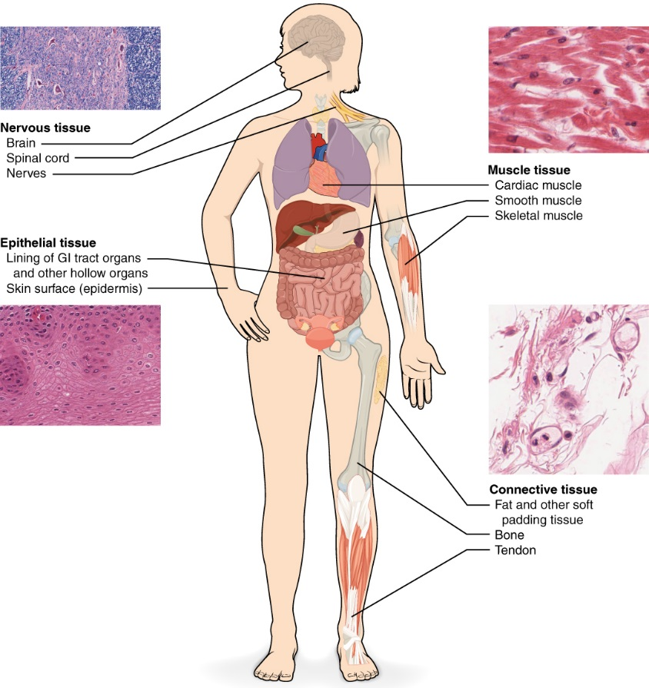

Embryonic Origin of Tissues
The zygote, or fertilized egg, is a single cell formed by the fusion of an egg and sperm. After fertilization the zygote gives rise to rapid mitotic cycles, generating many cells to form the embryo. The first embryonic cells generated have the ability to differentiate into any type of cell in the body and, as such, are called totipotent, meaning each has the capacity to divide, differentiate, and develop into a new organism. As cell proliferation progresses, three major cell lineages are established within the embryo. Each of these lineages of embryonic cells forms the distinct germ layers from which all the tissues and organs of the human body eventually form. Each germ layer is identified by its relative position: ectoderm (ecto- = “outer”), mesoderm (meso- = “middle”), and endoderm (endo- = “inner”). [link] shows the types of tissues and organs associated with the each of the three germ layers. Note that epithelial tissue originates in all three layers, whereas nervous tissue derives primarily from the ectoderm and muscle tissue from mesoderm.

Embryonic Origin of Tissues and Major Organs
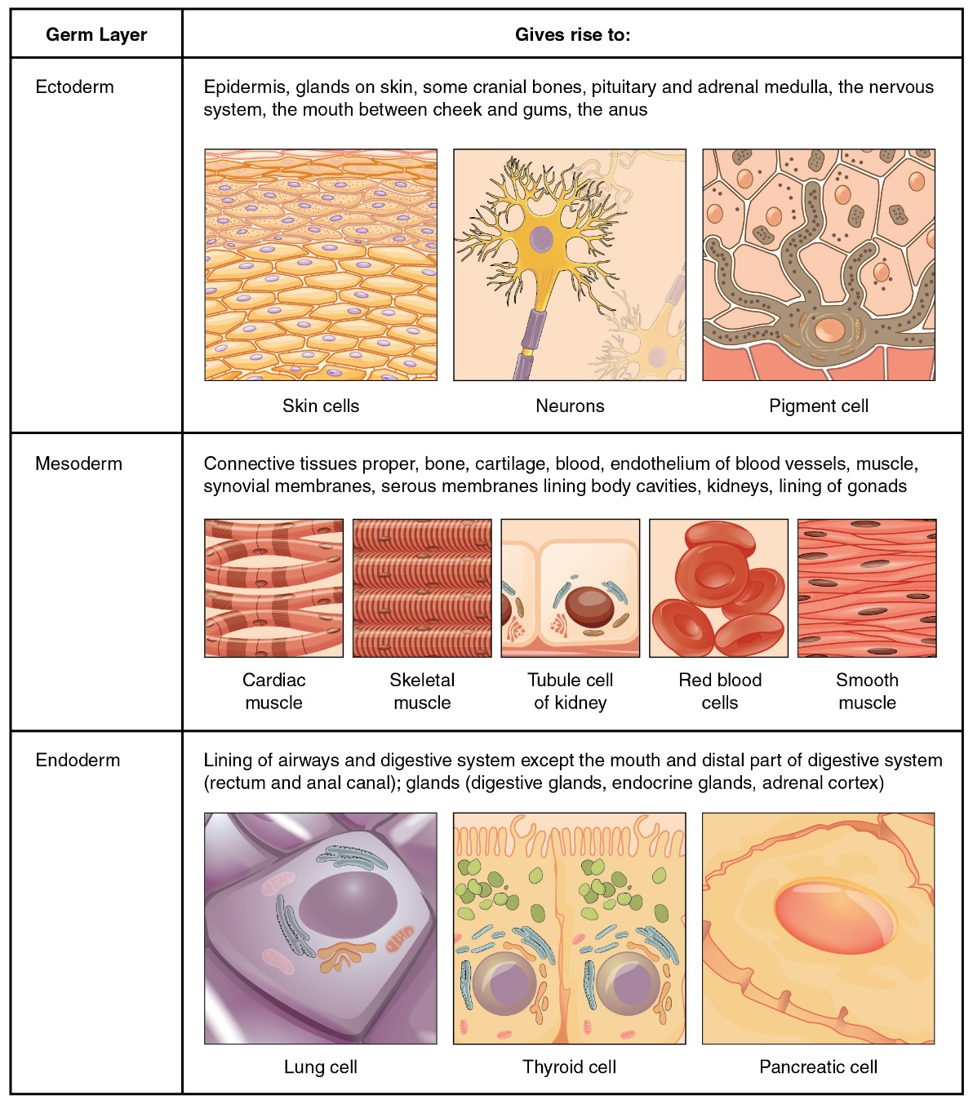

How do somatic stem cells differ from embryonic stem cells?

Tissue Membranes
A tissue membrane is a thin layer or sheet of cells that covers the outside of the body (for example, skin), the organs (for example, pericardium), internal passageways that lead to the exterior of the body (for example, abdominal mesenteries), and the lining of the moveable joint cavities. There are two basic types of tissue membranes: connective tissue and epithelial membranes ([link]).
Tissue Membranes
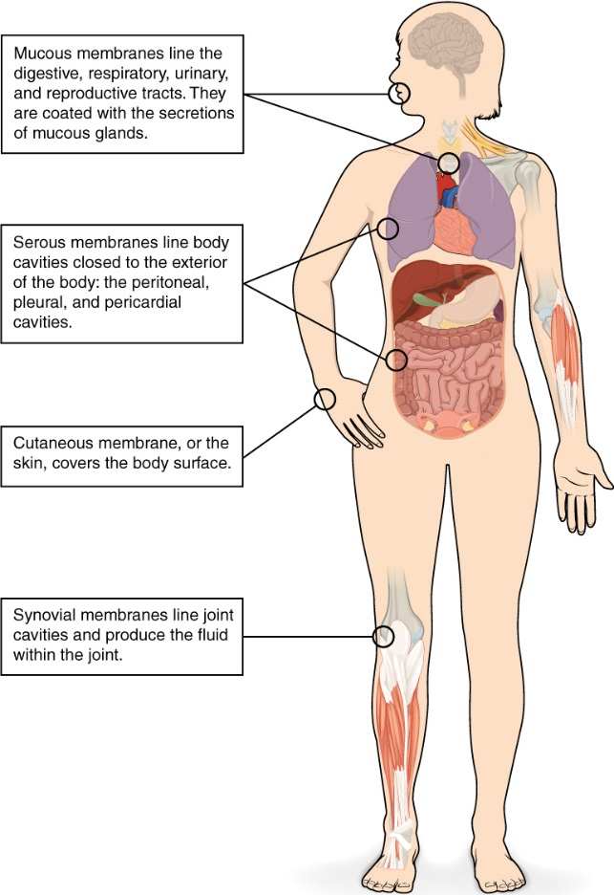
The two broad categories of tissue membranes in the body are (1) connective tissue membranes, which include synovial membranes, and (2) epithelial membranes, which include mucous membranes, serous membranes, and the cutaneous membrane, in other words, the skin.

Connective Tissue Membranes
The connective tissue membrane is formed solely from connective tissue. These membranes encapsulate organs, such as the kidneys, and line our movable joints. A synovial membraneis a type of connective tissue membrane that lines the cavity of a freely movable joint. For example, synovial membranes surround the joints of the shoulder, elbow, and knee. Fibroblasts in the inner layer of the synovial membrane release hyaluronan into the joint cavity. The hyaluronan effectively traps available water to form the synovial fluid, a natural lubricant that enables the bones of a joint to move freely against one another without much friction. This synovial fluid readily exchanges water and nutrients with blood, as do all body fluids.

Epithelial Membranes
The epithelial membrane is composed of epithelium attached to a layer of connective tissue, for example, your skin. The mucous membrane is also a composite of connective and epithelial tissues. Sometimes called mucosae, these epithelial membranes line the body cavities and hollow passageways that open to the external environment, and include the digestive, respiratory, excretory, and reproductive tracts. Mucous, produced by the epithelial exocrine glands, covers the epithelial layer. The underlying connective tissue, called the lamina propria (literally “own layer”), help support the fragile epithelial layer.
A serous membrane is an epithelial membrane composed of mesodermally derived epithelium called the mesothelium that is supported by connective tissue. These membranes line the coelomic cavities of the body, that is, those cavities that do not open to the outside, and they cover the organs located within those cavities. They are essentially membranous bags, with mesothelium lining the inside and connective tissue on the outside. Serous fluid secreted by the cells of the thin squamous mesothelium lubricates the membrane and reduces abrasion and friction between organs. Serous membranes are identified according locations. Three serous membranes line the thoracic cavity; the two pleura that cover the lungs and the pericardium that covers the heart. A fourth, the peritoneum, is the serous membrane in the abdominal cavity that covers abdominal organs and forms double sheets of mesenteries that suspend many of the digestive organs.
The skin is an epithelial membrane also called the cutaneous membrane. It is a stratified squamous epithelial membrane resting on top of connective tissue. The apical surface of this membrane is exposed to the external environment and is covered with dead, keratinized cells that help protect the body from desiccation and pathogens.

Chapter Review
The human body contains more than 200 types of cells that can all be classified into four types of tissues: epithelial, connective, muscle, and nervous. Epithelial tissues act as coverings controlling the movement of materials across the surface. Connective tissue integrates the various parts of the body and provides support and protection to organs. Muscle tissue allows the body to move. Nervous tissues propagate information.
The study of the shape and arrangement of cells in tissue is called histology. All cells and tissues in the body derive from three germ layers in the embryo: the ectoderm, mesoderm, and endoderm.
Different types of tissues form membranes that enclose organs, provide a friction-free interaction between organs, and keep organs together. Synovial membranes are connective tissue membranes that protect and line the joints. Epithelial membranes are formed from epithelial tissue attached to a layer of connective tissue. There are three types of epithelial membranes: mucous, which contain glands; serous, which secrete fluid; and cutaneous which makes up the skin

Credit : http://oerpub.github.io/epubjs-demo-book/content/m46046.xhtml
