Biology 1 Name:
DNA Structure & Replication Practice Date:

1. What will pair up with each of the following in DNA Replication?
G - T - A - C -

2. When looking at a nucleotide, what does each of the following stand for?
G - T - A - C -

3. If I have 14 guanine and 37 thymine, how many adenine will I have?

4. If there are 12 cytosine and 15 thymine, how many guanine will I have?

5. If a sample of DNA contains 32 % cytosine, what percent of the sample is guanine?

6. If a sample of DNA contains 26 % cytosine, what percent of the sample is adenine?

7. For each of the following complete the missing line:

DNA: TAAGCGTAGCTG
Comp DNA:

DNA: GCCGATATGCAACGCGCCTTAA
Comp DNA:

DNA: CAAAATGCGTGTAATTTGCTTAACGGG
Comp DNA:

DNA: ACTCTCGTGTGAAAATGCTCTCTCCCGGGG
Comp DNA:

8. Explain what the role of DNA helicase is.

9. Explain both roles of DNA polymerase.

10. During what phase of the cell cycle is DNA replicated?

11. What are the 3 parts of a nucleotide?

12. What combines with phosphate to make up the backbone of DNA? (Be specific.)

13. Which Nitrogen bases are purines?

14. Which Nitrogen bases are pyrimidines?

15. Explain the base pairing rules in your own words.

16. Use the key below to circle each type of molecule/part of DNA in the picture below with the appropriate color. You must circle at least one of each of the following.

Key
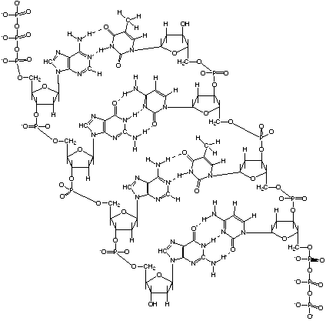
Phosphate Group = Purple
Sugar Molecule = Brown
Hydrogen Bonds = Orange
Adenine = Red
Thymine = Blue
Guanine = Green
Cytosine = Yellow

