Biology I
DNA, RNA & Gene Expression Virtual Investigation - INSTRUCTIONS

Go to the following website: http://learning.kentwoodps.org/science/holt/biology_vi/

Click “Genetics”. Then click the “DNA, RNA & Gene Expression”.
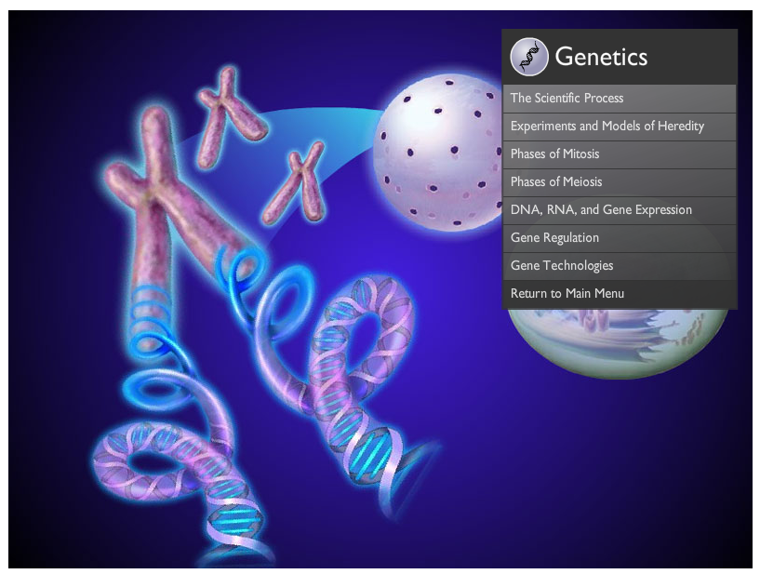
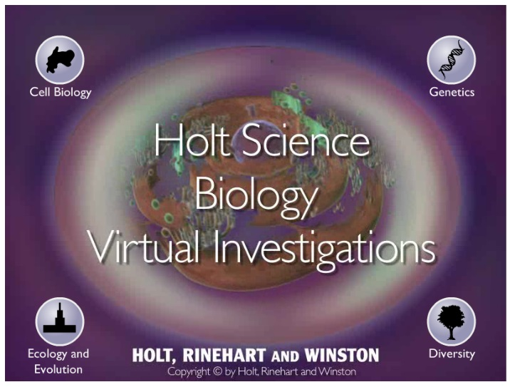

Now you are ready to work through a Virtual Investigation. Answer the following questions as you proceed.

Remember, for full credit you must use complete sentences!

Biology I Name:
DNA, RNA & Gene Expression Name:
Virtual Investigation Hour:

Navigate through the virtual investigation titled “DNA, RNA & Gene Expression” on the Holt website. Answer these questions as you proceed. This should serve as a refresher on the scientific method. Remember, for full credit you must use complete sentences.

Part 1 of 5
Look at the diagram in this part of the investigation. Draw and label a diagram showing the interaction between the following terms/molecules: “DNA”, “replication fork”, “DNA helicase” & “DNA polymerase”

Part 2 of 5
Unwind and replicate the DNA strand given. Record the sequence of the two new DNA molecules below.

Part 3 of 5
What enzyme is responsible for completing the process in this section?

______________________________________________________________________

Record the sequence of nucleotides in the mRNA molecule you construct in this step.

Part 4 of 5
Look at the diagram in this part of the investigation. Draw and label a diagram showing the interaction between the following terms/molecules: “ribosome”, “mRNA”, “tRNA”, “polypeptide” & “amino acid”

List the 6 codons used to build the polypeptide in this step.

Part 5 of 5

What protein are you synthesizing in this step? ________________________
Record the nucleotide sequence in the DNA molecule used in this step.

Record the nucleotide sequence in the mRNA molecule used in this step.

Record the sequence of codons used in this step.

In people affected by sickle-cell anemia, the amino acid _______________________________ is replaced by

__________________________ in their hemoglobin. This causes the red blood cells to be misshaped.

On Your Own
(Answers not found on the website)

What is the start codon? Give its sequence and the amino acid that it codes for.

______________________________________________________________________________________________________

List the three stop codons.
________________________________________________________________________

What is a mutation? How do mutations affect protein?

______________________________________________________________________________________________________

______________________________________________________________________________________________________

______________________________________________________________________________________________________

______________________________________________________________________________________________________

EXTRA CREDIT: Parts 4 & 5 of 5

Use the genetic code to translate the 6 codons used in part 4 & 5 into amino acids. Record your answers below:
Part 4 of 5 amino acids | Part 5 of 5 amino acids

