DNA: Definition, Structure & Discovery
By Rachael Rettner, Senior Writer | December 7, 2017
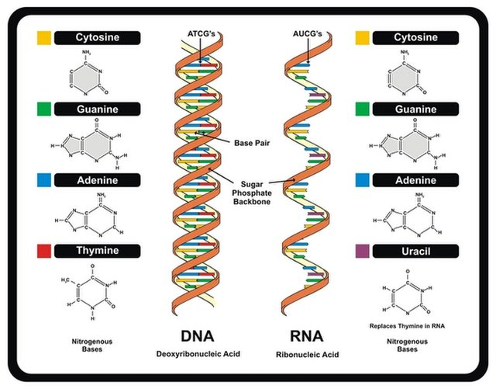
The structure of DNA and RNA. DNA is a double helix, while RNA is a single helix. Both have sets of nucleotides that contain genetic information.
Credit: udaix Shutterstock
Deoxyribonucleic acid or DNA is a molecule that contains the instructions an organism needs to develop, live and reproduce. These instructions are found inside every cell, and are passed down from parents to their children.

DNA structure
DNA is made up of molecules called nucleotides. Each nucleotide contains a phosphate group, a sugar group and a nitrogen base. The four types of nitrogen bases are adenine (A), thymine (T), guanine (G) and cytosine (C). The order of these bases is what determines DNA's instructions, or genetic code. Human DNA has around 3 billion bases, and more than 99 percent of those bases are the same in all people, according to the U.S. National Library of Medicine (NLM).

Similar to the way the order of letters in the alphabet can be used to form a word, the order of nitrogen bases in a DNA sequence forms genes, which in the language of the cell, tells cells how to make proteins. Another type of nucleic acid, ribonucleic acid, or RNA, translates genetic information from DNA into proteins.
Nucleotides are attached together to form two long strands that spiral to create a structure called a double helix. If you think of the double helix structure as a ladder, the phosphate and sugar molecules would be the sides, while the bases would be the rungs. The bases on one strand pair with the bases on another strand: adenine pairs with thymine, and guanine pairs with cytosine.
DNA molecules are long — so long, in fact, that they can't fit into cells without the right packaging. To fit inside cells, DNA is coiled tightly to form structures we call chromosomes. Each chromosome contains a single DNA molecule. Humans have 23 pairs of chromosomes, which are found inside the cell's nucleus.

DNA discovery
DNA was first observed by a German biochemist named Frederich Miescher in 1869. But for many years, researchers did not realize the importance of this molecule. It was not until 1953 that James Watson, Francis Crick, Maurice Wilkins and Rosalind Franklin figured out the structure of DNA — a double helix — which they realized could carry biological information.
Watson, Crick and Wilkins were awarded the Nobel Prize in Medicine in 1962 "for their discoveries concerning the molecular structure of nucleic acids and its significance for information transfer in living material." Franklin was not included in the award, although her work was integral to the research.

DNA sequencing
DNA sequencing is technology that allows researchers to determine the order of bases in a DNA sequence. The technology can be used to determine the order of bases in genes, chromosomes, or an entire genome. In 2000, researchers completed the first full sequence of the human genome, according to a report by the National Human Genome Research Institute.

DNA testing
A person's DNA contains information about their heritage, and can sometimes reveal whether they are at risk for certain diseases. DNA tests, or genetic tests, are used for a variety of reasons, including to diagnose genetic disorders, to determine whether a person is a carrier of a genetic mutation that they could pass on to their children, and to examine whether a person is at risk for a genetic disease. For instance, mutations in the BRCA1 and BRCA2 genes are known to increase the risk of breast and ovarian cancer, and analysis of these genes in a genetic test can reveal whether a person has these mutations.
Genetic test results can have implications for a person's health, and the tests are often provided along with genetic counseling to help individuals understand the results and consequences of the test.
There are now many at-home genetic testing kits, but some of them are unreliable. Also, NBC News reports that people should be careful with these kits, since the tests are essentially handing over a person's genetic code to a stranger.

