Fermentation: Obtaining energy in the absence of oxygen.

By far the most effective way for organisms to obtain ATP is with cellular respiration using oxygen gas. But what about situations where there is no oxygen? Can life exist without oxygen? Yes! There are many places on our planet where life exists today with little to no oxygen. In some tightly-packed soils, you only need to dig a few inches to get to a place where very little oxygen is able to penetrate into the ground. Organisms in these environments must have ways of obtaining energy without oxygen.

We also know that there was no free oxygen gas in Earth’s atmosphere when life first formed. In fact, it was more than a billion years after those first organisms appeared before there was enough oxygen in the atmosphere (provided by the photosynthetic organisms that evolved some time later) to make respiration possible. No organism can live without a constant supply of ATP, so how did those earliest organisms survive? Their cells must have used a process that forms ATP without oxygen. Fermentation, aka anaerobic (“without oxygen”) respiration, is one such a process and is believed to be the way that the Earth’s first organisms obtained energy. Many organisms today, including some human cells, retain the ability to carry out fermentation, however they will only do so in an oxygen-free environment.

Long before there was any recorded history, fermentation was used by humans to produce food and drink. For more than 7000 years humans have known that certain foods (grains, fruit juices, even sugar water) kept in airtight environments will change into alcoholic beverages. Later various cultures learned how to keep certain foods in airtight containers and transform them into delicious products such as yogurt, pickles, kimchi, soy sauce, vinegar, miso, sourdough bread, and sauerkraut. Although people knew how to create the right environment for these transformations, it was thousands of years before they had any idea of why they happened. It wasn't until the early 1800's that scientists figured out that the changes were a result of the natural life processes of microorganisms (yeasts and bacteria) in the foods.

Organisms that carry out fermentation are heterotrophs – that is, they must eat food and break it down to obtain ATP. As with cellular respiration, fermentation is a process in which food molecules are rearranged, ATP is released, and usually CO₂ is produced as a waste product. However in fermentation the six-carbon chain of glucose is not broken down completely as it is in respiration. (Think about our reaction for cellular respiration: the six carbons in glucose all end up in the six molecules of carbon dioxide on the other end of the reaction.) In addition to CO₂, there is always a two or three-carbon compound produced at the end of fermentation reactions. These end products vary depending on the organism. If the organism is yeast, the product is alcohol (C₂H₅OH). Some bacteria form acetic acid (vinegar - C₂H₄O₂), others lactic acid (C₃H₆O₃). Because some of the carbon chain remains intact in these products, much of the energy remains stored in the molecules and far less energy is released. Fermentation yields only 2 ATP per glucose compared to 36 ATP per glucose for respiration.

Only the simplest organisms (yeast and bacteria) can survive for any length of time on the small amount of ATP provided by fermentation. However certain cells in more complex organisms, such as human skeletal muscle cells, retain the ability to use fermentation for short periods when their needs exceed the body's ability to provide O₂ fast enough, such as during very strenuous exercise. The muscle fatigue and "burn" we feel during intense exercise is caused by the build-up of lactic acid in muscle tissues. However, it dissipates quickly and does not contribute to muscle soreness that occurs the next day. (Something else is going on there.)

Compared to cellular respiration, fermentation is a simple process. It happens in the cytoplasm of cells without the need for complex structures like mitochondria. As the figure below shows, there are two parts to the process. The first is identical to the beginning of respiration. It breaks down glucose into two 3-carbon molecules and produces 2 ATP. The next step when oxygen is present is to go through the reactions of respiration, but in the absence of oxygen some cells will do fermentation. Even simple organisms prefer respiration because it yields so much more energy. This why fermentation will occur ONLY if/when no oxygen is present. The diagram below shows this process in human muscle and in yeast.

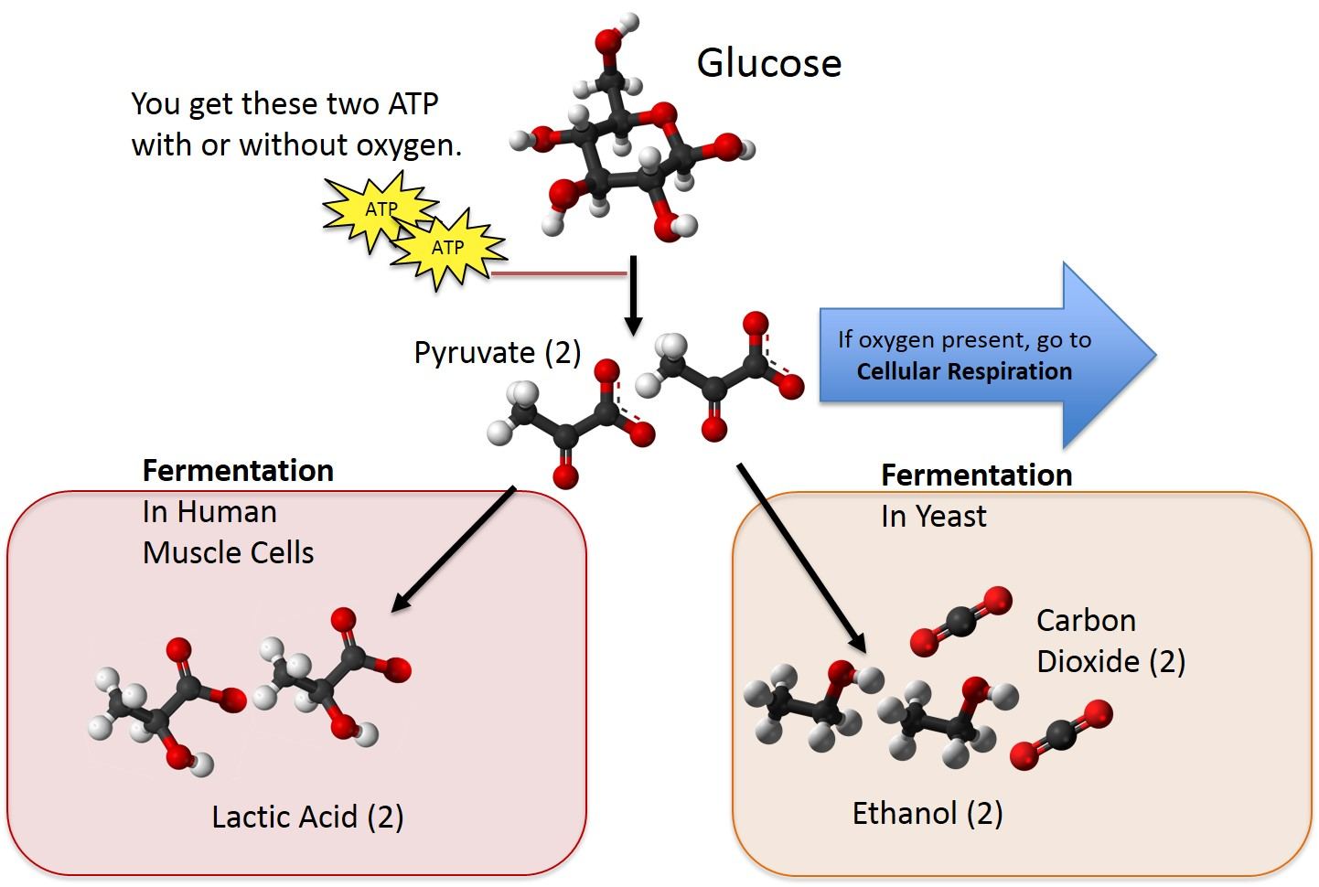
If you’ve got oxygen around and can use it, you should! This arrow leads you to an additional 34 ATP from this glucose!
Image courtesy MBER-bio

