Biology 1 Name:
Classical Genetics Test Review Date:
Practice Hour:
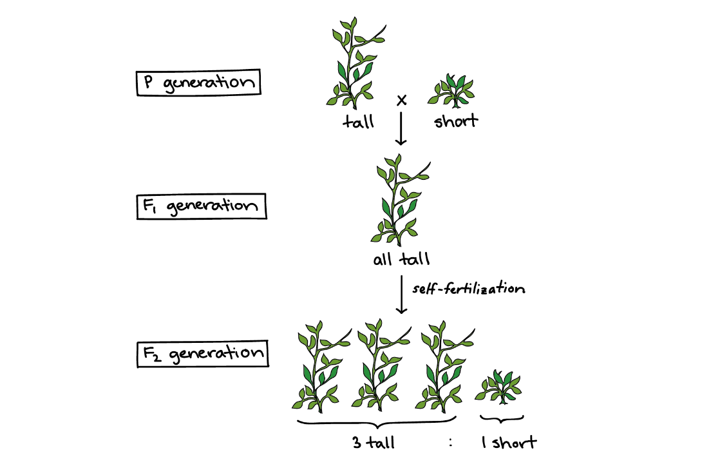

Mendel:
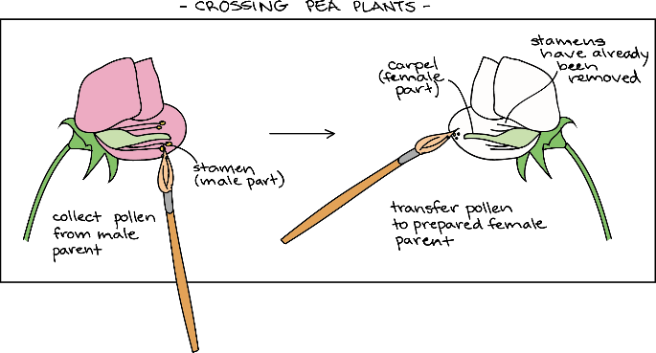

Monohybrid Crosses:

Yellow seeds are dominant to green seeds in peas. Show a cross between a homozygous yellow seed with a green seed. Identify the genotypic and phenotypic ratios.

As in the previous problem… The offspring have self-fertilized. Show this in a Punnett square. Identify the genotypic and phenotypic ratios.

Dihybrid Crosses:

Purebred wingless red-eyed fruit fly is crossed with a purebred winged white-eyed fruit fly. What is the genotype of the offspring? (Hint: They should all be the same so don’t do an entire dihybrid cross to answer this)

Two of the F1 flies (answer from above) are mated to produce an F2 generation of flies. What is the phenotypic ratio of the F2 flies? You can do the cross below. Be sure to list the phenotypes after you’ve completed the cross:

Phenotypes:

Exceptions:

The Set-up:
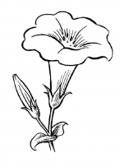
A snapdragon plant with red flowers is homozygous dominant (RR). A snapdragon plant with white flowers is homozygous recessive (rr). Heterozygous snapdragons (Rr) produce pink flowers.

A red plant is crossed with a white plant.

What color will the offspring be?

The Set-up:
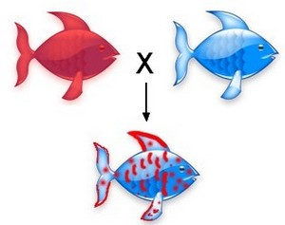
In a certain fish, blue scales (B) and red (R) scales. Homozygous fish have either red or blue scales only. When a fish has a heterozygous genotype, it has a patchwork of blue and red scales.
B R = patchwork fish
B B = blue fish
R R = red fish

Cross a red fish with a blue fish.

What is the likelihood of blue offspring?

The Set-up:
In humans, blood type A (I^{A}) and blood type B (I^{B}) are both dominant. This means that an individual that receives alleles for both type A and type B blood (I^{A} I^{B}) will have blood type AB. Individuals with type O blood are homozygous recessive (ii).

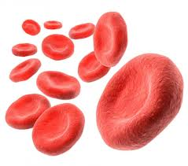
A heterozygous type AB male is crossed with a type O female.

What blood type will the offspring have?

A type O male is crossed with a heterozygous type A female.

What blood type will the offspring have?

The Set-up:
In humans, the trait for normal color vision is located on the X-chromosome (X^{N}). A mutated copy of this gene (X^{n}) leads to condition called color-blindness. This is characterized by an inability to perceive differences in colors. The Y-chromosome does not contain this gene. Therefore, females get two copies of the gene and can have normal vision, but carry the mutated gene (X^{N}X^{n}) have no copies of the mutated gene (X^{N}X^{N}) or be color blind (X^{n}X^{n}). Males are either normal (X^{N}Y⁻) or colorblind (X^{n}Y⁻).

Cross a normal male with a female carrier.

What is the probability of a male offspring being colorblind?

What is the probability of a female offspring being is colorblind?

Pedigrees:

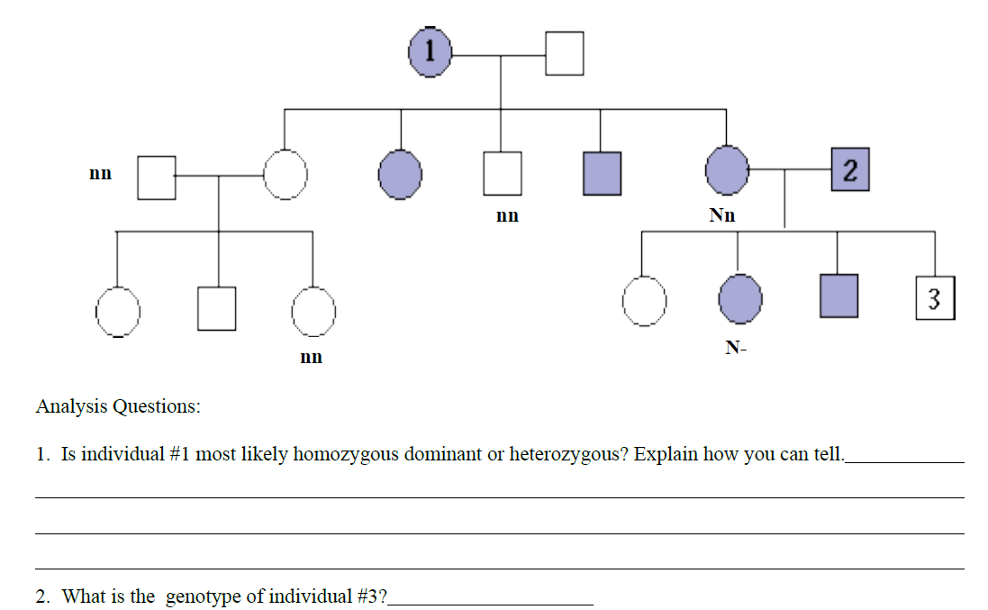

Is the trait most likely autosomal dominant or autosomal recessive? If recessive, shade carriers.

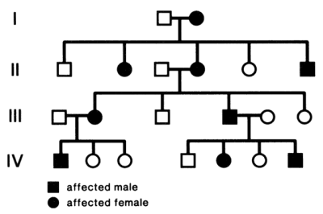
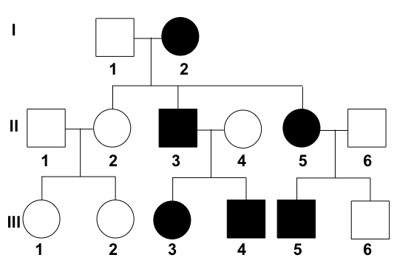

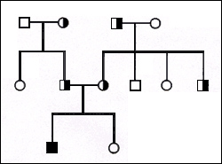
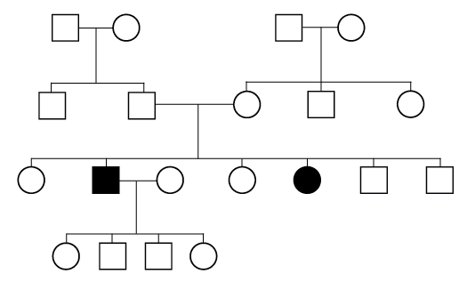

How are these sex-linked recessive (X-chromosome) pedigrees different than the pedigrees above?
