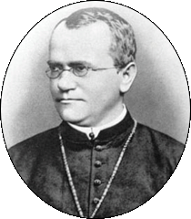***Biology 1***

***Classical Genetics –Notes***

***Background:***

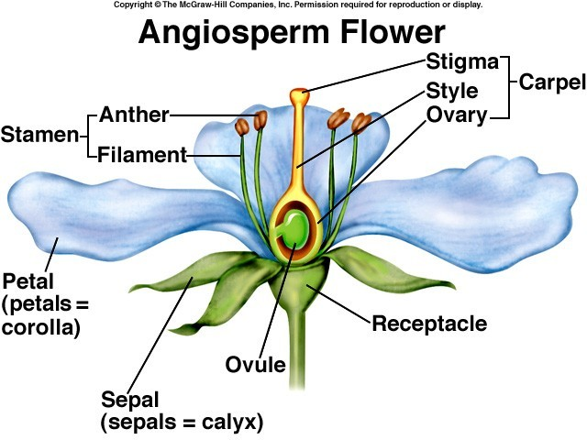

Self Pollination

Cross Pollination

True Breeding Plants

***The experiment (what was done): The results (what was observed):***

P (__________) generation:

F1(__________) generation:

F2(__________) generation: (see chart on next page for F2 results)

***F2 Results***

|  |  |  |  |
| --- | --- | --- | --- |
| *Characteristic* | *Dominant Trait* | *Recessive Trait* | *Ratio* |
| seed shape |  |  |  |
| pod shape |  |  |  |
| flower color |  |  |  |
| seed color |  |  |  |
| pod color |  |  |  |
| stem length |  |  |  |

Definitions to know:

Law of Segregation:

Law of Independent Assortment:

Gene:

Allele:

Genotype:

Homozygous:

Heterozygous:

Phenotype:

***The Punnett Square:***

***Examples:***

***Dihybrid Crosses –***

***Round peas are dominant, wrinkled peas are recessive (R)***

***Yellow peas are dominant, green peas are recessive (Y)***

***Cross two pea plants that are heterozygous for ROUND and YELLOW.***

Parent Genotypes: ________________ X ________________

Possible Gametes:

|  |  |  |  |
| --- | --- | --- | --- |
|  |  |  |  |
|  |  |  |  |
|  |  |  |  |
|  |  |  |  |

**Offspring Genotypes: Offspring Phenotypes:**

***RRYY - Round, Yellow -***

***RRYy -***

***RRyy - Round, Green -***

***RrYY -***

***RrYy – Wrinkled, Yellow -***

***Rryy –***

***rrYY - Wrinkled, Green -***

***rrYy -***

***rryy -***