CHEMISTRY REVIEW SHEET SECOND SEMESTER
Chemistry
Utica Community Schools – Semester Two Review
Directions:
- You will be given a periodic table with polyatomic ions and any formulas you may need.
- If you complete the entire review sheet by the day of your exam you will be eligible for the curve should one be applied.
- The answers to this review must be on a separate sheet of lined paper. To the best of our ability we have tried to provide a chapter that can be reviewed to help with that content.

Chapter 3: Airbags
- Know how to perform mole conversions using moles, grams, and representative particles.
  - What is a representative particle? What is the name of the representative particle for the ionic compound? The covalent compound? An element?
  - How many representative particles are in a 53.79 gram sample of SrCO₃?
  - How many moles of AlF₃ are in a 10.0 gram sample of AlF₃?
  - How many grams of SO₂ are in a 0.65 mole sample of SO₂?
  - How many moles of copper atoms in 75 g of Cu?
  - In a sample with 17.0 grams of water, how many molecules of water are present?
Chapter 5: Soap
- For each example below, predict if the bonding will be ionic or covalent.
    - Ca with Cl
    - C with H
    - Carbon monoxide
    - KBr
    - SO₂
    - Magnesium iodide
- Draw Lewis dot structures for these simple compounds listed below.
    - Br₂
    - Cl₂
    - O₂
    - N₂
    - CH₄
    - NH₃
    - H₂O
    - HF
    - C₂H₅OH
- For every molecule below, state whether the molecule is polar (has a dipole) or nonpolar. Look for symmetry – a sign of being NONPOLAR! A lone pair on the central atom generally leads to polarity or having a dipole. You will need the Lewis dot structures from question 3 to do this problem.
    - Cl₂
    - O₂
    - CH₄
    - NH₃
    - H₂O
    - HF
    - C₂H₅OH

Chapter 5: Soap (Continued)
- Use your answers from number 4 to explain why oxygen is gas but water is a liquid at room temperature.
- Is this statement True or False? We can represent the same molecule with different models. The benefit of different models is that they show different properties.
- Which state of matter has the strongest intermolecular forces of attraction? Which state has the weakest? Why is water a liquid at room temperature but carbon dioxide is a gas?
- Explain why fluorine and chlorine are gases but bromine is a liquid and iodine is a solid.
- What three elements can hydrogen bond with to create the IMF of Hydrogen Bonding BETWEEN molecules?
- What type of intermolecular force(s) is being shown in this diagram?
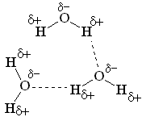
- The following questions all pertain to intermolecular forces. Please answer each question.
  - What is a London Dispersion force?
  - What is a Dipole-Dipole Attraction?
  - What is Hydrogen Bonding?
  - Rank the three intermolecular forces from weakest to strongest.
  - What types of intermolecular forces are present on each of the following molecules: You will need the Lewis Dot Drawings and Polarity information from questions 3 and 4.
    - Cl₂
    - O₂
    - CH₄
    - NH₃
    - H₂O
    - HF

- What type of compounds (IONIC OR COVALENT) are sugar (C₆H₁₂O₆), ammonia (NH₃), water (H₂O) and butane (C₄H₁₀)? Why is sugar a solid at room temperature yet ammonia is a gas? Why does water boil at a higher temperature than butane?
- Calculate the molar mass of water. Calculate the molar mass of C₂H₅OH. Water boils at a temperuture about 25 degrees higher than C₂H₅OH. Explain why using IMF’s as an answer!
- What happens to the strength of the intermolecular forces as water is freezing? As water is melting?
- True or False: Solids have greater intermolecular forces than liquids and gases.
- True or False: As you go down the halogen family, intermolecular forces increase.
- Fill in the blank: The higher the intermolecular forces the ____________________ the melting point and the ____________________the boiling point.
- True or False: The IMF with the highest boiling points is hydrogen bonding.
- Arrange the following from lowest melting point to highest melting point: A nonpolar covalent, an ionic compound, a polar covalent compound with hydrogen bonding capability, a polar covalent compound with dipole-dipole attractions.

Chapter 5: Soap (Continued)
- The molecular formula and boiling points of hydrocarbons are given in the table below.
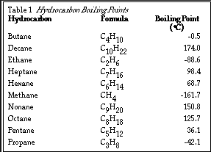
Based on the information in the table, what is the trend in the boiling point as the number of carbons increase? Based on IMFs, why is this so?

- Rank these three molecules from highest boiling point to lowest: HCl, CH₄, H₂O. Why did you choose this order?

Chapter 6: Sports Drinks
- Use the following balanced equation to answer the following problems:
C₅H₁₂ + 8O₂ 5CO₂ + 6H₂O
i) When 2.5 moles of oxygen gas react completely with pentane, how many moles of
carbon dioxide are produced?
ii) How many grams of pentane gas are needed to completely react with 348.5 grams of
oxygen?
Chapter 7: Hot Packs
- When bonds are broken, does this release energy or require energy?
- When bonds are formed, does this release energy or require energy?
- Fill in the blanks. When bonds are broken, energy is _______________________. When bonds are formed, energy is __________________________.
- For the reaction given below, list the bonds that are broken. Make a list of the bonds being formed:
C₃H₈ + 5O₂ 4H₂O + 3CO₂

- List single, double, and triple bonds in order of increasing strength. In order of increasing length. Describe the bond between N₂ using these characteristics.
- Label the following phase changes as exothermic or endothermic.
    - Water is boiling, energy is gained by the system. ΔH is positive
    - Water is condensing, energy is lost to the surroundings. ΔH is negative
    - Water is freezing, energy is lost to the surroundings. ΔH is negative.

- Are these reactions exothermic or endothermic?
    - 2H₂ + O₂ → 2H₂O +483.6 kJ
    - N₂ + 2O₂ + 34kJ 2NO₂
    - Heat + H₂O₂ H₂O + O₂
    - S + O₂ SO₂ + Heat
Chapter 7: Hot Packs (Continued)
- Is the diagram shown below exothermic or endothermic? For an exothermic reaction are the reactants higher or lower than the products? What would happen to the temperature of this reaction mixture?
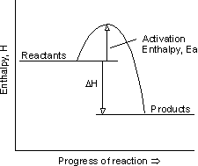

- Is the diagram shown below endothermic or exothermic? Would the ΔH be positive or negative? In an endothermic reaction are the reactants higher or lower than the products.
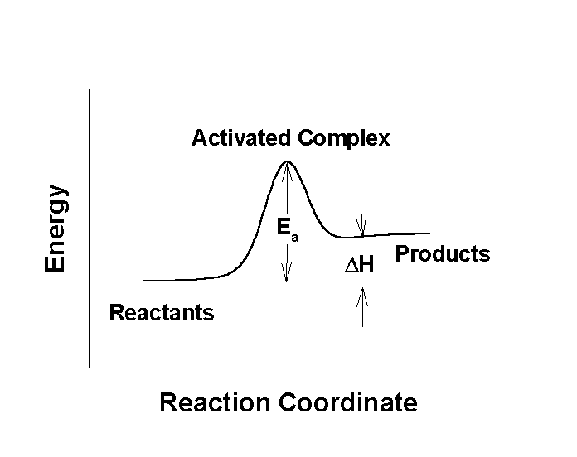
- Explain why freezing is an exothermic change of state.
- Define Specific Heat
- Which would require more energy to increase by 1°C? 20 grams of water or 20 grams of aluminum? Note that water’s specific heat is 4.184 J/g°C and aluminum is 0.900 J/g°C.

Chapter 7: Hot Packs (Continued)
- Study the diagram below. Answer the questions that follow:

Potential Energy Diagram in the formation of a Hydrogen Molecule
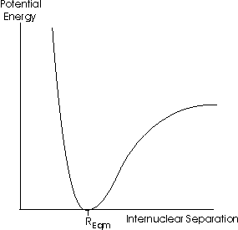
Point R, the lowest point on this diagram, represents the distance at which a bond has reached its lowest potential energy and hence represents the distance at which the bond will form. At R, the bond is formed but notice that to the left and right of the R, the potential energy rises. This means that as bonds are pulled apart, the potential energy rises. As the bond is pushed to close together, the potential rises.
    - Where is the bond most stable? Before R, at R or after R?
    - What happens to potential energy as we move away from point R
    - When atoms bond, they achieve a lower, more stable energy – True or False?
    - As atoms are pulled apart from bonding, their potential energy increases. True or False?
- Answer the questions below about the following temperature versus time graph of water.
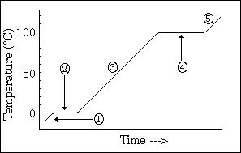

    - What state(s) of matter are shown at all numbered regions on this graph?
    - Identify all regions on the graph where average kinetic energy is increasing.
    - Identify all regions on the graph where only potential energy is increasing.
    - During phase 2, as energy is being added, what is happening to the substance? Why is this process endothermic?
    - When ice melts, the kinetic energy of the water molecules must break what types of forces?
    - What instrument could you use to make the measurements on this curve?
- Use the heat of the reaction (or Thermostoich) to answer the question below:
    - How much heat will be released if 25.0 grams of hydrogen react with nitrogen in the following balanced equation: N₂ + 3H₂ 2NH₃ ΔH = -91.8 kJ
- What is the direction of heat flow? From hot to cold or cold to hot?
- What is the Law of Conservation of Energy? How does it apply to a calorimeter?
- What is true of the energy changes between the system and the surrounding within a closed system such as the one shown below?
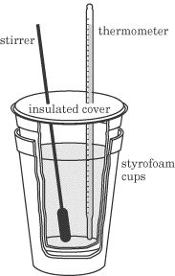

Chapter 8: Chemistry in Industry or Equilibrium
- Use LeChatlier’s Principle to answer the following set of questions:
- What is the effect of adding more hydrogen gas to the following equilibrium reaction? Which way will the reaction favor and will more ammonia be produced or less?
2NO_{(g)} + O_{2(g)} ↔ 2NO_{2(g)} + heat
- For the reaction shown above, what would happen to the concentration of reactants if pressure were increased on the system?
- If the NO₂ is increased, how will the equilibrium be affected? What will happen to the concentration of the oxygen gas?
- If more heat is added by raising the temperature, which way will the reaction shift?

- Research the causes of acid rain. What compounds are responsible for acid rain? Where do they primarily come from?
Chapter 9: Forensic Chemistry
- Define Percent by Mass, Empirical Formula and Molecular Formula
- What is the percent by mass of each element in NH₃?
- What is the percent by mass of Ca in Ca₃P₂?
- The empirical formula for benzene is CH. If the molecular weight of benzene is approximately 78.0g/mol, what is the molecular formula?
- What is the empirical formula of a compound that is 18.8% sodium, 29.0% chlorine and 52.2% oxygen?
Chapter 10: Batteries
- Write the chemical formula for lithium bromide. What is the oxidation state of bromine in this compound?
- Write the chemical formula for strontium sulfide. What is the oxidation state of strontium in this compound?
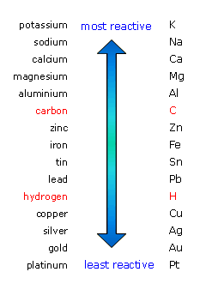
- Know how to predict the products of single replacement reactions. You may use the activity series to the left to answer these questions. Don’t forget to balance!!
  - Na + Cu₃(PO₄)₂ → _________________________________
  - Li + Al(NO₃)₃ → _________________________________
  - Mg + Fe₂O₃ → ___________________________________
- Define anode and cathode for an electrochemical cell. At which electrode does reduction occur in an electrochemical cell?
- Label each reaction below as either being oxidation or reduction:
    - Cu → Cu⁺² + 2e⁻
    - Zn⁺² + 2e⁻ → Zn

Inquiry, Reflection and Social Implications Priority Standards

The following questions reflect standards that are not necessarily chemistry but rather emphasize the broader scope of scientific study

- A student wants to find out how much energy is released when NaOH solid is dissolved in water. The student put 50 g of water into two cups and he measures the temperature of each water sample. The student then adds 10 grams of NaOH to the second cup and immediately stirs as the temperature change is observed. What is the control in this experiment? What should the student hold constant during the experiment?
- True or False: An unknown liquid boils at 100°C and melts at 0°C. The substance is water.
- Which of the following are true for salts:
  - Most dissolve in water
  - They are solid at room temperature
  - They conduct electricity when dissolved
  - They have high melting points
  - They are ionic compounds
- What is the effect on the global community of burning high sulfur coal?
- When pharmaceutical companies want to know the side effects of a new drug they will give the drug to one set of people and then give a placebo to another set of people. What is a placebo? Why would we need to use placebos in an experiment? What is their function?

