Biology 1
Chemical Reactions
Supplemental Notes

Chemical Reactions: The Components

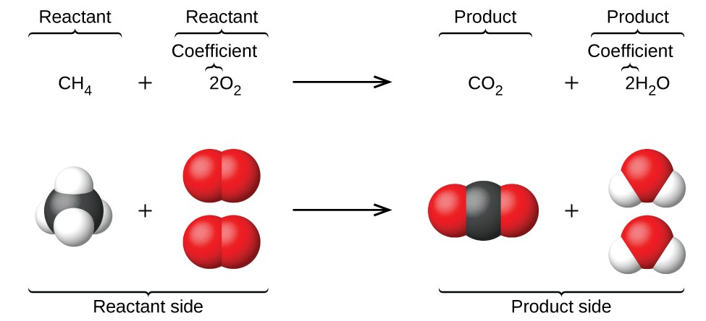

Chemical Reactions: The Energy

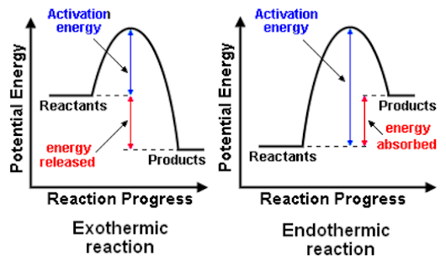

Biology 1
Chemical Reactions
Supplemental Notes

Chemical Reactions: The Components

Chemical Reactions: Molecules Have Energy

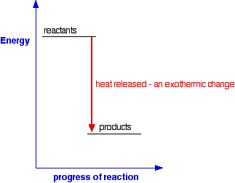
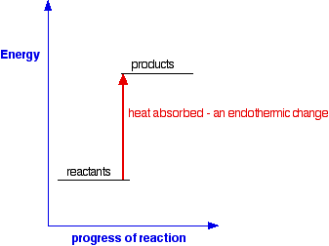

Chemical Reactions: The Energy

