Biology 1 Name:
Cell Reproduction – Chapter 8 Date:
TEST Hour:
Study Guide

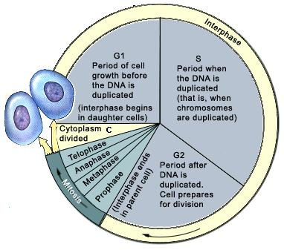
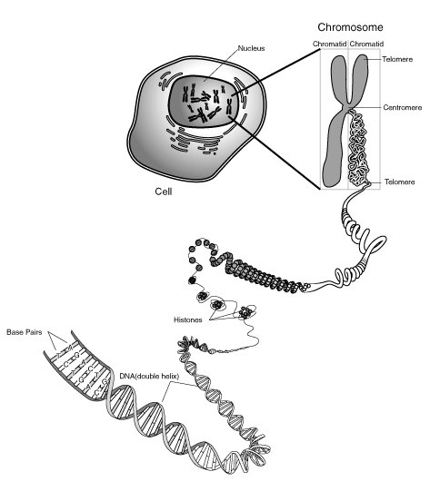
The test will cover cellular reproduction. Be familiar with the following terms and diagrams.
Chromosome
Cell
Histones
Nucleus
Chromatids
Centromere
Telomere
Telomere
Chromatin

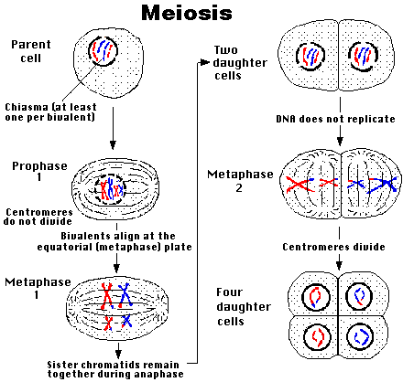

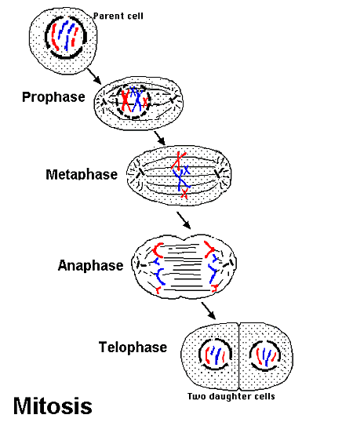

MEIOSIS 2
Chromosomes

MEIOSIS 1

Homologous Chromosomes

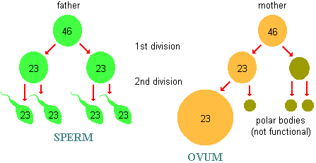

- Asexual Reproduction
- Sexual Reproduction
- Haploid
- Diploid
- Karyotype
- Autosome
- Sex Chromosomes
- n
- 2n
- Cancer
- Cell Plate

- Somatic Cells
- Gametes
- Homologous Chromosomes
- Sister Chromatids
- Tetrad
- Crossing Over
- Meiosis 1 & 2
- Spermatogenesis
- Oogenesis
- Polar Bodies

