Biology 1 Name:
Cells Practice Test Date:
Hour:

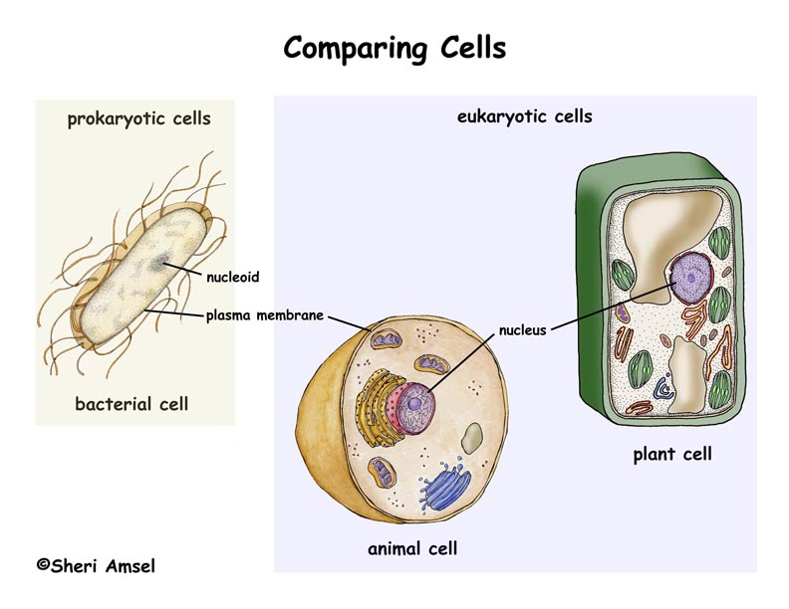

What are the three parts of the cell theory?
1.
2.
3.

Organelle | Function (in 6 words or less)
Cell Wall

Cell Membrane

Nucleus

Ribosome

Golgi Complex

Endoplasmic Reticulum
Mitochondria

Vesicles

Chloroplasts

Large/Contractile Vacuole
Organelle | Present In Prokaryote? | Present In Eukaryote?
 |  | Present in Plant Cell | Present in Animal Cell
Cell Wall

Cell Membrane
Nucleus

Ribosome

Golgi Complex
Endoplasmic Reticulum
Mitochondria

Vesicles

Chloroplasts

Large/Contractile Vacuole
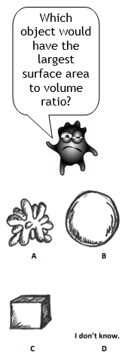
Check the appropriate boxes below:

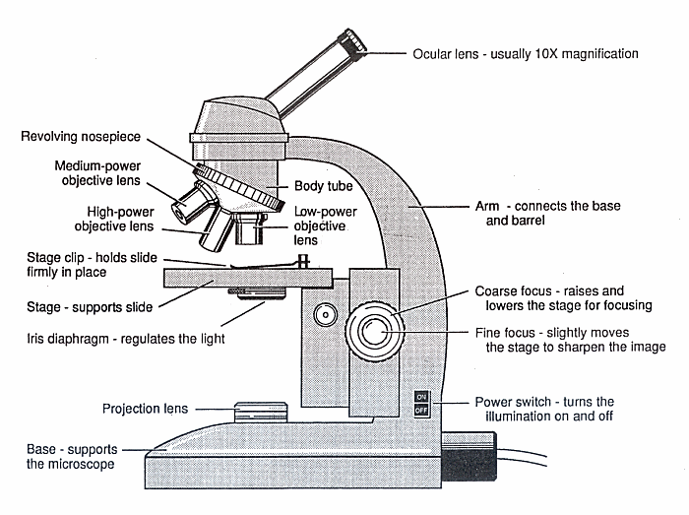
2
1
A

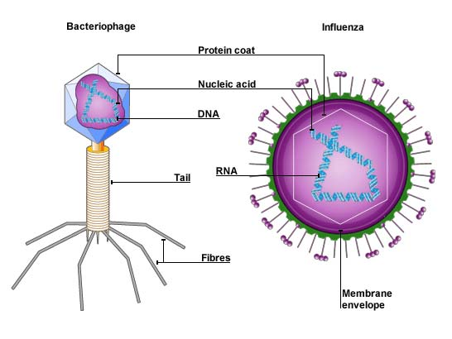

B
3
G

C
F

E

Part of Virus | Number on Diagram  What are antibiotics?  Describe the origins of eukaryote organelles.
Nucleic Acid Core
Protein Capsid
Envelope
D

Part of Microscope
A
B
C
D
E
F
G

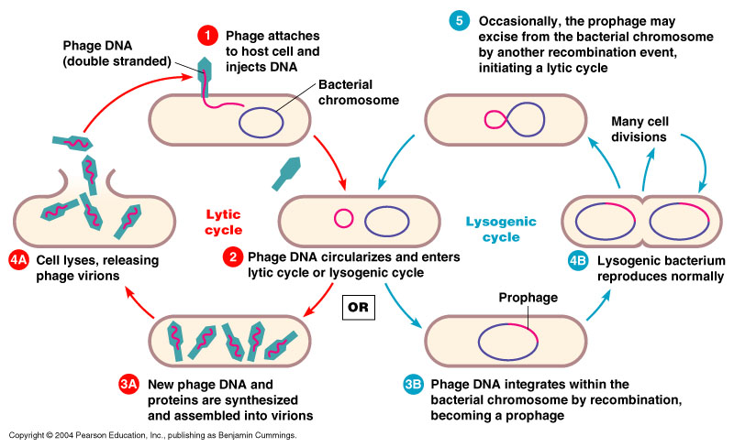
Fill in the blanks

Who are we?
…and what did we do?

