Biology 1 Name:
Growth & Development Date:
Cell Cycle Quiz Hour:
Study Guide

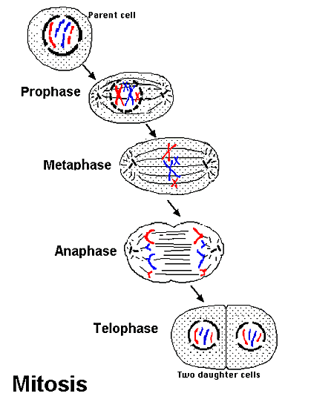
This quiz will cover the cell cycle and mitosis. Here are some diagrams to help you review. You must know what happens in each part of the cell cycle and be able to recognize cells in each phase.

Biology 1 Name:
Cell Reproduction – Chapter 8 Date:
Cell Cycle Quiz Hour:
Study Guide

This quiz will cover the cell cycle and mitosis. Here are some diagrams to help you review. You must know what happens in each part of the cell cycle and be able to recognize cells in each phase.

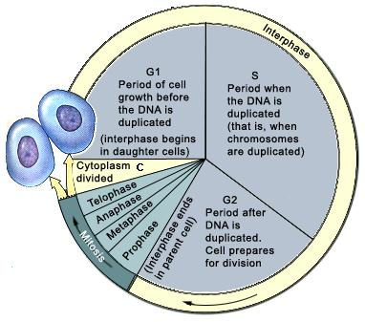
GØ
GØ

