BUILD AN ATOM – Google phet Build an Atom

**PART I: ATOM SCREEN**

*Build an Atom simulation* (<http://phet.colorado.edu/en/simulation/build-an-atom>)

1. Download the simulation. Select atom. Explore the ***Build an Atom*** simulation with your group. As you explore, talk about what you find. (Make sure you have the “Net Charge” and “Mass Number” boxes opened (ie. Changed + to -.)) Select the to start over.
   1. List two things your group observed in the simulation.

i.

ii.

* 1. What particle(s) are found in the center of the atom and what is their charge(s)?
  2. What particle(s) are found outside the center of the atom and what is their charge(s)?

1. Play until you discover which **particle(s)** determine(s) the name of the **element** you build. What did you discover?
2. What is the **element symbol** of the following atoms?
3. An atom with 3 protons and 4 neutrons: _____________
4. An atom with 2 protons and 4 neutrons: _____________
5. An atom with 4 protons and 4 neutrons: _____________
6. Play with the simulation to discover which particles affect the **charge** of an atom. An atom with a charge is called an **ion** (it can be either positive or negative!). You can see the charge of the atom in the upper right hand corner of the model.
7. Fill in the blanks below to show your results:

Neutral atoms have the same number of protons and electrons.

Positive ions have ________________________________ protons than electrons.

Negative ions have _______________________________ protons than electrons.

1. Develop a relationship (in the form of a single sentence or equation) that can predict the charge of an atom based on the number and types of particle.
2. Reset the simulation and play with the model to discover what affects the **mass** number of your atom or ion. Don’t forget to expand the net charge and mass number boxes again.
3. What is a rule for determining the mass number of an atom or ion?
4. Select Game at the bottom of your screen

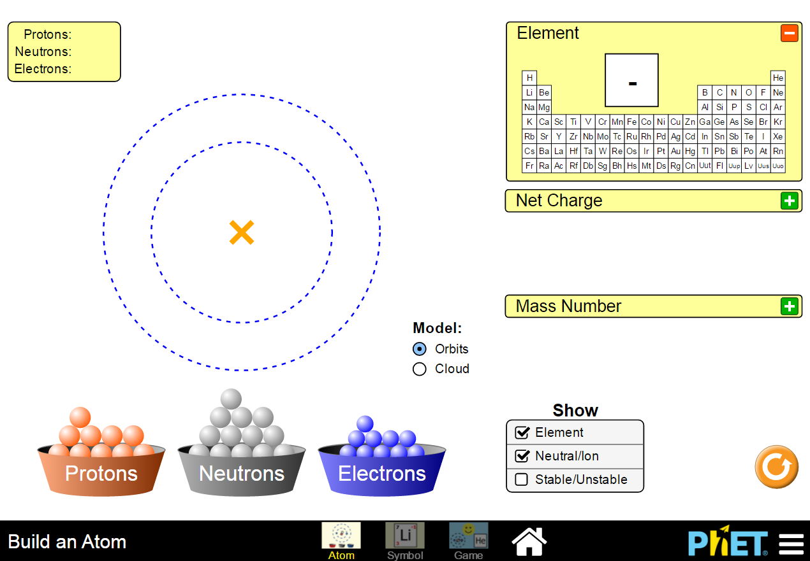

First play the game on the left. Make sure a different person plays each game. Every team member should play **at least** one game and record their score.

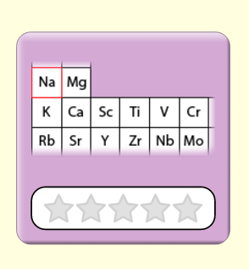 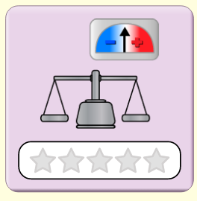

Name _______________________ Score __________ Name _______________________ Score __________

Name _______________________ Score __________ Name _______________________ Score __________

PART II: Symbol SCREEN

1. Click on the ***Symbol*** readout box (located to the left of the game box), figure out **which particles** affect each component of the atomic symbol. Do this by adding and removing particles until you have come up with a conclusion.
2. In the atomic symbol below, label each letter (*a*, *b*, *c*, and *d*) with:

* the **particle(s)** used to determine the letter, and
* **how** the value of each letter is determined (which you will answer in question 9)

a= _____________________ b= _____________________

c = _____________________ d =_____________________

1. Create a definition or mathematical expression for each of these items based on your labels from the atomic symbol above.
2. Element Symbol

ii) Charge

iii)Atomic Number

iv)Mass Number

1. Practice applying your understanding by playing the 3rd and 4th game levels. Play until you can get all the questions correct on the 4th level.

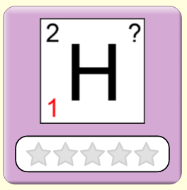 

Name _____________________ # attempts to score 100% _____________ Game 3

Name _____________________ # attempts to score 100% _____________ Game 3

Name _____________________ # attempts to score 100% _____________ Game 4

Name _____________________ # attempts to score 100% _____________ Game 4

1. In addition to atomic symbol, we can represent atoms by name and mass number.
2. Complete the table below:

|  |  |
| --- | --- |
| Symbol | Name |
|  | Carbon-12 ion |
|  |  |
|  |  |

1. Each representation (Symbol and Name) in the table above provides information about the atom. Describe the similarities and differences between the ***Symbol* and *Name*** representations.

PART III: ISOTOPES

1. Play with the simulation to determine (make sure all boxes are clicked):
   1. Which particles affect the stability of the atom? _____________________
   2. Which particles do not affect the stability of the atom? _______________
2. What are the names of the stable forms of oxygen?
3. Oxygen-16
4. Oxygen-____
5. Oxygen-____
6. List all of the things that are the same about these atoms (ignore the electrons).
7. List all of the things that are different about these atoms (ignore the electrons).
8. The atoms in the previous question are **isotopes** of each other. Based on this information, list the requirements for two atoms to be isotopes of each other.

1. Test your understanding of isotopes by examining the relationships between the pairs of atoms listed below:

|  |  |  |
| --- | --- | --- |
| Atom 1 | Atom 2 | Relationship between atom 1 and atom 2 |
|  |  | Isotopes  Same Atom, Not Isotopes of Each Other  Different Element |
| Carbon-12 |  | Isotopes  Same Atom, Not Isotopes of Each Other  Different Element |
| Argon-40 | Argon-41 | Isotopes  Same Atom, Not Isotopes of Each Other  Different Element |
|  | Boron-10 | Isotopes  Same Atom, Not Isotopes of Each Other  Different Element |
| An atom with 13 protons and 13 neutrons | An atom with 14 protons and 13 neutrons | Isotopes  Same Atom, Not Isotopes of Each Other  Different Element |

EXERCISES

1. The periodic table has a great deal of information about every atom. Using your periodic table, answer the following questions:
2. What is the atomic number of chlorine (Cl)? _____
3. What is the atomic number of tungsten (W)? _____
4. How many protons are there in any Cl atom?_____
5. How many protons are there in any Te atom? _____
6. ­Can you tell from the periodic table **exactly** how many neutrons are in an atom? _________
7. Complete the following table:

|  |  |  |  |  |  |  |
| --- | --- | --- | --- | --- | --- | --- |
| Name | Symbol | Atomic number | Mass Number | Number of neutrons | Number of Electrons | Charge |
| hydrogen-2 | 2H | 1 | 2 | 1 | 1 | 0 |
|  | 3H |  |  |  |  |  |
| sodium-22 | 22Na+ |  |  |  | 10 |  |
|  |  | 12 | 24 |  | 12 |  |
|  |  | 12 | 25 |  | 13 |  |
|  | 46Ti-2 |  |  |  |  |  |
|  | 107Ag |  |  |  |  |  |
|  | 19F-1 |  |  |  |  |  |
| carbon-12 |  |  |  |  | 6 |  |
| carbon-13 |  |  |  |  | 6 |  |
| carbon-14 |  |  |  |  | 6 |  |
| carbon-12 |  |  |  |  | 7 |  |
| carbon-12 |  |  |  |  | 5 |  |
|  | 4He |  |  |  |  |  |
|  |  | 8 |  | 8 | 10 |  |
| argon-40 |  | 18 |  |  | 18 |  |
|  | 70Ga |  |  |  |  |  |
|  | 70Ga+3 |  |  |  |  |  |
|  |  | 4 | 9 |  | 2 |  |
|  |  | 7 |  | 8 | 8 |  |

1. To test your knowledge of isotopes, draw arrows between all pairs of atoms in the table above that are isotopes of each other.