Name____________________________________________________Date_______________ Hr _________

An INTRODUCTION to ACIDS and BASES: Lab Investigation

QUESTION: How do you distinguish an acid from a base using metals, carbonates and indicators?

SAFETY: WEAR GOGGLES! Acids and bases can cause severe eye damage and they can burn the skin. Washing your hands after contacting the solutions is suggested.

Procedure:

- Read the labels on all of your samples before you begin.
- Take the first solution to be tested and put 3 drops of it into each of the wells of the first row of your spot plate.
- Test the first solution with all of the indicators and solids at your bench. You may not have all of the indictors listed so please test with those that you have. Record your observations in the data table below labeled Table 1 – Indicator Results
- Repeat steps 1-3 for all the solutions at your bench.

Table 1 – Indicator and Other Test Results
Solution to be Tested | Bromthymol Blue  Test Result Color | Methyl Red Test Result Color | pH Paper Test Color | Red Litmus Paper Result | Blue Litmus Paper Result | Did it react with the metal, Mg? | Did it react with the NaHCO₃?
HCl
H₂SO₄
Vinegar
NaOH
KOH
Windex
Unknown

Colors associated with the pH Values
Indicators Used in this Lab | 1 | 2 | 3 | 4 | 5 | 6 | 7 | 8 | 9 | 10 | 11 | 12 | 13 | 14
Bromthymol Blue | Y | Y | Y | Y | Y | Y | G | B | B | B | B | B | B | B
Methyl Red | R | R | R | P | P | Y | Y | Y | Y | Y | Y | Y | Y | Y
Phenol Red | Y | Y | Y | Y | Y | P | P | R | R | R | R | R | R | R
pH paper | R | R | R | O | O | O | Y/G | G | G | G | B | B | Pu | Pu
Pink Litmus Paper | P | P | P | P | P | P |  | B | B | B | B | B | B | B
Blue Litmus Paper | P | P | P | P | P | P |  | B | B | B | B | B | B | B
Y = Yellow; O = Orange; Pu = Purple; B = Blue; G = Green; R = Red; P = Pink;
Questions:
- In Table 1 you tested your solutions against indicators. What did these results tell you about the pH of the HCl, H₂SO₄, and Vinegar solutions? Please indicate a range.

- Make a claim and state your evidence for what type of compound (acid or base) you would classify HCl, H₂SO₄, and vinegar as being. You must provide at least 2 separate pieces of evidence for your claim.

- Research the active ingredient in vinegar. What is the chemical formula for this compound? How would knowing this chemical formula have helped you predict that it is an acid without having to test it with an indicator?

- What did these results tell you about the pH of the NaOH, KOH, and Windex solutions? Please indicate a range.

- Make a claim and state your evidence for what type of compound you would classify NaOH, KOH and Windex as being. You must provide at least 2 separate pieces of evidence for your claim.

- Research the active ingredient in Windex. What is the chemical formula for this compound? How would knowing this chemical formula have helped you predict that it is a base without having to test it with an indicator?

- List any compound you tested in table 1 that reacted with the metal, Mg. What do these three compounds all have in common?

- List any compound you tested in table 1 that reacted with NaHCO₃. What do these three compounds all have in common?

- Identify your Unknown as an acid or a base. State three pieces of evidence to substantiate your claim.

- Complete the two lists below based on your observations from this lab. Include at least three different characteristics for both acids and bases:

Characteristics of Acids Characteristics of Bases

Extension Questions:
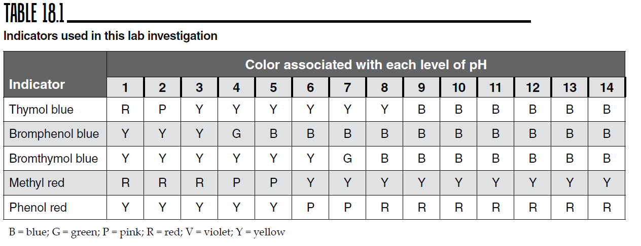

- Mrs. Swanson was testing her daughter’s hand soap to determine its acidity. When she tested it with Thymol blue it turned yellow. What can Mrs. Swanson conclude about the pH range of the hand soap? State the range using Table 18.1. Based on this range can you state clearly that the soap solution is acidic, basic or neutral? Why or Why not?

- Mrs. Swanson used a second indicator, phenol red, with the soap. This time the solution turned pink. Does this change the pH range? If so, what is the estimated range of the pH now? Can you clearly classify the soap as an acid or base? Why or why not?

- Develop one other test that would enable Mrs. Swanson to get almost an exact pH of the soap using the indicators in Table 18. State the indicator you would use and clearly state the evidence to support your claim. Make a final statement as to whether the soap is acidic, basic or neutral.

- Tums is a medicine used to reduce symptoms of upset stomach. Often an upset stomach is caused by excessive acid in the stomach.

  - Do you think TUMS© is an acid or a base?

  - What is a test you could run to verify your claim in part a.

  - Research the active ingredient in TUMS and explain how that ingredient works to cure your upset stomach. Show a chemical reaction to help explain the science.

- Chemists can measure pH 3 ways. With liquid indicators, pH paper and pH probes. What is a pH probe? Research why a pH probe is the most reliable method of pH detection.

