Making Sense of Chemical Reactions
Electrolysis: Splitting Water – PRE-LAB QUESTIONS

We know that somehow our bodies transform the matter in our food into other substances and that as a result we get the energy we need for life. As a first step toward understanding the complex processes happening when organisms get energy from food we will observe a much simpler example of matter transformation. We will closely observe the transformation of one kind of matter (water) into new substances and pay special attention to any energy changes involved.

Changing one type of matter into another is the definition of a chemical reaction. Scientists know that in chemical reactions two things always happen: 1) atoms in molecules are rearranged to form new substances and 2) energy is either used or given off. Chemical reactions obey two important scientific laws. One, the Law of Conservation of Matter states: matter cannot be created or destroyed. In other words, atoms are rearranged, but never created or destroyed. The second is the Law Conservation of Energy: energy cannot be created or destroyed. Energy may move around, or it may change forms but it never disappears. As we observe this reaction we will try to track what is happening with both the energy (Where did it come from? Where did it go?) and the matter (What is produced and how much of it?).

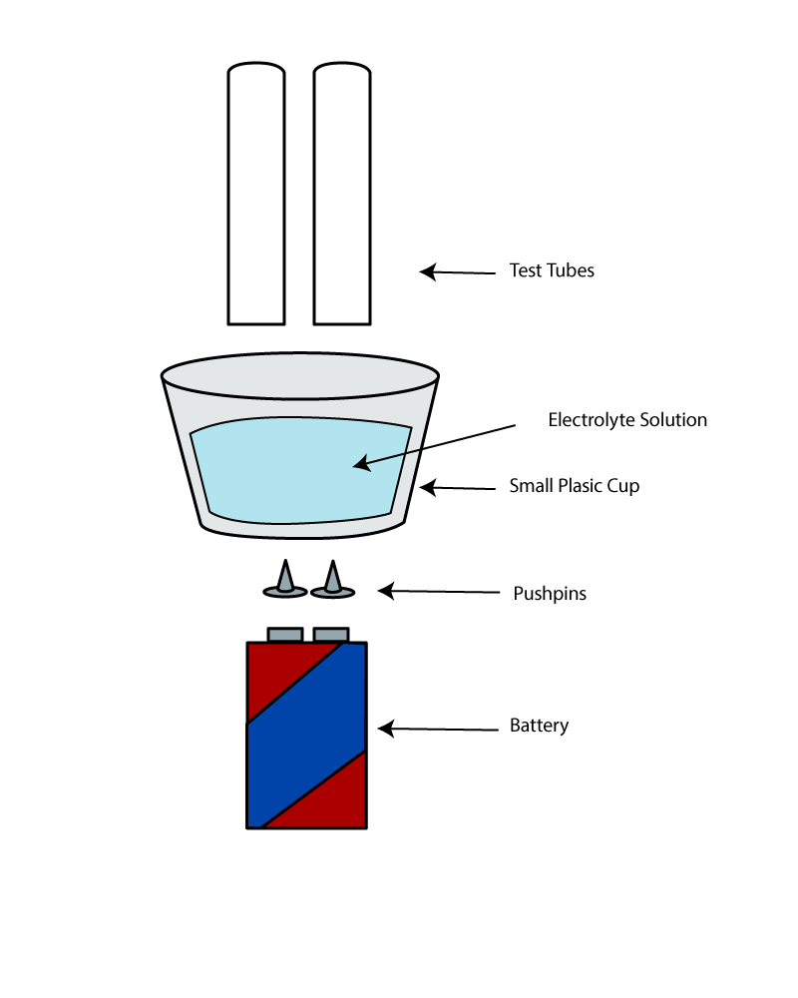
MATERIALS: Electrolysis apparatus (built by student - see Figure at right),
Water-Sodium Bicarbonate solution (100 parts water: 2 parts sodium bicarbonate)

PRELAB QUESTIONS
- Based on the figure, what type of energy is used in this set-up?

- What is the chemical formula for water?

  - If we break apart water molecules what elements will we get?

  - How many atoms of each element will we get for each molecule we break apart?

- What are some new substances that might possibly form using the elements in water molecules? (look ahead to Table 2 for help with this)

Making Sense of Chemical Reactions
Electrolysis: Splitting Water – LAB PROCEDURE / DATA

PROCEDURE:
- Build the electrolysis apparatus according to the diagram provided.
- You will record changes in volume and make detailed qualitative observations. Both are very important!
  - In making your observations pay special attention to what is happening with energy and with matter (particularly the nature and amount of new substances formed.)
- Once built and running, record the initial size (in mm) of the bubble trapped at the top of the top of the inverted test tube. To do this, simply use a ruler to measure the trapped air bubble’s vertical dimensions.
- After 2 minutes: Record the size of the air bubble trapped at the top of the inverted test tube (in mm).
- Repeat step 4 until you have 12 minutes of data.

Table 1.
TIME  (minutes) | Quantity of Gas (mm)
 | - ELECTRODE |  | + ELECTRODE
 | Reading (mm) | Change (mm) | Reading (mm) | Change (mm)
0
2
4
6
8
10
12
TOTAL CHANGE

Qualitative Observations During Electrolysis:

Data Analysis:
Create a multiple line graph (one line for the product formed at each electrode). Time should be on the X-axis. Graph “change” on the Y axis.

Key
-
Electrode
+
Electrode

Conclusions:

Was energy being consumed or released during this reaction? Where was the energy coming from or going to? Explain. Also, discuss the role of the battery in the reaction.

Table 2.
Reactants | Potential Products
4H₂O_{(l)} | 3H_{2 (g)} + O_{2 (g) +} H₂O_{2 (l)}
3H₂O_{(l)} | O_{3 (g)} + 3H_{2 (g)}
2H₂O_{(l)} | 2H_{2 (g)} + O_{2 (g)}
H₂ = Hydrogen, O₂ = Oxygen, O₃ = Ozone, H₂O₂ = Hydrogen Peroxide
(g) = gas, (l) = liquid, (s) = solid

Use Table 2. and the data that you collected (both qualitative and quantitative) to answer the following questions: What were the reactants in this chemical reaction? What were the products?

Watch the teacher perform tests on the two substances created and fill in the box below.
Qualitative Observations of substance created at cathode (+):

Qualitative Observations of substance created at anode (-):

Complete the following potential energy diagram. Complete the line for energy over time and fill in the boxes.

Summary of Reaction:
Reactants Products

Reactants
Energy
(Calories)
Reaction Progress/Time

REVERSE REACTION:
Watch the reverse reaction performed by the teacher. Record your observations below.
Qualitative Observations REVERSE REACTION:

Complete the following potential energy diagram for the REVERSE REACTION. Complete the line for energy over time and fill in the boxes.

Summary of REVERSE Reaction:
Reactants Products

Energy
(Calories)
Reaction Progress/Time
Reactants

