**Chemistry Notes: 2.6 Chemical Reactions**

What happens during a chemical reaction?



What is the purpose of a chemical equation?

Example of converting the word equation to formulas:

**Word equation:** magnesium metal is reacted with aqueous hydrochloric acid to produce aqueous magnesium chloride and hydrogen gas.

Formula Equation:

Visualization:

Picture6

Parts of a Chemical Equation:

s=

l=

g=

aq=

**NaCl (aq) + AgNO3 (aq) → AgCl(s) + NaNO3 (aq)**

Special Note about Diatomics!!!!

There are 7! They are:



Three ways to remember:

1)

2)

3)

**The Double Replacement Reaction:**

Defn:

General Format:

Let’s Practice!!! Write the word equation into the symbol form:

Aqueous solutions of Copper (II) nitrate and sodium hydroxide form solid copper (II) hydroxide and aqueous sodium nitrate

Example: Predict the products!! CaCl2 + AgNO3 🡪

Double Replacement NEUTRALIZATION:

General Format:

The products are always _______________________________ and _______________________________

Example: sulfuric acidand sodium hydroxide react to form...

Example: Sr(OH)2 + HBr 🡪

Example: H2SO4 + Ca(OH)2 🡪

**2.7 The Balanced Equation**

We balance equations because they must obey the Law of Conservation of Matter!

Law of Conservation of Matter –

*Also called Law of Conservation of Mass

It is critical that we have the same ___________________and _________________ of atoms on each side of the equation.

**2 H2 + O2 🡪 2 H2O**

The 2’s in **front** of H2 and H2O are called ________________________________. They tell you the number of compounds in the reaction. They _______________________________ the equation!

The 2’s used as **subscripts** on the H2, O2, and H2Oare called ___________________________. They represent the number of atoms in the compound. They _____________________________ within a compound.

How to balance by inspection (by looking ☺):

1. **Make a table of elements**
2. **Count the number of each element or ion on the reactants and products side**
3. **Add coefficients to balance the numbers**
4. **Assumed Ones are in front of anyone that didn’t get a coefficient!**

CH4 + O2 🡪 H2O + CO2

Reactants Products

C

H

O

Balancing Tips:

1. Balance atoms that appear only once on each side first
2. Balance polyatomic ions as one unit if they appear on both sides
3. Save elements that appear more than one time per side until last

More Equations to Balance:

_____ Pb + _____PbO2 +_____H+1  🡪 _____H2O + _____Pb+2

_____ H3PO4 + ______ Ca(OH)2 🡪 ______ Ca3(PO4)2  + _____HOH

_­­____ HCl + _____ Ca(OH)2 🡪 _____ CaCl2 + _____ H2O

_­­­____ H2 + ______ O2 🡪 _____ H2O

_____ Fe + ______ O2 🡪 ______ Fe2O3

**2.8 Speeding up a Reaction**

The Study of Rates in Chemistry is called _____________________________.

Reaction Rate:

Collision Theory states that a reaction can only occur if all of the following conditions are met:



What is Activation Energy?

Reaction Coordinate Diagram:

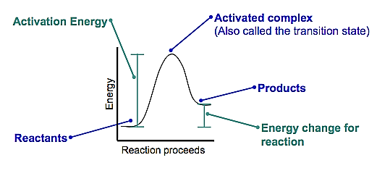

Factors Affection Reaction Rates:

1. Surface Area -
2. Reactant Concentrations –
3. Temperature-
4. Catalyst -