Name:
Biology 1 Name:
Considering Evolution & Classification Date:
Internet Activity Hour:

Follow the instructions below to build branching diagrams that show relationships between organisms. After you correctly complete each “tree” you will be asked to answer a question. Draw the completed “tree” in the appropriate place below. Record the question and answer or turn them into a single coherent statement in the appropriate space.

Go to: https://www.pbs.org/wgbh/nova/labs/lab/evolution/
Click on “Play Game” – Select “Guess Pass”
Click on “Training Trees”

Select “Red, Green & Gecko”
Use the space below to draw the cladogram that you built.
Note: This is the “teach you how this thing works trial” – after putting the Palm Tree and the Gecko on the diagram, you must click the magnifying glass and then read the information about one of the organisms to show that you are able to. In future problems, you can click on organisms and read a detailed description of their characteristics to help you classify them.
Cladogram Constructed:
Conclusion Question & Answer (or single statement):

Select “Familiar Faces”

Cladogram Constructed:
Conclusion Question & Answer (or single statement):

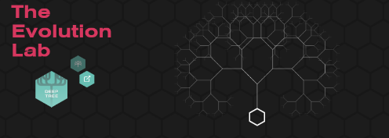

Select “Tree of Life: Vegetarian Edition”

Cladogram Constructed:
Conclusion Question & Answer (or single statement):

Click on “Fossils: Rocking the Earth”
Select “Eating Dinosaurs for Dinner”

Cladogram Constructed:
Conclusion Question & Answer (or single statement):

