Biology 1 Name:
Respiration Date:
As A Chemical Reaction Hour:
Shown below is the chemical equation for cellular respiration with symbols for the reactants and products of the reaction.
Label the following molecules in the diagram below:
Glucose, Carbon Dioxide, Oxygen Gas, Water
Color following molecules/atoms in the diagram below:
Oxygen Atoms (red) Carbon Atoms (green) Hydrogen Atoms (blue)
ATP Molecule (orange) Glucose Molecule (green, blue & red stripes)
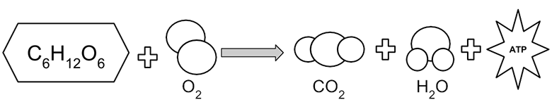

Instructions:
Reactant | Structure (# & types of atoms) | Source/Where it is found | Product | Structure (# & types of atoms) | Source/Where it is found
 |  |  | ATP | C - 10  H – 16  N – 5  O – 13  P - 3 | In cells
Using the diagram above, and your notes from class, fill in the chart below.

Instructions:
Using the diagram above, and your notes from class, fill in the chart below. Place the bulleted terms on the chart
- Reactants
- Products
- Food/Glucose
- CO₂
- H₂0
- O₂
- Energy Change

